Hello Kent 2020– guidance for schools and departments

This document aims to help schools and departments use the ‘Hello Kent’ designs and add events to the new ‘Hello Kent’ website – www.kent.ac.uk/hello (available from early August 2020).

Background
The University commissioned a review of student welcome, induction and transition activities in 2018-2019
Overall purpose of the review was:
- to explore how best to strengthen, develop, align and co-ordinate all induction, transitions and welcome week activities and arrangements from across the University, Kent Union and GK Unions; and;
- ensure that they best support, fully engage and, address the needs of a more demographically diverse student body.
In 2019, the focus of the review work was to explore how the University could work in partnership with Kent Union and GK Unions and across all its departments to create a more accessible and unified approach to welcome and induction.
For 2020, we are going to build on last year’s work and develop our communications with returning and final year students.
There will be a new set of ‘Welcome back’ webpages to help returning students settle into their second year and make the most of the opportunities available to them.
We are also introducing a ‘Hello Kent’ app to improve students’ access to key orientation information.

Branding, marketing materials and merchandise
We are using the same Hello Kent artwork as last year.
The ‘Hello Kent’ campaign has:
  - a unique title font (Arial light) that can only be used for ‘Hello Kent’. All sub text will be Arial. We will circulate the Hello Kent artwork for download as soon as the digital materials are available.
  - Use the energy palette colours (Sky Blue, Salmon and Kiwi Green)
  - Feature images that have received a unique treatment, which can only be used for the ‘Hello Kent’ campaign. This treatment is only to be applied by the University design team. Approved images will be circulated with the digital artwork.
Here’s a few mock-ups of the artwork:
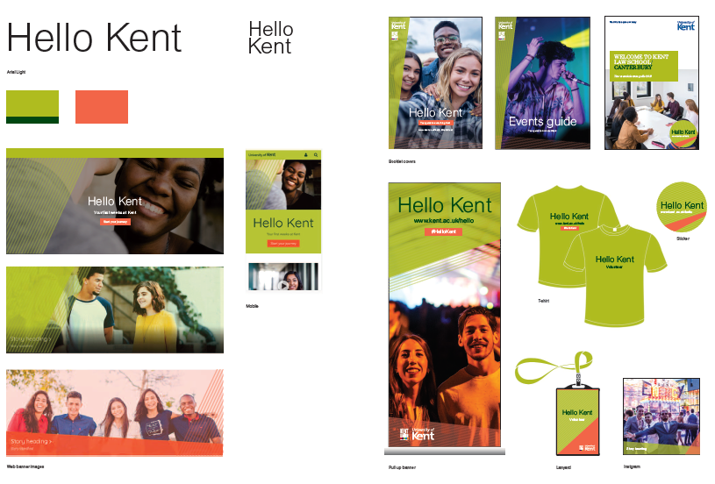

Website and app
This website – www.kent.ac.uk/hello - will go live in early August 2020 and will be promoted to all incoming students. The website will link to key enrolment information on the Getting Started webpages, maps, helpful student blogs/vlogs and a shared calendar with Canterbury and Medway events, as well as events organised by the University and Union.
The Getting Started webpages will still house all the enrolment information. The Hello Kent website is a campaign website that pulls all university and union information and events into one place, making it easier for students to find everything on offer during their first week.
This year we are also creating a Hello Kent app to support communications. The Hello Kent website will be used to help populate the app. The Hello Kent events and blog posts will be included in the app.
Please signpost incoming and returning students to this website and app in your pre-arrival and welcome week communications.

Adding events
Key feedback we received from students is they want to see all welcome events in one place.
We will be encouraging schools/departments to use the Events Factory to add their events, including virtual events, to the calendar: https://webtools.kent.ac.uk/events/.
Please note: We recommend only adding events open to all or large student groups (eg international and pg students) to the ‘Hello Kent’ calendar. School specific events can stay in School calendars.
The Hello Kent website will link directly to school calendars so those students can view school events.

Step one: getting access to your events calendar
Most schools/departments will already have an events calendar created in Events Factory.
To gain access to your school/department events calendar you can email helpdesk@kent.ac.uk and request permission.
Alternatively, if you know who is responsible for your School’s/Department’s calendar you can ask them to give you access.
If your school/department does not have an events calendar, the IT Service Desk can create one on your behalf - helpdesk@kent.ac.uk.
Step two: add an event
- Go to https://webtools.kent.ac.uk/events/
- Select the calendar you have access to (for example ‘Kent Union’)
- Select green button ‘Add Event’
- Fill out as much of the online form as possible including essential information marked with a red asterisks. Make sure you choose a campus so the user can filter by location.
- Make it clear which events are virtual and which are face-to-face
- Tag the event accordingly (see step three below)
- Add a relevant banner image. If you don’t have an image to hand, you can choose a relevant image from:
  - The University image library – https://www.kent.ac.uk/brand/visual/image-library.html
  - Unsplash - https://unsplash.com/
- Crop banner images to a 3:2 ration (minimum of 1920 x 1280 pixels). IS have a tool to help you with this - https://www.kent.ac.uk/digital/cropper/docs/. You can read the full guide on image sizing at - https://staff.kent.ac.uk/digital/service-manual/preparing-feature-panel-images
- Under ‘Promote this event’ at the end of the form select ‘Hello Kent’. This will make sure it is surfaced on www.kent.ac.uk/hello.
Tip – add a map url from the Kent maps system so students can easily find where your event is taking place. For example, the Student Hub at Medway map url is https://www.kent.ac.uk/maps/medway/medway-campus/building/medway-student-hub and the Venue at Canterbury is https://www.kent.ac.uk/maps/canterbury/canterbury-campus/building/students-centre-the-venue.
Step three: tagging your event
To make it easier for students to find relevant events, we have created a series of tags for you to use with your ‘Hello Kent’ events:
- International Students
- Postgraduate Students
- Library
- Union
- Sport
- Social
- Health and wellbeing
- Student skills and employability
- Theatre and performance
- Food and drink
- Making music
Tip – these are shared across the whole of Events Factory. You should start to see a list of suggested tags as you begin to type any of the above, you can then click the right one to add it to your event. A single event can have multiple tags.

Social media
Please use our artwork and the hashtag #HelloKent in all your social media that welcomes new and returning students to Kent. Additionally, academic schools and centres can create a school specific hashtag e.g. #helloSMSAS, which we would like to be used alongside the #HelloKent hashtag.

To do list for arrivals 2020
- Add your events to www.kent.ac.uk/calendar and tag appropriately by 29 July 2020
- Use Hello Kent branding in your welcome communications (including Moodle)
- Make it clear which events are online and which are face-to-face
- Tell colleagues about ‘Hello Kent’
- Signpost students to www.kent.ac.uk/hello in all welcome communications
- Use #HelloKent in all your social media activity
- Join and add to the Kent Facebook group for new students - https://www.facebook.com/groups/KentFreshers20/
- Subscribe to the student-comms@kent.ac.uk mailing list for updates on the ‘Hello Kent’ campaign and to receive online materials.

Key dates to remember

30 July 2019 – deadline to add your appropriate welcome events to the ‘Hello Kent’ website using www.kent.ac.uk/calendar (see point 4 above)
Early August 2020 – www.kent.ac.uk/hello and Hello Kent app goes live
5-21 September 2020 – Students start moving into accommodation
21-25 September 2020 – Welcome Week

Key web links
www.kent.ac.uk/hello
www.kent.ac.uk/calendar
https://www.facebook.com/groups/KentFreshers20/
www.kent.ac.uk/maps

Best practice tips
  - Include building names as well as room numbers when communicating event locations and link to www.kent.ac.uk/maps. Students can search for rooms in the search bar just using room numbers and get directions!
  - Use Plain English. See - https://blogs.kent.ac.uk/plainenglish/
  - Use multimedia content when posting to social media.

Contact and feedback
Please email communications@kent.ac.uk if you have any questions or feedback on the ‘Hello Kent’ campaign and website.

