Accessibility Tour Medway Building Tour February 2020

## Attendees

* Claire Chapman – L&OD Consultant (EDI)
* Michelle Dawson – Fire Safety and PEEP Adviser
* Lynne Reagan – Student Support and Wellbeing Manager (Medway Campus), Student Support

## Background and Aim of the Accessibility Tour

The accessibility tour is an initiative which has arisen from the Disability Staff Network, aiming to better understand the campus experience for disabled members of staff or students. The aim is to understand the campus experience for those utilising facilities at the Medway Campus in particular the Medway Building.

## Itinerary

This walk started at the first floor entrance to the Medway Building

A walk around the Medway building took place to understand the accessible route that is used by staff and students using the building as part of day to day activities to see if any improvements can be made to the route.

## Medway Accessible Route

The route was walked to understand what a member of staff or student that is to use the accessible route would see. It is understood that the building infrastructure cannot be changed but there were a few areas that could enhance the experience of staff and students.

Initial access to the building is via the external entrance on the first floor via electronic automatic doors or by the entrance on the ground floor then via the lift.

Initial comments are that the entrance is bright and spacious with a manned reception desk and security office. The reception desk is low and welcoming.

The Medway building has the same layout on the ground, and first floor, a central space, offices to the right and on the second and subsequent floors having an additional set of offices off to the right (as you look at the building)

On each floor at the top of the stairs and out the front of the lift space there are low chairs, it is light with space for turning, on the 2nd floor there was also an evacuation chair for use.

Disabled toilets on each floor were checked, each facility has an emergency pull cord though a concern was raised that these potentially go through to unmanned desks, it is **recommended that all emergency calls are fed through to the security gate house which is manned.**

Moving along the corridors on each floor to the left of the building, access was good on each floor, the corridors were clear and there was no clutter. Towards the end of the corridor on each floor there was signage for emergency fire exits with safe refuge space with electronic communications and details on what action to take.

Off to the right set of offices the corridors are wide and free from clutter, at the end of the corridor there is a fire exit with signage for safe refuge externally, on inspection of the outside area though there is no signage and no means of communication, so if a member of staff or student were to use this as a safe refuge potentially no one would know that they are there. As a minimum signage is required with security contact 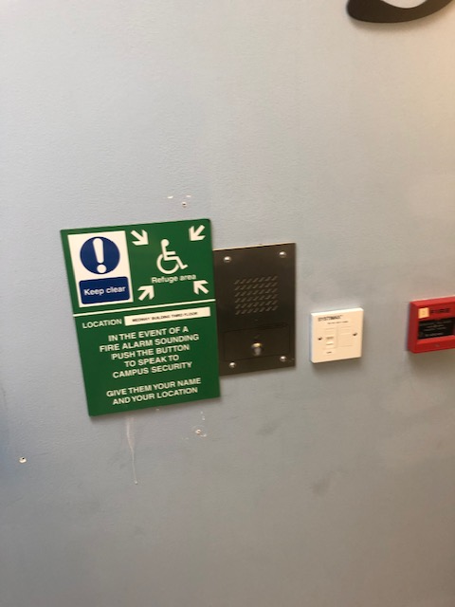details and information to activate the safe zone app, and **action should be taken with some urgency to implement safe refuge communication channels as a standard requirement.**

## Ground floor entrance

This access is pass controlled and members of staff and students who require this access should request this from security prior to needing to access the buidling. If the externl lift is out of action this entrance is used to provide access to the upper level of the campus.

If was found that there is Ramp access to the upper area of the campus but this has no signage and staff who have been employed for a number of years were unaware of this access.  
Access from the carpark can be found from the side of the student hub and over the bridge via a flat walkway. **It is recommended that signage is created from the student hub to mark the route and that signage is also placed on the ground floor door of the Medway building of the route with a map.**

