 **Accessibility Tour November 2019** 

**Attendees**

* Claire Chapman – L&OD Consultant (EDI)
* Michelle Dawson – Fire Safety and PEEP Adviser
* Sophie Pearson – Space & Workplace Manager
* Sandeep Sharma – Support Officer

**Background and Aim of the Accessibility Tour**

The accessibility tour is an initiative which has arisen from the Disability Staff Network, aiming to better understand the campus experience for disabled members of staff or students. This was the First accessibility tour for 2019/20. The aim is to understand the campus experience for those utilising facilities at the Canterbury Campus.

**Itinerary**

The group met at the student entrance of the registry at 13.00 on the 20th November and took the following route around the campus viewing main external access routes.

* Student Entrance Registry Building
* Make our way along the path past the Gulbenkian and Grimond
* Continue on down, past the UELT and Security building and cross the road and make our way down to the Sibson building (past Stacey, Ingram, Jennison)
* From the Sibson building continue on towards park wood and the sports pavilion
* head back towards Woodys and through the wooded area,
* Down the footpath past the Sports Centre and Canterbury mosque to Keynes College via Tanglewood
* From Keynes cross over University Road near the Venue/Jarman and along the main footpath back to the Registry

**General Observations**

Generally the University is making good provision for disabled students and staff, it was acknowledged that much had been done to improve the built environment over the last few years and since the last external Canterbury tour and that issues that had been previously been reported had been actioned.

**Areas of Improvement**

Since the last tour there are a number of improvements that have been made which have been highlighted throughout the tour summary

**Areas noted for investigation**

There are still come areas where further work is require which have highlighted throughout the summary with photos

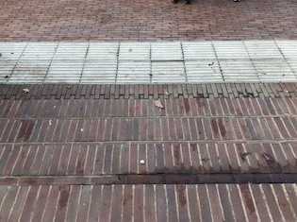**Stairs** – There have been a number of improvements made with most sets of concrete stairs now being painted with a white strip to help distinguish the different levels.

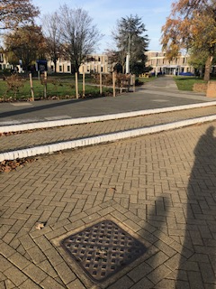**ACTION**: The stairs outside the Library still require action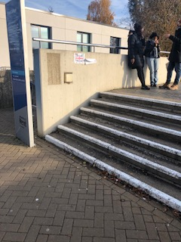

Most stairs have hand rails – **ACTION**: Elliot College still only has a handrail on one side (above) – Rutherford stairs have been improved with a handrail on each side of the stairs now

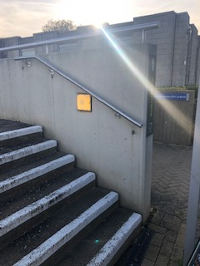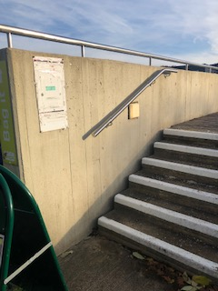

Improvement seen: The signage to the ramps has also been installed for at both Elliot and Rutherford Colleges

**Pathways**

Most pathways were in good condition and are reviewed regularly by the estates departments and repairs made immediately, the main campus is generally flat and so access is good.

All defects can be reported to the estates customer services departments via the website or phone number if there are any immediate concerns or cracked and dangerous pavements. <https://www.kent.ac.uk/estates/helpdesk/index.html>

Now that the cold weather is upon us, the estates department also have a process to ensure that all main routes are gritted if the weather shows signs of Icey conditions to prevent slippery conditions.

* 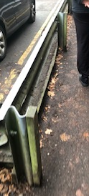Improvement seen - The Wood has been replaced and repainted on the crash barriers in the alley next to the sports centre since the last tour.

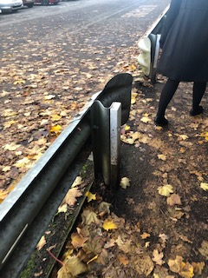

2018 2019

* Improvement seen - Where there was a large drop from the path to below some areas have had good railings installed to prevent falling (Marlowe)

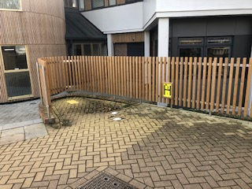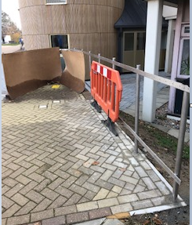

2019 2018

Where the path leads to a road to cross there was generally good indication for the visually impaired with the use of rumble strips etc.

There were some cases where these were not in place or not fully extending to the edge of the path so it would not be known where the path ends and the road starts. **ACTION**: There was also a section where this is no path to the crossing which would cause all pedestrians to go into the road. (Behind Woodys as you enter the wooded area

**ACTION:** Pathway – Rumble Strips to Park wood Residential area to Woodys need extending/Path to crossing

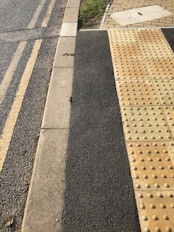

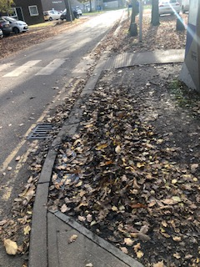

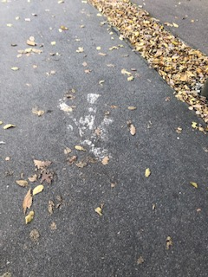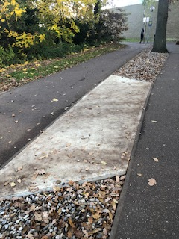A number of improvements have been made to the pathways through the wooded area on the way back to the main campus, Cycles and Pedestrians have been separated, **ACTION**: through the visuals need repainting.

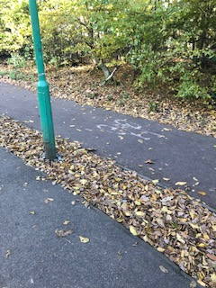

There have been additional cross over points added and the pebbles removed

One area for **ACTION** is where the cycle path meets a pedestrian route clearer markings are required – there are examples of good practice that could be replicated on the same path.

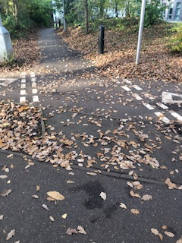

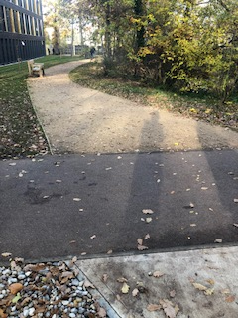

**Good practice ACTION REQIURED**

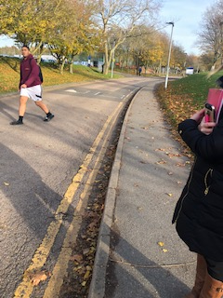Access to The Pavilion - On route to the pavilion is was noted that there is no Dropped kerb to allow safe passage from the pathway to the pavilion. The only way would be for a wheel chair user to travel along the highway to the entrance of the car park

**ACTION –** investigate the possibility of installing a dropped kerb (it is noted that this road/path belongs to Kent highways

**Access to Woodys**

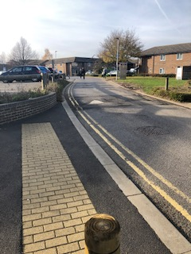It was noted that from the dropped kerb on the side of the accommodation, that there is no path for wheel chairs to follow to gain access to Woodys, without travelling along the highway past the car park to the accessible pathway.

**ACTION**: Signage or a painted pathway for safety could be implemented

**Signage**

Signage is good across the campus. There is a policy on signage which defines the styles and size. If the signage is to be changed this would result in a change of policy.[1]

There are standards for implementing signage – the signage outside Rutherford is positioned so that it does not allow people to walk to the bottom of the stairs holding the rail

**ACTION**: this could be repositioned by 90 degrees to allow access

Action: A frame boards to promote the eateries within Rutherford were also a hazard at the bottom of the stairs

Improvement seen– both Rutherford and Elliot ramps now have signage to indicate that there is a wheelchair ramp which can be used

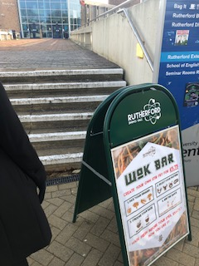

**Parking**

There is also some good access particularly outside Keynes where there has been spaces put in the barriers to allow wheelchair users to gain access to the pathway without having to travel long distances in the road. There are 2 spaces at the Pavillion

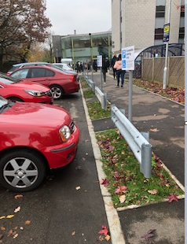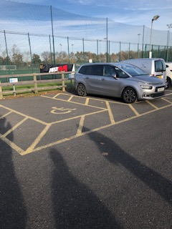

1. <https://www.kent.ac.uk/estates/services/Interiorservicesandsignage/Files/DMA_signage_catalogue.pdf>

   <https://www.kent.ac.uk/estates/services/Interiorservicesandsignage/signage.html>