Accessibility Mini Tour October 2019
Attendees
- Claire Chapman – L&OD Consultant (EDI)
Background and Aim of the Accessibility Tour
The accessibility tour is an initiative which has arisen from the Disability Staff Network, aiming to better understand the campus experience for disabled members of staff or students. This was the First accessibility tour to take place since 2014. The aim is to understand the campus experience for those utilising facilities at the Canterbury Campus.
Itinerary
This was an adhoc tour as the original tour was postponed due to the weather and will rearranged for Wednesday 20th November at 1pm
This walk started at the student entrance to the Registry
A small walk around the Rutherford building took place on the request of Claire Bird (applicant day coordinator) to understand the accessible route that is used as part of applicant events which are usually held in Rutherford dining hall to see if any improvements can be made to the route and the first impressions that are provided to applicants on viewing the campus.
After this the tour headed towards Keynes, past the coop building, past the entrance to Keynes, the main road route was taken along to and past UELT and the Library ending up back at the Registry.
Along the way photos were taken particularly of the issues with signage within Rutherford and the external uneven surfaces and pathways across the campus.
Rutherford Accessible Route
The route was walked to understand what an applicant that is to use the accessible route would see as this is the first impression of the University. It is understood that the building infrastructure cannot be changed but there were a few areas that could enhance the experience of the applicant.
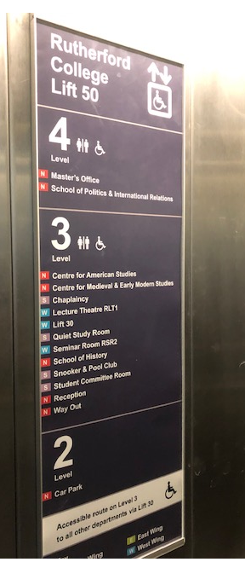
Initial access to the building is via the external ramp or by the lift from the carpark, the ivy on the ramp is long and for those within a wheel chair this would come into contact with their face.
Initial comments are the lift signage would benefit adding ‘accessible route’ to the signage so applicants know what level they are to exit the lift from.

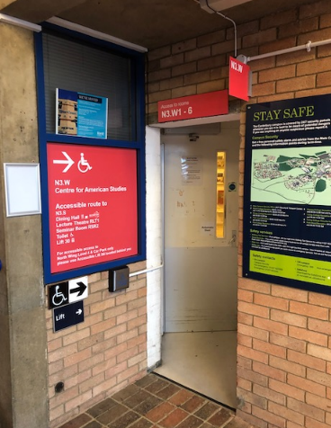
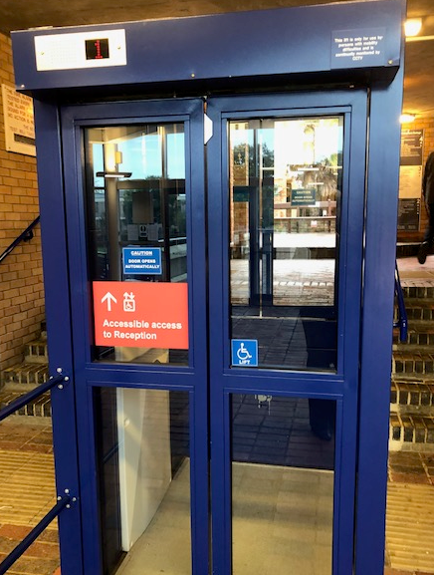
There are 2 accessible entrances in the foyer.

The route that is used for the applicant days is through the staff corridor and is clearly sign posted.
The entrance is narrow and would benefit from redecoration.

The corridor is long and narrow with a number of potential hazards for those with visual impairments or in a wheel chair
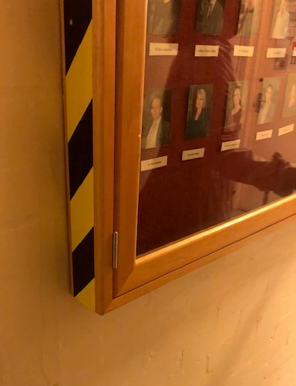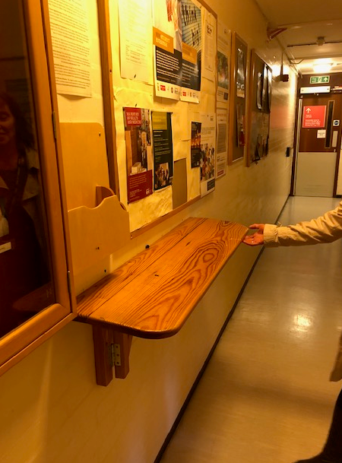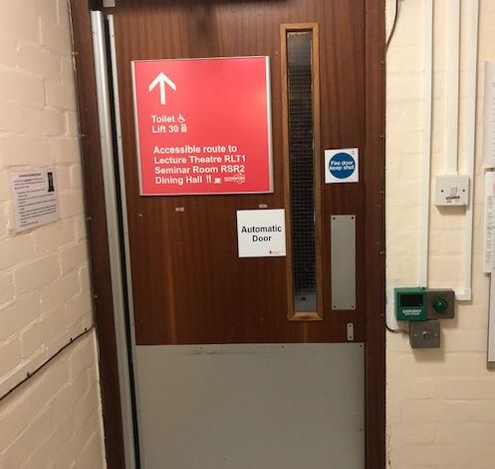

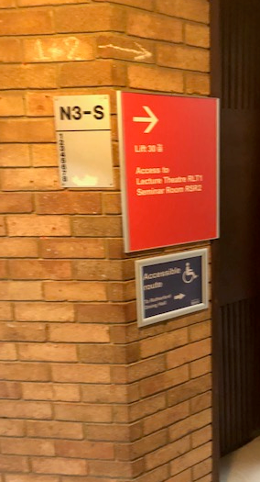
After exiting the corridor the applicant is to make their way to the dining hall for events

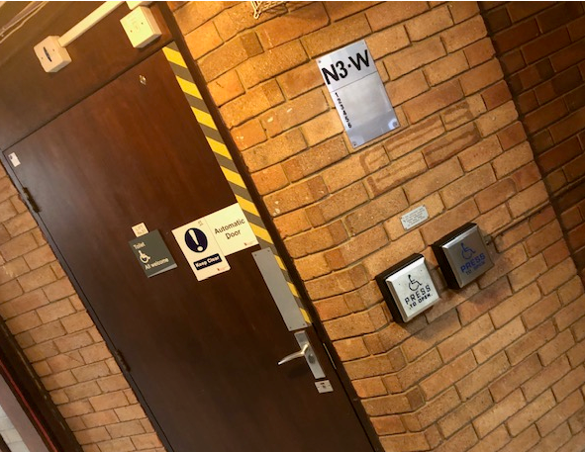
Along the whole route the new signage does not highlight the accessible route that applicants/visits are required to take to the Dining hall, the blue signage is a temporary sign that has been made specifically for applicant events.

Applicants are required to take another lift to another level and on exiting the lift the signage is not clear as to how to proceed to the dining hall, no direction is provided, it is only due to the temporary signage that the route is identified.
There is also a concern on the signage for the location of the accessible toilets and also the position of the press buttons. There are two located next to each other and it would be easy to press the incorrect button. Clearer signage is required

Pathways
Most pathways were in good condition and are reviewed regularly by the estates departments and repairs made immediately, the main campus is generally flat and so access is good.
All defects can be reported to the estates customer services departments via the website or phone number if there are any immediate concerns or cracked and dangerous pavements. https://www.kent.ac.uk/estates/helpdesk/index.html
Now that the cold weather is upon us, the estates department also have a process to ensure that all main routes are gritted if the weather shows signs of Icey conditions to prevent slippery conditions.

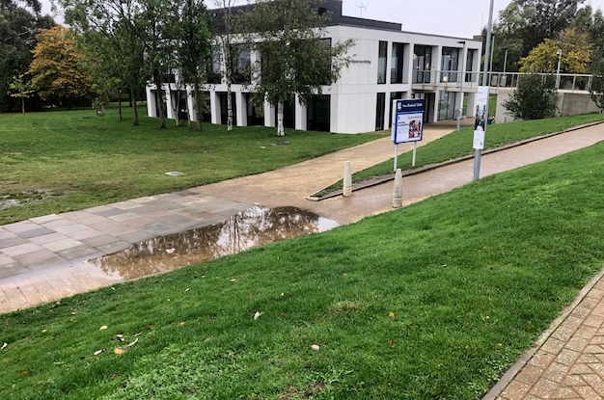
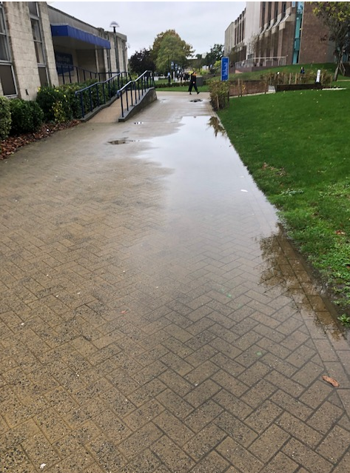
- Flooding/puddles due to uneven surfaces –
- in front Rutherford extension (picture 1),
- at the bottom of the ramp/Slope for the law school (picture 2)

Picture 1 Picture 2
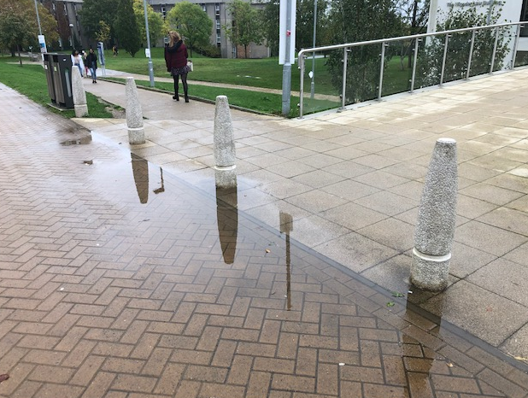
At the entrance to Kent Law school
(picture 3)

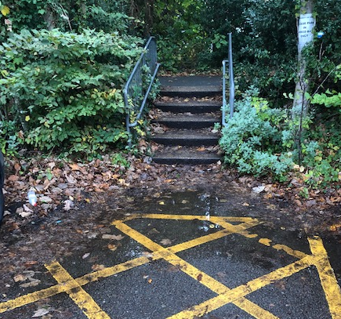
Stairs that come from the Alley way that leads to Keynes into the carpark
(picture 4)

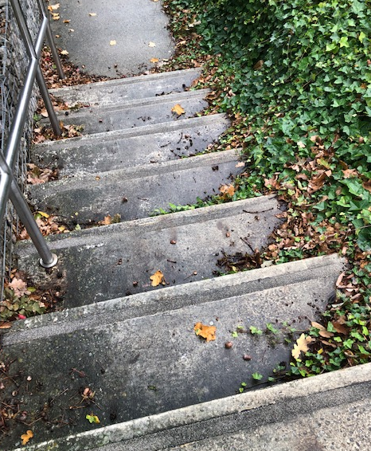
As you cross the road and head towards Giles lane, from Keynes and walk behind the Jarman building the stairs are slippy and covered in Ivy with the ivy covering part of each step.
Picture 5

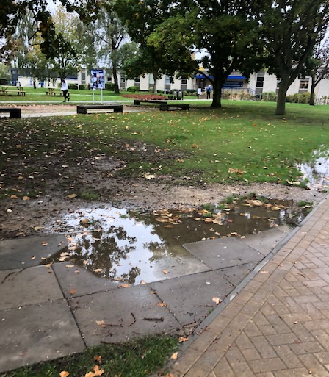
Outside the Gulbenkian
Picture 6

