Accessibility Tour May 2019
Attendees
- Claire Chapman – L&OD Consultant (EDI).
- Michelle Dawson - Fire Safety and PEEP Adviser, Safety, Health and Environment Unit.
- Mark Ashmore - Project Manager, Estates Department.
- Stuart Austin - Finance Assistant, Gulbenkian.
- Derek Baldwin - Chairperson, Disability Staff Network, University of Kent
Background and Aim of the Accessibility Tour
The accessibility tour is an initiative which has arisen from the Disability Staff Network, aiming to better understand the campus experience for disabled members of staff and students.
This is the Third accessibility tour to take place this academic year 18/19. The aim was to understand the experience for those who will be located in the new Economics building – Kennedy
- It is worth noting that when new builds are commissioned at Kent full consultation with an external provider to assess accessibility is part of the build process.
Itinerary
The group met at the entrance to the Kennedy Building and were shown around all floors by Mark Ashmore.
The building was not occupied at the time of the tour, it was recommended that the tour takes place again in the future when it is fully occupied.
General Observations
The outside of the building is flat, well lit with good landscaping and space provided for accessible parking bays.
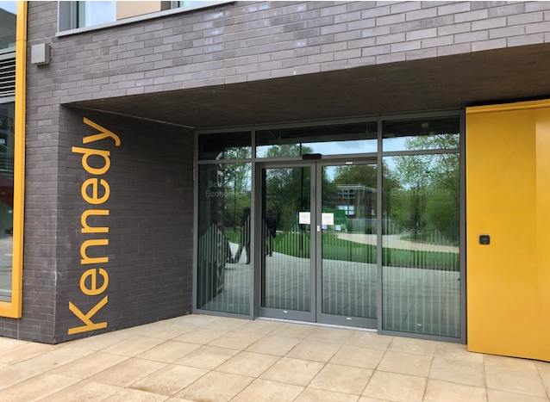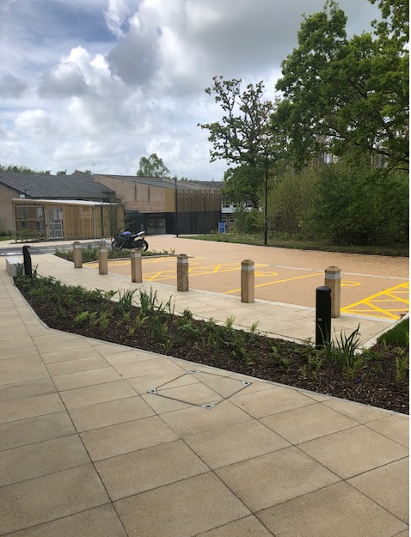

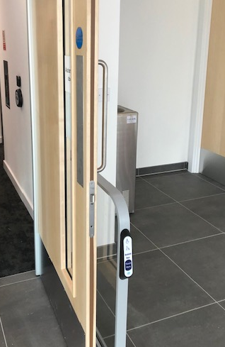
Access
Access into the building was via sensor doors which opened with ease for wheelchair users, the foyer is spacious and well lit, providing stairs and a lift for access to upper floors. Individual stairs on the stair case were easily distinguishable.
Doors where pass activated or via assisted control.
A question was raised about the distance from the pass reader to the door after a concern that the door may lock before a user has an opportunity to open or enter through the door.
It was noted that estates can be contacted and timings can be adjusted to ensure easy entrance.
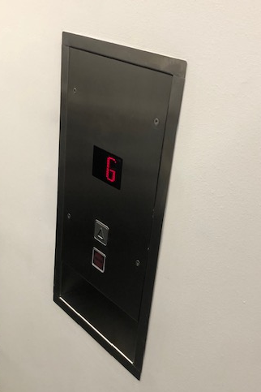
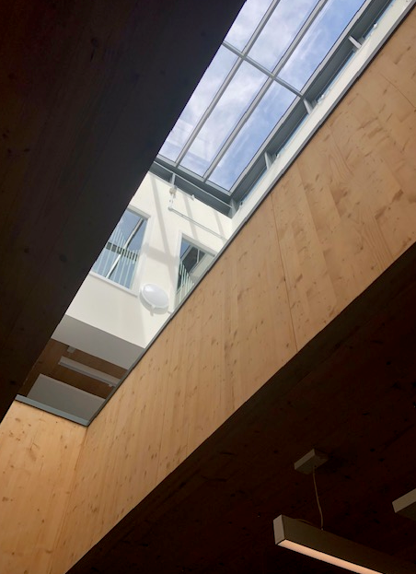
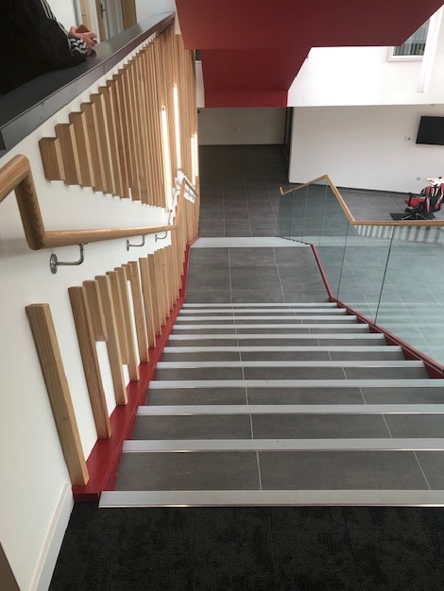

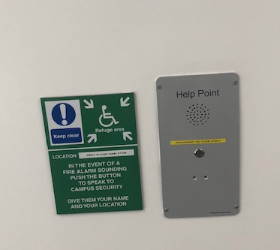
Safety
Space was provided at the top of each stair well for a safe place for wheelchair users for in the event that the fire alarm was to sound.
There was sufficient space within the lift for wheelchairs to access and exit the space.
Depending on what side the wheelchair accessed from though the ‘floor’ buttons were not accessible as they passed the buttons to access the lift.
Timings for door openings and exiting the lift need to be extended to prevent them from closing to soon.
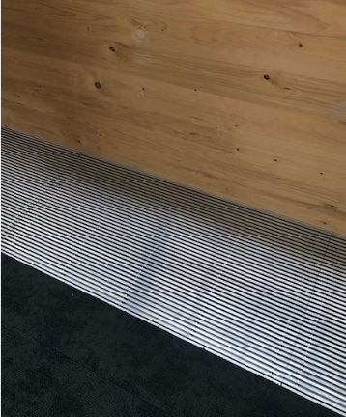
Travel
There were some loose grills when travelling over by foot and wheel chair which need to be tightened.
The Twist/Pile of the carpet caused some slight veering to the wheelchair but travel was not impaired.

Offices
All were pass controlled, windows were on a handle that could be easily reached.
Specific individual adaptations can be made as required by contacting OH and Estates
Facilities
There is sufficient space and turning capacity in each of the Disabled toilets at present.
In one cubicle it was noted that there was a baby changing unit and a concern was raised as to where the bins will be located, as these could limit the space available – to be reviewed after occupation.
Emergency cords were fitted in all areas that will go to campus security and the door closers were tested to ensure that doors could be easily opened and closed – all were ok
The shower cubicle still had the door closer fitted and it proved difficult to open the door while in a wheelchair.

General comments
Overall the new build was accessible, there were a few minor issues found as described all which can be amended to make work for the building and the staff that will occupy it. A very considerate build

