Accessibility Tour November 2018
Attendees
- Claire Chapman – L&OD Consultant (EDI)
- Derek Baldwin -Chairperson, Disability Staff Network, University of Kent
- Richard Cottam -Head Of Facilities Management, Estates Department
- Omolade Adedapo- Vice-President (Welfare), Kent Union Board of Trustees
- Teresa Curteis - Head of Traffic Management and Travel, Estates Department
- Ben Watson - Accessible Information Adviser, Student Support
- Sarah Fisher - User Experience and Digital Content Officer
- Leanne Hardy - Performance Improvement Officer, IS Quality and Marketing Team
- Hakki Aganoglu - IT-AV Technician, Campus Support

Apologies from –
- April McMahon - Deputy Vice-Chancellor Education, Office of the Vice-Chancellor
- Jim Higham - IT Service Desk Manager, IT Service Desk
- Michelle Dawson - Fire Safety and PEEP Adviser, Safety, Health and Environment Unit

Background and Aim of the Accessibility Tour
The accessibility tour is an initiative which has arisen from the Disability Staff Network, aiming to better understand the campus experience for disabled members of staff or students. This was the First accessibility tour to take place since 2014. The aim is to understand the campus experience for those utilising facilities at the Canterbury Campus.

Itinerary
The group met at the Main entrance to the library at 13.00 and took the following route around the campus viewing main external access routes.
- Library Main entrance
- Make our way along the path past the Senate building to the front of the Registry
- From the Registry, cross the road and go to the main entrance of Darwin building
- From Darwin, go down the side of the Registry past Cornwallis and the Gulbenkian and continue on down past the other entrance to the Library (i.e. past Grimond, Aphra/Lumley)
- Continue on down, past the UELT and Security building and cross the road and make our way down to the Sibson building (past Stacey, Ingram, Jennison)
- From the Sibson building head back towards Jennison then bear right, taking the footpath past the Sports Centre and Canterbury mosque to Keynes College via Tanglewood
- From Keynes cross over University Road near the Venue/Jarman and along the main footpath back to the Library where we started

General Observations
Generally the University is making good provision for disabled students, it was acknowledged that much had been done to improve the built environment over the last few years and that actions that had been previously reported had been actioned. While completing the tour some actions were classed as requiring immediate attention – I have included the work order number and the current status of these actions
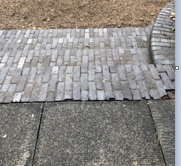
Areas noted for investigation
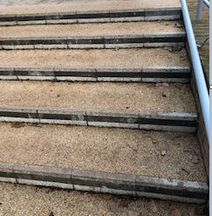
Stairs – there was a consistent issue across the campus about stairs and the way that entrance/ exit stairs to buildings and areas were marked. Many sets of the stair were of the same materials and so it would be hard for someone who had a visual impairment to know where the stairs started and stopped. Where stairs did have some sort of mark, the paint was dull and needed to re-done or to be cleaned.

Above – Picture to right - outside of Stacey building ‘snake pit’ no rumble strips and hard to distinguish between stair levels
Above Picture to left - Stairs by Jennison- stairs have different coloured strip but do need cleaning off
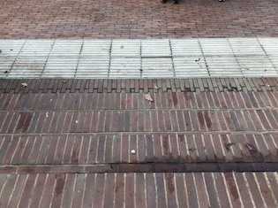
Picture to left - stairs to and from the Library – hard to distinguish where they start and stop

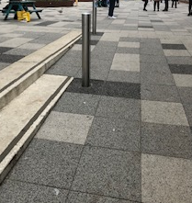
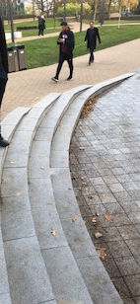
Some stairs blend into the surroundings and so could become a trip hazard in some area there was good practice and bollards have been put in situ to prevent tripping (left outside venue)
But not all places – Outside Marlowe – right

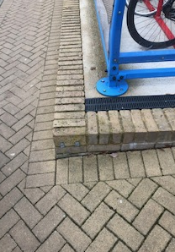
Although not strictly a step, there were corners of small raised walls which could cause a trip hazard- bike hut outside sports centre, this needs to be highlighted to remove the hazard

Pathways
Most pathways were in good condition and are reviewed regularly by the estates departments and repairs made immediately, the main campus is generally flat and so access is good.
All defects can be reported to the estates customer services departments via the website or phone number if there are any immediate concerns or cracked and dangerous pavements. https://www.kent.ac.uk/estates/helpdesk/index.html
Now that the cold weather is upon us, the estates department also have a process to ensure that all main routes are gritted if the weather shows signs of Icey conditions to prevent slippery conditions.
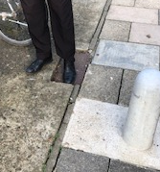
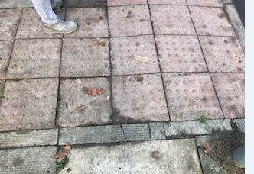
There were a few issues raised on pathways
- Trip hazard (down the site of the registry by the bike racks)

- Dropped paving- at the traffic lights as you cross from behind security on the way over to Sibson

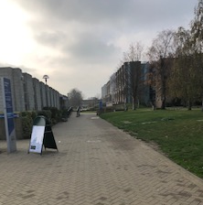
- Flooding/puddles due to uneven surfaces – in front of the English building ( Picture to right)
- Raised pathways due to the trees in the pathway down to Jennison building
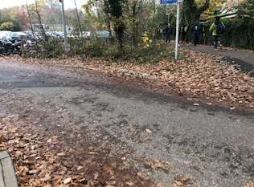
- Leaves covering dropped curbs and wheel chair access outside of Keynes building (below)

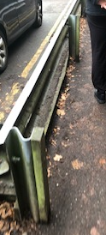

- Wood needs replacing on the crash barriers in the alley next to the sports centre and they need to be painted to make then distinguishable. (right)

- Where there was a large drop from the path to below some areas have had good railings installed to prevent falling (Marlowe and Jennison- below left and centre) but other areas haven’t, walkway up to the venue - below right)
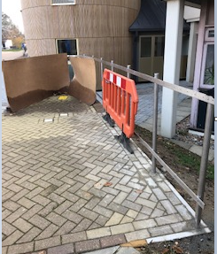
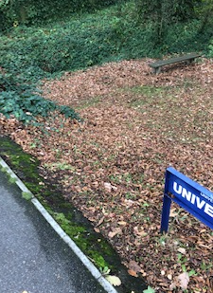
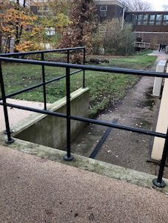
Where the path leads to a road to cross there was generally good indication for the visually impaired with the use of rumble strips etc.
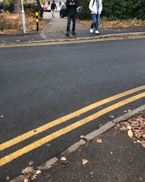
There were some cases where these were not in place
- Alley from the sports centre to Hospitality (right picture)
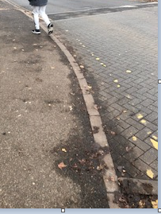
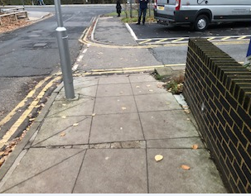
- Exit from Keynes to the main road and as you cross the road to venue (below left and centre)
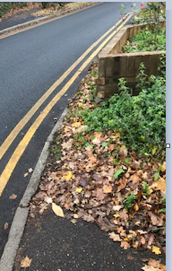
Visual restriction down the road for wheelchair users as they exit the alley by the Mosque and cross to hospitality due to the wall , this is out of the remit of the estates department as they do not own the wall, maybe warnings could be put in place.

There were some areas of action within the pathways with respect to the drainage – some have very large grates which could lead to someone losing their footing (outside rear entrance to library) , some were dented ( alley behind sports centre) and so stored puddles and leaves, lightweight covers are being used in high traffic areas and there are still paths where the concrete gullies are being used- which cause wheel chair users issues – Pathway to main entrance to library and rear entrance of library.
- Drain covers alley by sports centre
- Library drain
- Gulley’s
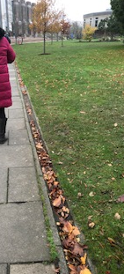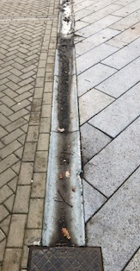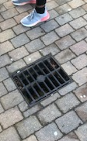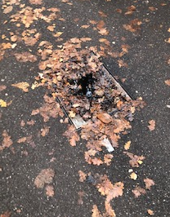
Gulley’s and drainage

Signage
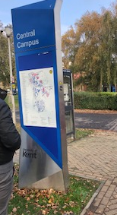
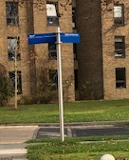
Signage is good across the campus, a question was raised over the size of the font and whether the best use of space had been made on signage. There is a policy on signage which defines the styles and size. If the signage is to be changed this would result in a change of policy.
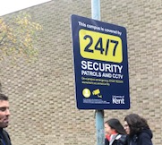
There are standards for implementing signage and outside the sports centre the signage did not meet this criteria and caused a collision hazard as it was sited very low
- Signage of Campus maps and directions
- Low signage outside sports centre ( work order 627327 – now complete 23.11.18)

Wheelchair access
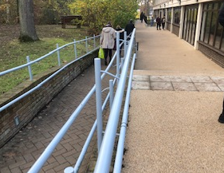
All buildings had a ramp to allow for wheelchairs users to access buildings, some were more accessible than others and more clearly marked than others.
- Good access on the way to Sibson

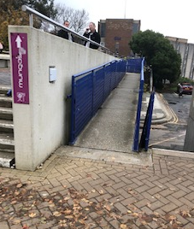
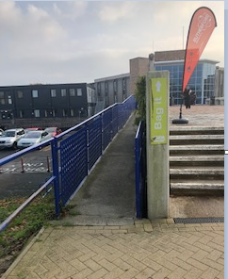
- Rutherford and Elliot ramps have no signage to indicate that there is a ramp which can be used this needs to be rectified

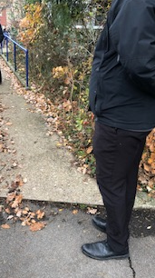
- Hospitality ramp had to be accessed via the car park and there was a step up to access the ramp- ( right) the step up needs to be reduced and it would be better if there was a clear marked pathway for the Wheelchair user to follow instead of crossing the parking are

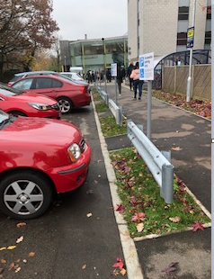
There is also some good access particularly outside Keynes where there has been spaces put in the barriers to allow wheelchair users to gain access to the pathway without having to travel long distances in the road.

https://www.kent.ac.uk/estates/services/Interiorservicesandsignage/Files/DMA_signage_catalogue.pdf https://www.kent.ac.uk/estates/services/Interiorservicesandsignage/signage.html

