Accessibility Tour February 2019
Attendees
- Claire Chapman – L&OD Consultant (EDI).
- Richard Cottam - Head Of Facilities Management, Estates Department.
- Michelle Dawson - Fire Safety and PEEP Adviser, Safety, Health and Environment Unit.
- Lynne Regan - Student Support and Wellbeing Manager (Medway Campus), Student Support.
- Alice Heggie - Marketing and Events Coordinator, Kent Innovation & Enterprise.
Background and Aim of the Accessibility Tour
The accessibility tour is an initiative which has arisen from the Disability Staff Network, aiming to better understand the campus experience for disabled members of staff and students. This is the second accessibility tour to take place this academic year 18/19. The aim was to understand the campus experience for those utilising facilities at the Medway Campus.
- It is worth noting that Kent has no authority over the walkways at the historic dockyard.
- Every effort has been made to ensure maximum accessibility for all visitors to The Historic Dockyard Chatham – the world’s most complete dockyard of the age of sail.
- The Historic Dockyard is, however, an 80 acre (32 hectare) site with over 100 historic buildings and structures and 3 historic warships, and this alone provides some limitations and challenges to access.
The dockyard provide the following information for their visitors on accessibility:
S:\Learning and Development\1. LD New\6. EDI\DISABILITY\Accessibility Tours\2018\Access-Statement-3.pdf
Itinerary
The group met at the Royal Church entrance within the Historic Dockyard at 13.30 and took the following route around the campus viewing main external access routes. This route was chosen as this was a typical route that would be taken to move across the two campuses.
- The Royal Church
- Past the Ropery
- Clock Tower Building
- Smitherie’s
- Galvanising workshop
- Along Western Avenue over the crossing at Dock Road onto the Pembroke Campus
- Along Central Avenue
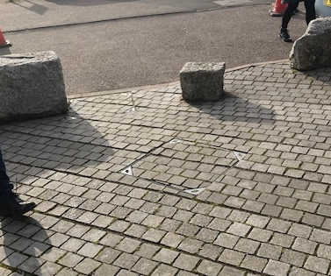
- Down the lift and then past the Drill Hall to Kent buildings
General Observations
Generally the Environment is making provision for disabled staff and students, it was acknowledged that there are limitations due to the Historic nature of the site and that some adaptations cannot be made, there were some areas though that it was felt with minor adjustments greater accessibility could be gained. It was also noted that some of the issues are out of the control of the University as they relate to the other businesses on the site.
Outside the Travel lodge- small stone in dropped curb area.

Access
Access into the Historic dockyard is via a pass activated gateway, there is also a push button on the exit. This is an automated gate and wide enough for all users.
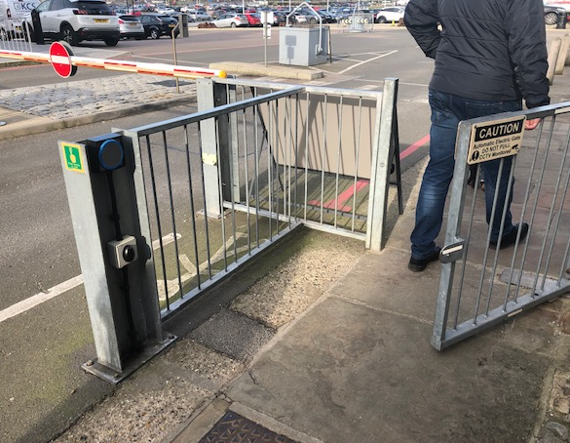
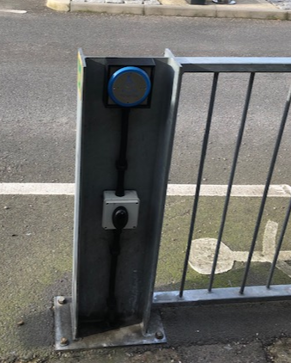

Pathways
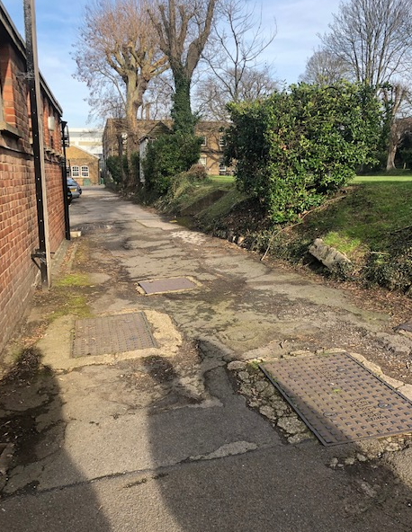
Pathways were in varying conditions, some were in need of repair at the Historic Dockyard, Pembroke campus pathways were in better condition.
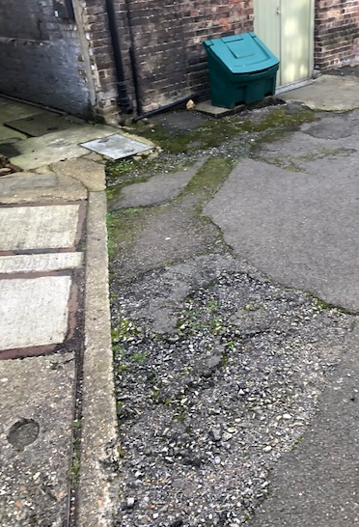

The Historic Dockyard and Pembroke campus are at varying levels with a number of areas being accessed via steps or an alternative, longer route for wheelchair users.

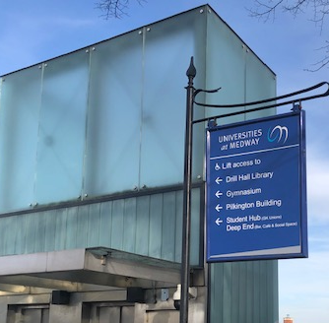
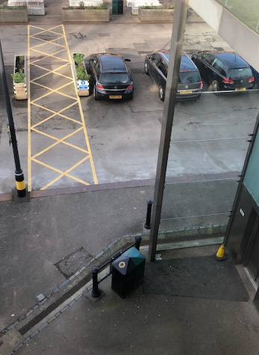
A lift is available at the Pembroke campus to allow movement between the 2 levels and was in operation on the day of the tour.

If the central lift was not in operation at the Pembroke campus, there was another option at special request to use the lift in the Pilkington building to go between levels.
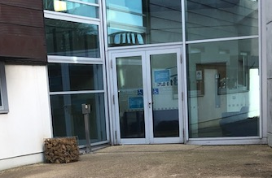
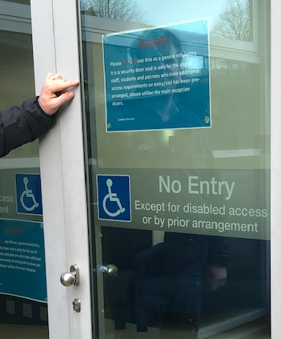

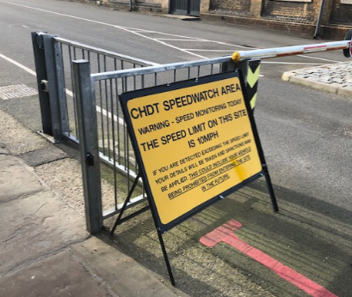
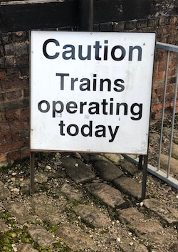
Pathway materials also vary across each site – The Historic Dockyard has a mix of tarmac & cobbles and there is also a set of train rails that cut through part of the pathways.
If trains are in operation- there is signage displayed as you enter the site, there are also speed watch signs displayed to ensure that all road traffic complies with the speed restrictions for safety and to preserve the site.

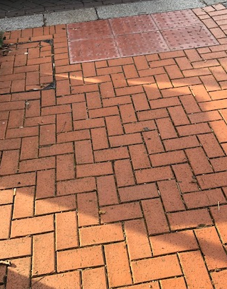
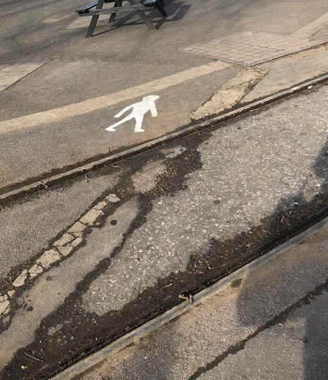
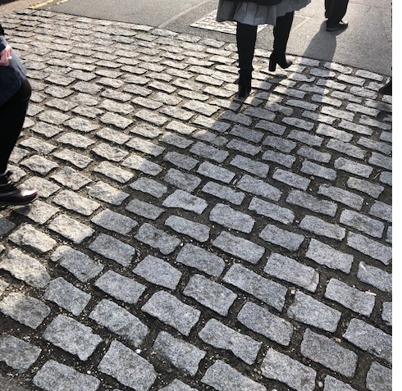
The route to the Pembroke campus is maintained by the Chatham Maritime trust and is mainly brick paving and then the Pembroke campus which is maintained by the universities is mainly tarmac or gravel.
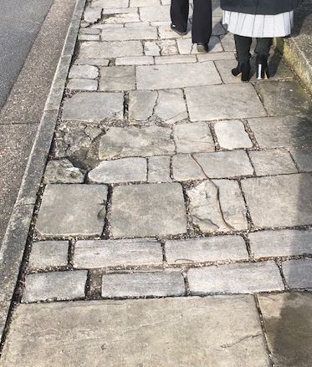
Where the rails intersect the walk ways there is the possibility of wheels, sticks, heels becoming stuck, it would be good if the rails could be more clearly highlighted.

(All defects can be reported to the estates customer services departments via the website or phone number if there are any immediate concerns or cracked and dangerous pavements. https://www.kent.ac.uk/estates/helpdesk/index.html)

There were a few issues raised on pathways mainly around access with respect to quality of dropped curbs. Dropped curbs were inconsistent and not located at each road intersection. Making the route to be taken longer than necessary and causing a number of crossings of main roadways to be taken. At the Pembroke campus, in some areas, additional tarmac had been laid creating access for wheel chair users but was inconsistent and not of the standard expected.
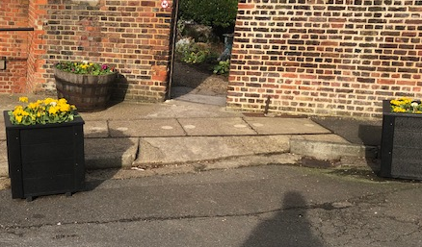
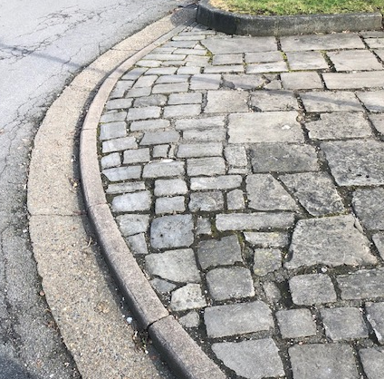
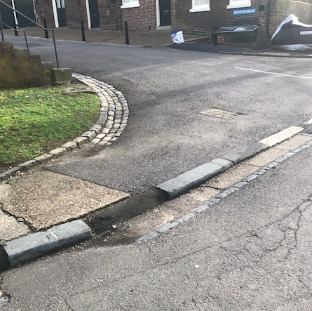
Historic Dockyard

Pembroke Campus
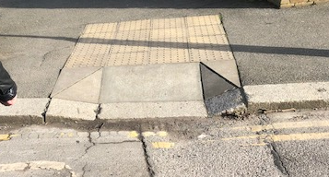
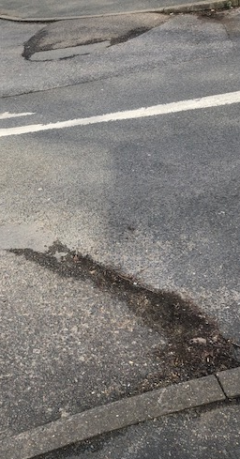
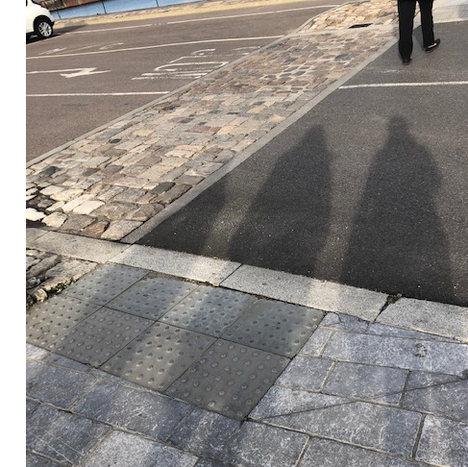
Within the carpark immediately outside the Historic Dockyard entrance, the quality of the dropped curbs do meet expectations and are of a good quality.
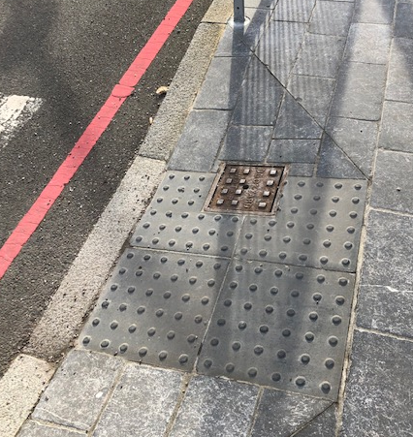

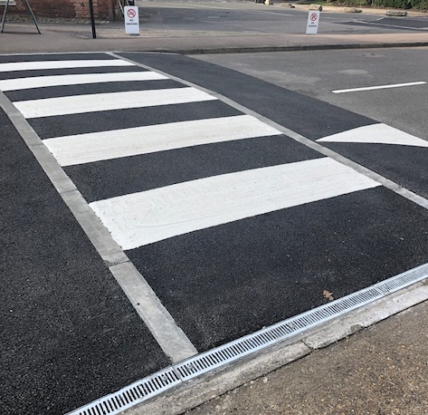
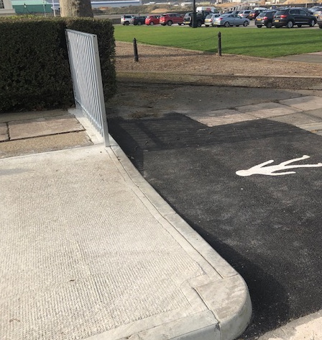
Some areas of the Dockyard have been altered with designated walking routes being installed and new dropped curbs installed.
A new raised zebra crossing has been installed outside the Ropery that ensures that it is at the same level as the path – no rumble strips have installed to alert users of the change in level or the crossing, this was also seen at the Pembroke campus.

Some pathways were blocked with equipment and would also be too narrow for wheelchair users to use. Tree obstructions on some pathways would cause issues for those who have a visual impairment to navigate.
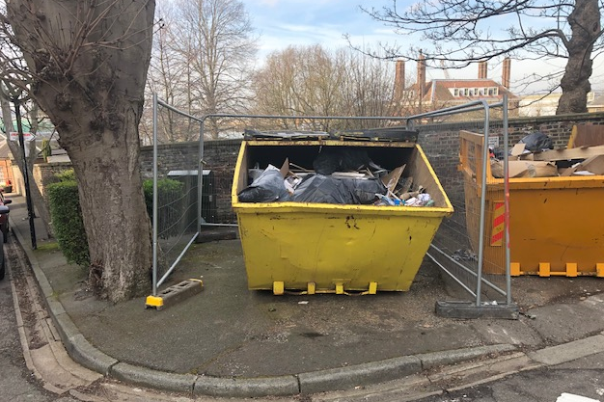
There were some areas of action within the pathways with respect to the drainage – some have very large grates which could lead to someone losing their footing, and there are areas where the concrete gullies are being used - which cause wheel chair users issues.
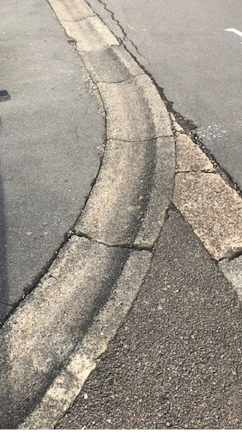
Gulley’s and drainage

Wheelchair access
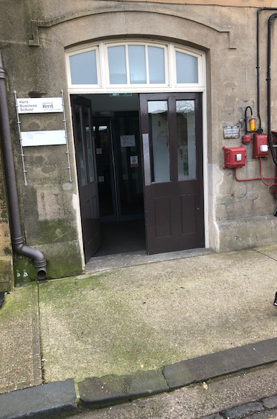
Most Buildings had a ramp or a form of access to allow for wheelchairs users to access buildings, some were more accessible than others and more clearly marked than others. There is a lack of consistency in the approach to ramps across the campuses.
Historic Dockyard
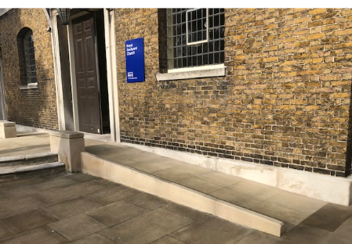
- Good access on the way to the dockyard church

- The access to the Kent business school is limited the drop curb was steep and it was on an uneven surface, as well as large heavy doors with no electronic door opener

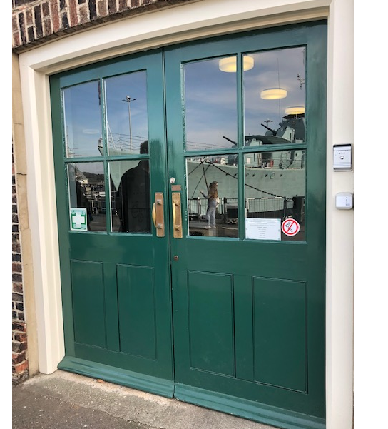
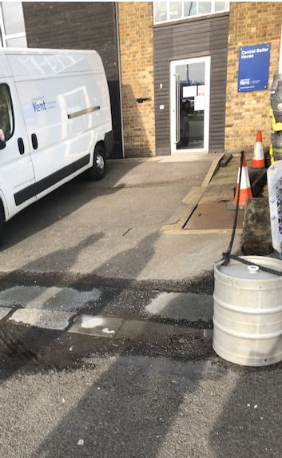
- Access to the central boiler house was through a gulley which had evidence of laying water and the ramp was very steep.

- Access to the Clock tower building was restricted , no electronic door opener

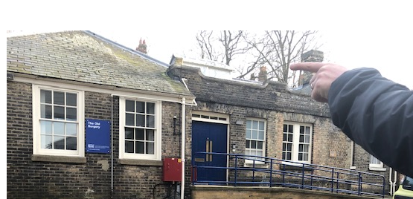
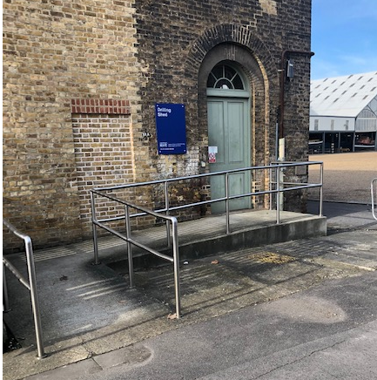
- Good access ramps were in place for the Old Surgery, the Engineering workshop, the drilling shed and reception.

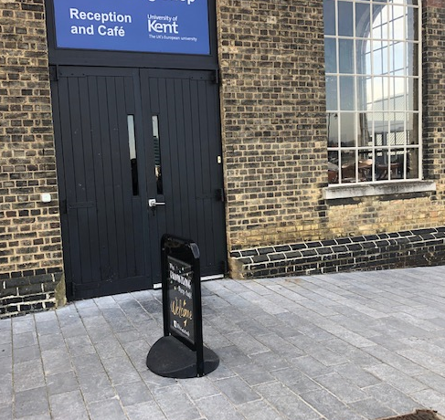

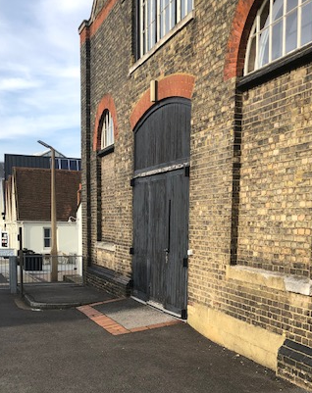
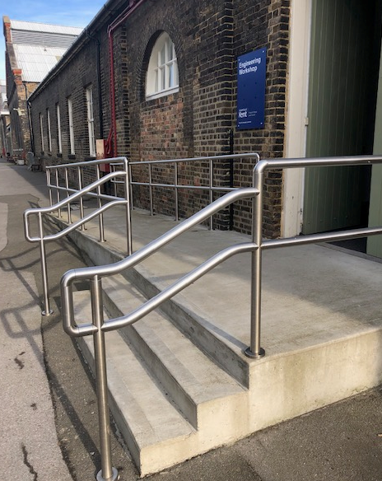

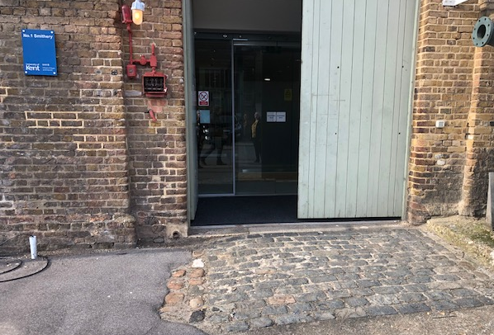
Access to the Smitheries would be difficult for wheelchair users and visually impaired due to the materials and the different levels as you enter/exit the entrance.

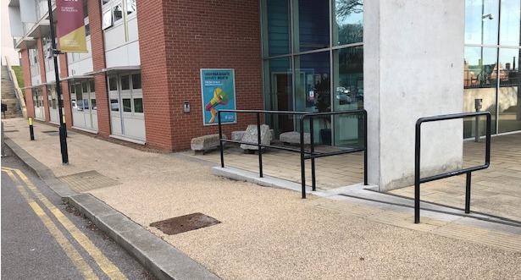
Pembroke Campus
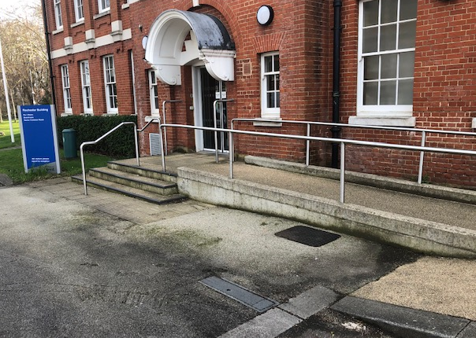
Good wheel chair access was available across all of the Kent buildings on the Pembroke campus, all with rails and ramps in place.

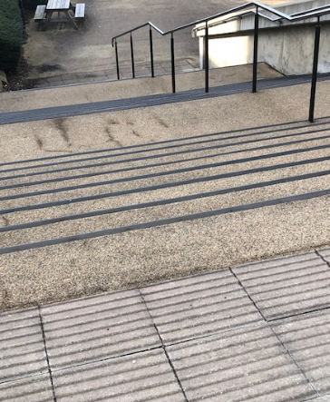
Where there is change in level at the Pembroke campus and stairs were in place they were well defined and individual steps were visible and included the rumble strips to show that a change in level was imminent.

Onsite Parking
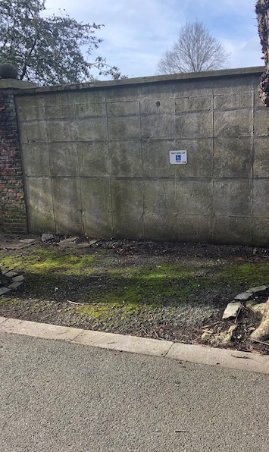
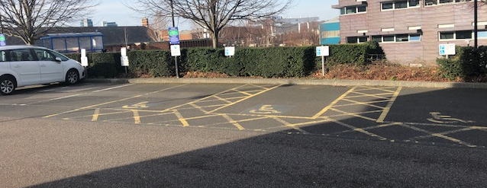
There were limited spaces for Disabled parking outside KBS on the Historic Dockyard, there more spaces were reserved for Visitors. There were sufficient well marked disabled spaces on the Pembroke campus

