Last Updated: 21 May 2021

The University of Kent
COVID-19 Code of Conduct for Students and Staff

Helping keep our community safe on our socially distanced campuses

PLEASE NOTE: This Code of Conduct is likely to be subject to regular updates as it is aligned to Government guidance, which can change at very short notice.

Contents

Please use the links below to find specific information relating to the necessary adaptations made to ensure our sites are COVID Secure, and outlines what we all need to do to make sure we keep each other safe.

Introduction 3

Coronavirus (COVID-19) 4

Duty of care – Protecting our community 7

Travel to and from campus 9

Hygiene, cleanliness & ventilation 11

Social distancing (physical distancing) measures 13

Face Coverings 15

Vulnerable Groups 18

Mental health (Stress/Anxiety) 19

Addendum 1: Additional Information for Students 20

Have you downloaded the free SafeZone app?

https://www.kent.ac.uk/safezone/
It’s designed to help students and staff summon first-aid, security or safety assistance via your mobile phone or Staff PC

Introduction

Although the risk of COVID-19 transmission remains, as students and staff return to campus we must adapt to new ways of studying and working.
This Code of Conduct aims to explain the changes to our environment; the necessary adaptations made to ensure our sites are COVID Secure, and outlines what we all need to do to make sure we keep each other safe. Failure to follow these behaviours could lead to an increase in infections and a localised outbreak on campus.
The main ways of reducing transmission are washing or sanitising your hands regularly, practising social distancing, and wearing a face covering.
The COVID-19 Risk Assessment for the University of Kent details the control measures in place which must be adhered to by all those at risk, all University students and staff; contractors; delivery drivers and visitors. Subsequently, key safety measures have been implemented on campus, which must be adhered to by students and staff, whilst the threat of transmission remains.

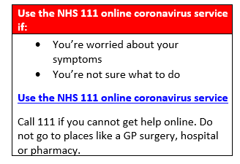  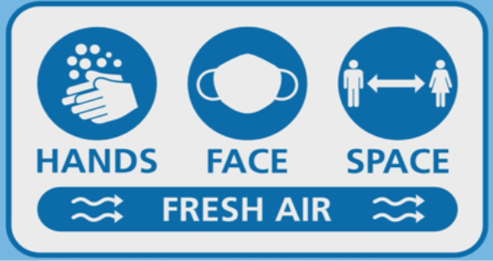 | All information and guidance is based on current Government advice, and we are fully aware that we will need to be flexible in our approach to returning to some form of normality as all is subject to change as the weeks and months progress.  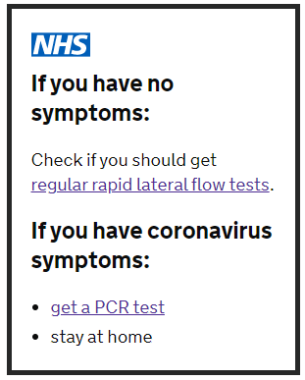

Please note that students and staff are expected to follow all standard guidelines when on and off campus, in addition to those outlined in this COVID-19 Code of Conduct.

- Student Charter
- Staff Code of Conduct
If you have any individual concerns about personal risks or specific vulnerabilities, or need any support or advice; students should contact Student Support, and staff should speak to their line manager.

Coronavirus (COVID-19)

It is essential that you and your household self-isolate* if you, or anyone you live with, develops any of the following:

- A high temperature (fever)
This means that you feel hot to touch on your chest or back (you do not need to measure your temperature)
- A new continuous cough
This means coughing for more than an hour, or 3 or more coughing episodes in 24 hours (if you usually have a cough, it may be worse than usual)
- A new loss or change to your sense of smell or taste
This means you have noticed you cannot smell or taste anything or things smell or taste different to normal

COVID-19 transmission is thought to occur in different ways:

- Through contact with respiratory droplets or aerosols that are produced when an infected person coughs, sneezes, or talks. Droplets are not airborne for long, but smaller fine aerosols do persist in the air, both can be inhaled into the lungs of an uninfected person.

- Through contact with a surface contaminated with the virus droplets. A person touching the contaminated surface and then touching their own eyes, nose or mouth, could become infected with the virus. It is currently believed that COVID-19 droplets can survive for up to 72 hours on plastic, 48 hours on stainless steel and 8 hours on copper.

- It is now clear that people who do not have symptoms (asymptomatic), but are infected play a role in the spread of the infection.

Latest NHS information and advice about coronavirus: www.nhs.uk/conditions/coronavirus-covid-19/

*Self-Isolation: It is very important that people with symptoms, which may be due to coronavirus (COVID-19), and their household members stay at home. Staying at home will help prevent the spread of the virus to family, friends, and the wider community. Government Guidance for households with possible or confirmed coronavirus infection

You should also self-isolate if the NHS ‘test and trace’ service or the University’s COVID_Support team alerts you that you have been in contact with a person who has tested positive for coronavirus - see NHS Test and Trace Guidance for full information on the process to follow if the NHS ‘test and trace’ service contacts you.

If you become unwell whilst on campus with coronavirus symptoms:

Self-isolate – Test – Inform: New reporting procedures have been developed for those experiencing symptoms of COVID-19 or have been advised to self-isolate:
- Student Procedures

- Staff Procedures

Summary:
- If you have coronavirus symptoms (fever, continuous cough, change in or loss of taste or smell) try to book a coronavirus test before you leave as you may be able to get an immediate test on campus. This must be at the public test centre in Rutherford carpark and not at the University’s Asymptomatic Test Site.

- go home as soon as possible, following Government advice on travel and self-isolation

- inform your line manager. Students should go online to inform the University of your need to self-isolate.

- If you need to wait on campus for transport home and you have your own office, please wait there. If you need to wait and don't have your own office it is best to wait outside well away from others. However, if the weather is bad, or you will have a long wait rooms have been set aside for your use.

Call Campus Security on 01227 823300, who will direct you to the nearest available room on campus to await transport.

Anyone with symptoms should arrange to have a test as soon as possible, to see if they have COVID-19. Call the dedicated NHS hotline, Tel: 119 or book online via the NHS website.
The NHS provides full information about what to do once you get your test result: www.nhs.uk/conditions/coronavirus-covid-19/testing-and-tracing/what-your-test-result-means/
If you were on campus in the period from 48 hours before the start of symptoms until you self-isolated, any positive results must be reported to the University as soon as possible so the appropriate action can be taken. This is because, although the incubation period for COVID-19 can be up to 10 days, the infectious period when you can pass it on to others starts 48 hours before symptoms start.

Any occurrences of suspected coronavirus should be reported so the University can act:

Students: Please go online to inform the University of your need to self-isolate.

Staff: Report this to your line manager, and follow the staff reporting procedure

Our COVID Support Team will instigate an internal track and trace process, alongside the NHS Test and Trace service, to ensure any contacts on campus are able to self-isolate as soon as possible.

You should also continue to report any absence in line with standard reporting procedures.

You will also be contacted by the NHS Test and Trace service to report where you've been recently and who you've been in close contact with. This is important in helping the NHS contact anyone who may have caught the virus from you. See NHS Advice on how you will be contacted, what you’ll be asked to do and how your information will be used.

Asymptomatic Testing
The University is running an Asymptomatic Test Site on campus and all students and staff accessing campus regularly you should be tested for COVID twice a week. On the Canterbury campus, this is in the Sports Centre and it is at the Deep End in Medway. Booking is available here. If visiting on an ad hoc basis, you should be tested on the days you are on campus. Students and staff are strongly encouraged to take up this opportunity.
Asymptomatic testing is only for students and staff who have no COVID-19 symptoms. If you have Covid-19 symptoms, you should follow latest guidance in our COVID-19 pages for students and staff.
Local symptom-free Community Test Sites are another option, especially for those visiting campus on an adhoc basis who would prefer to be tested prior to their arrival - to book a test at your local KCC centre, please visit: Symptom-free testing - Kent County Council.

Duty of care – Protecting our community

You should be aware that this is a concerning and anxiety-provoking time for many people. Please be patient with others as they learn to adopt these new behaviours on campus and please continue to offer support or highlight any concerns you have for the health and wellbeing of another individual.

Each and every one of us has a role to play in slowing the spread, and in protecting themselves, their family, and our community at Kent. This is a very difficult time for everyone. Some people may feel more vulnerable due to either their own health risks, or those of their family, or their anxiety about transmitting the infection to other vulnerable people.

Respect and courtesy for each other should be paramount when working within the new measures and expected behaviours within the University. This can be achieved by following the guidance relevant to each area and complying politely with any reminders. We should also remember to be kind when reminding others of the new ways of behaving on our sites; we are all human, and others may not realise they are not following social distancing guidance, or following the new one-way system for example.

If you are concerned that someone is not adhering to the expected behaviours, or you feel uncomfortable about someone getting too close to you, it is perfectly reasonable to ask them to step back. However, please remember not everyone is able to wear face coverings and it is important to be respectful to those staff and students also.

The University is proud to be a diverse and inclusive community and all students, staff and visitors at our University must be treated with dignity and respect. Discrimination, prejudice and victimisation will not be tolerated.
If you have been the subject of, or witnessed any discrimination, harassment or victimisation linked to COVID-19 (or for any other reason), or any insensitivity linked to culture or race please report it:
Students: You can report this on our online reporting tool Inform Kent (InK) (There is an option to report anonymously if preferred), or directly to the Student Conduct and Complaints Office at sccoffice@kent.ac.uk using a Student Discipline reporting form.
Any students subject to discrimination, bullying or harassment will be offered appropriate support via the Student Support and Wellbeing Team.
Staff: Visit our Equality and Diversity webpage: Harassment step by step reporting process (Dignity at work)
All reports will be treated confidentially.

If anyone feels at risk or unsafe they have the right to remove themselves from campus immediately and report the incident so an investigation can take place.

NHS test and Trace App
Through the new NHS Test and Trace app you can report symptoms, order a coronavirus test, check in to venues by scanning a QR code and help the NHS trace those who may have coronavirus. The app will do all this while protecting your identity and data security. If you haven’t done so already, please download it and help keep our University community safe.  Information on how you will be contacted can be found on our Student Coronavirus page and Staff Coronavirus page (Health and Wellbeing Section).  A newly added FAQ has also been added to the Student Coronavirus and Staff Coronavirus pages concerning where you be able to see the NHS track and trace on campus. This confirms there are some venues on campus that display the NHS QR poster and what you need to do in order to check in whether you have downloaded the app or not, according to Government guidelines. | 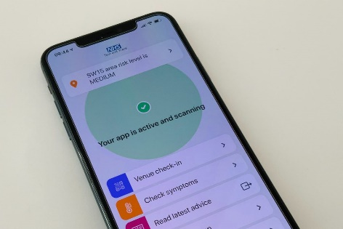

SafeZone App
The SafeZone app is designed to help students and staff summon first-aid, security or safety assistance via your mobile phone or Staff PC. There is a function where it can also be set as a “check-in timer” where it will alert you as you are nearing the set time chosen and then it will automatically alert Campus Security 5 minutes later who will check on your welfare.
Make sure you have SafeZone downloaded when you go onto your campus.

Further information and FAQ’s can be found at: https://www.kent.ac.uk/safezone/

Travel to and from campus

To ensure that you are prepared, plan your journey before leaving home. Remember to consider the diversions you may have on route to your destination, as well as the return journey home. For example, some travel providers are not accepting cash or you may stop on the way to visit a shop where you will be required to wear a face covering.
We encourage you to minimise your use of public transport, by walking or cycling where possible. If these are not an option for you, then you may be eligible to apply for a parking permit to park on campus. Note students living on campus or within the local exclusion zone are not eligible to apply for a permit.

You should wash your hands thoroughly when you arrive on campus, using the handwashing facilities or hand sanitisers provided. You should also wash your hands thoroughly as soon as you get home.

Public Transport
Where you need to use public transport, please think about social distancing, where possible staying away from others and avoiding touching surfaces.
If you normally use public transport, and start to display COVID symptoms whilst on campus, and you should consider alternative transport options to return home. If there are no other transport options available to you, advice from NHS 119 is that you should use a taxi with a screen to get home. You can use public transport but only as a last resort. In this case, you should try to travel outside peak times keeping socially distanced.

Please note that it is a legal requirement that you must wear a face covering on public transport.

Before using public transport, you should refer to the Government's guidance:
- www.gov.uk/guidance/coronavirus-covid-19-safer-travel-guidance-for-passengers
- www.gov.uk/government/publications/how-to-wear-and-make-a-cloth-face-covering/how-to-wear-and-make-a-cloth-face-covering.

Local transport providers have produced their own guidance. Click on the image for information:

Cycling
- Staff Cycle to Work Scheme
The Cycle to Work Scheme offers staff the opportunity to buy a brand new bike (including electric bikes) and accessories from a range of participating local stores at a discounted rate.

Visit the Staff Finance website for more information

- ByCycle Long Term Bike Hire
We work with ByCycle to provide low cost bike hire to all attending the Canterbury campus. All bikes available are second hand but all come equipped with lights, a bell and a lock and have received a full service - they are as good as new and are ready to ride! Each bike has been security tagged and is registered to the University of Kent.
Visit the Estates website for more information

Further information about travel during this time and information about using the Campus Shuttle and other travel facilities are available on the transport pages, within the Estates website.

If you are concerned about travelling on public transport, and there is no other option available, you should speak to your line manager or Student Support, as they may be able to accommodate some flexibility to your start and finish times to prevent travel during peak times.

Hygiene, cleanliness & ventilation

To reduce the risk of infection spread, we have introduced a number of important measures, which are set out in our COVID-19 risk assessments.
Examples include:
- the installation of additional hand sanitiser stations at main entrances to buildings
- enhanced cleaning of high touch points
- having signage and posters to provide regular reminders to students and staff to maintain hygiene standards
While we are taking these stringent additional measures, there are key hygiene behaviours we expect on campus to prevent transmission of the virus:
- washing your hands often and thoroughly, for 20 seconds
- avoiding touching your face, particularly your eyes, nose and mouth
- coughing or sneezing into a tissue, and binning it safely, or into your arm if a tissue is not available
- increase natural ventilation where safe to do so by opening windows

Handwashing
Handwashing is vital in the fight against coronavirus and a behaviour that we all need to adopt on campus. Washing or sanitising hands regularly with hot soapy water and drying them thoroughly will help to wash off any virus that may be on the skin.

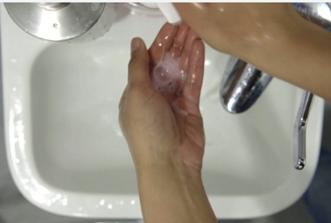
Click on the image below for practical advice on washing your hands
NHS

NHS guidance, complete with a video about handwashing. It states that regularly washing hands with soap and warm water for 20 seconds is central to preventing COVID-19 transmission

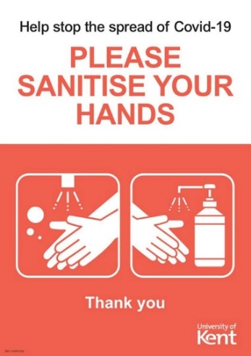
We all need to ensure that we wash our hands frequently:
- when arriving on campus, and upon your return
home

- after blowing your nose, coughing or sneezing

- before eating or handling food

- after touching surfaces, such as doorknobs, drawer
handles and printers

- after using the toilet facilities

Everyday interactions like shaking hands, handing someone a coffee, sharing food or giving a hug may all heighten the risk of interaction and, therefore, need to be avoided.

Recent studies suggest the COVID-19 virus can live up to 24 hours on cardboard, as well as three days on hard surfaces such as metal or hard plastic. Wiping down surfaces with detergent, sanitisers, warm washing up liquid and then washing your hands will help to reduce the risk of transmission to yourself.

Ventilation
Ventilation is the process of introducing fresh air into indoor spaces while removing stale air. Letting fresh air into indoor spaces can help remove air that contains virus particles and prevent the spread of coronavirus (COVID-19).

Where possible increase natural ventilation by opening windows.

Being in a room with fresh air can reduce your risk of infection from particles by over 70%, as fresh air dilutes the particles.
Public Information Film:

Click on the image to the right to view a UK Government film created with scientists and an engineer from Leeds University.

The film illustrates how coronavirus lingers in the air in spaces with no fresh air, increasing the risk of people breathing in infected particles, and how the risk can be reduced significantly by regularly ventilating enclosed areas.

As we spend more time indoors, experts are recommending that people either:

- open windows for short, sharp bursts of 10 to 15 minutes regularly throughout the day
- leave windows open a small amount continuously

This is to remove any infected particles lingering in the room.

Social distancing (physical distancing) measures

Social distancing (also known as physical distancing) means that we need to keep our distance from others when outside our own home. Making sure we all adhere to this on campus can help stop the spread of all infections including COVID-19. As COVID-19 is an infection where there is currently no general population immunity (“herd immunity”) and until vaccinations are fully rolled out, social distancing is a vital protection measure.

While on campus, you must maintain social distancing (in line with Government guidelines). Reducing social contact between healthy individuals outside of the home can help to delay the transmission of COVID-19 and reduce the size of an outbreak.

To assist with social distancing, we have introduced a number of important measures, which are set out in our COVID-19 risk assessments.

Examples include:
- reduced occupancy of all buildings and work / study areas
- staggering start and finish times to reduce overcrowding
- one-way systems, wherever possible, to reduce instances of people having to pass each other in close proximity
- spacing workstations out
- having floor markings to help people maintain social distancing
- installing screens or barriers to separate people from each other
- in limited circumstances and where there is a business critical need, allowing back-to-back or side-to-side working
- limit numbers accessing communal facilities at any one time, particularly in break /kitchen areas
- signage and posters advising on limits to numbers entering specific areas such as lifts, break areas.
You should continue to practice social distancing in common areas, including at building entrances, kitchens, exits, lifts, break areas and toilets.

There is one exception to the social distancing measures: If a fire alarm sounds, exit any building via the nearest escape route regardless of new layout and signage. On evacuation, try to social distance as best you can, and spread out when at the fire assembly point, if this proves impossible it is best to move away from the area.

Example desk layouts

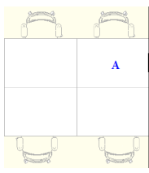

A 6-person set up will need to have staggered workstations, allowing two workstations within the bay to be used.

In a 4-person set up, only workstation A can be used.

If you feel uncomfortable about someone getting to close to you, it is perfectly acceptable to step back to ensure that you are protecting yourself and maintaining social distancing.

Often, we move around our campuses paying little attention to our surroundings and signage as this is all so familiar already. However, it is essential that you observe the signs, look out for hazards and move cautiously so you can follow any new guidance.

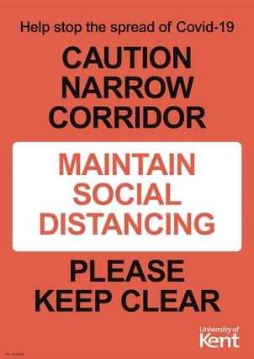
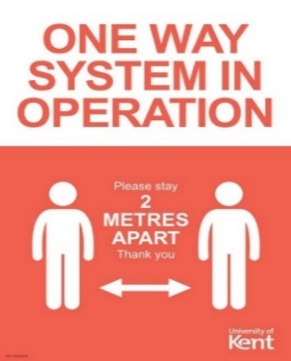
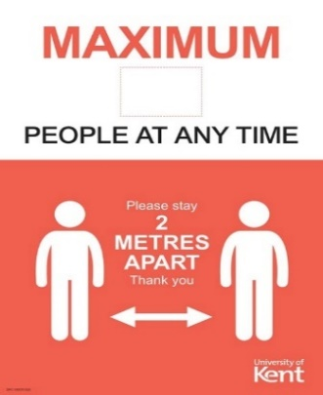
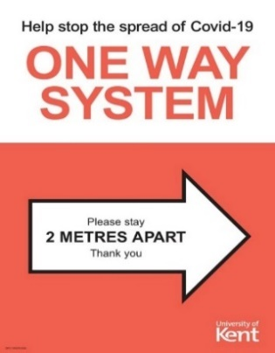
Examples of new signage to look out for at our UK Campuses:

Face Coverings

Face coverings help to stop asymptomatic individuals spreading COVID-19 to others when we are in an enclosed space. They may also provide a small amount of protection to the wearer.
As part of the Government’s advice on Staying Safe Outside your Home, they recommend that you should wear a face covering in enclosed public spaces where you will come into contact with people you do not normally meet.
Government guidance on mandatory face coverings provides an up to date list of places where you must wear a face covering by law.

In line with Government advice and as outlined in our risk assessment, it is expected that all students and staff wear face coverings on campus in areas that are accessed by others. This includes teaching spaces and multi-occupancy offices. (see page 11 for exemptions)

All internal public areas across campus are at risk of becoming crowded, particularly as students and staff move between teaching spaces. Because of this, the University expects all to wear face coverings in public areas of buildings.

Students should wear face coverings when going to, during, and when leaving teaching sessions.

In line with legal requirements face coverings must also be worn on campus in any shops, banks, libraries and post offices (including independent retailers), and when buying takeaway food or drink at coffee shops and all other food outlets on campus.

Face coverings will only be effective if they are worn properly, covering the nose and mouth, fitted snugly, and kept clean. They can easily be made at home, the key thing being that it should cover the mouth and nose.

Click on the images below for practical advice on using and caring for face coverings:
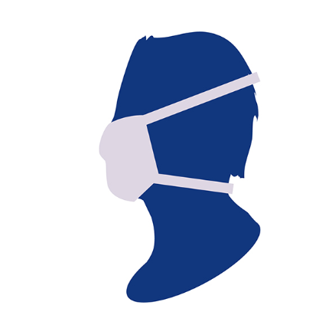 | UK Government  Government advice on how to wear and make a cloth face covering.  A cloth face covering should cover your mouth and nose while allowing you to breathe comfortably. It can be as simple as a scarf or bandana that ties behind the head, but multi-layer face coverings are more effective
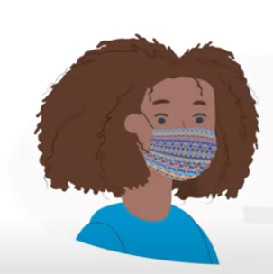 | World Health Organisation (WHO)  YouTube video on how to wear a fabric face covering safely  A fabric covering can act as a barrier to prevent the spread of the virus. However, it must be used correctly and always combined with other measures to protect yourself and everyone else.

Advice includes that you must:

- wash your hands thoroughly before putting a face covering on and after removing it
- change your face covering if it becomes damp or if you have touched it
- change and wash your face covering daily

Please remember that personal, non-medical face coverings:

- do not replace social distancing - which should still be observed
- should not be confused with surgical masks or respirators
- should not be worn by children under the age of 3 or people who have problems breathing while wearing a face covering
- should not be worn where there are additional risks, for example from chemical contamination or naked flames
Exemptions to wearing a face covering where they are mandated

In settings where face coverings are mandated in England, there are some circumstances, for health, age or equality reasons, whereby people are not expected to wear face coverings in these settings. Please be mindful and respectful of such circumstances noting that some people are less able to wear face coverings.

The Government have identified exemptions to wearing a face covering Please see point 3 of the guidance: ‘When you do not need to wear a face covering’. If you aren’t able to wear a face covering, although there is no requirement to provide medical evidence, it is a good idea to think about how you communicate this.

Although you are under no obligation to do so, some may feel more comfortable showing something to announce that they do not have to wear a face covering. This could be in the form of a Sunflower lanyard, an exemption card, badge or even a home-made sign.

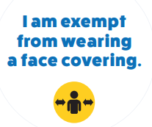 | The UK Government have provided a series of pdf templates that can be printed or saved to display on your mobile phone. Visit Access exemption card templates to view the options available
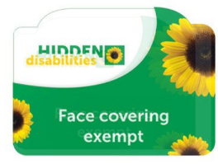 | The Hidden Disabilities programme supports people living with non-visible disabilities to discreetly indicate that they may need additional support. They have produced a ‘Face Covering Exempt’ card, which is available to purchase online for a nominal fee.
Please note that, off campus, shops and public transport can still refuse you entry if you are not wearing a face covering, although wearing an exemption card could reduce the likelihood of confrontations on and off campus. The decision as to whether or not to publicise the fact you have a hidden disability or health condition preventing the use of a face covering is one of personal choice.

What this means for people who are deaf or have hearing loss

Many people with hearing loss rely on lip reading to communicate and face coverings make this impossible. Thanks to lobbying by hearing loss charities, new regulations and guidance mean you don’t have to wear a face covering if you need to communicate with someone who relies on lip reading, or if you have another reasonable justification. You won’t be acting illegally or face a penalty if you are communicating with someone with hearing loss and remove your face covering to do so. Work continues to seek clarity on whether there are any safety issues associated with wearing face coverings with clear panels. It is therefore currently unclear whether face shields meet the Government recommendations for public usage. Visit the Action on Hearing Loss website for more information and support.

Action on Hearing Loss have also developed communication tips to help the public communicate more effectively with someone with hearing loss.

If you have symptoms of COVID-19 (cough, and/or high temperature, and/or loss of, or change in, your normal sense of smell or taste - anosmia), you and your household must isolate at home: wearing a face covering does not change this. In addition, if you are closer than 2m to someone for more than 15min and they develop symptoms or test positive for COVID-19, wearing a face covering does not remove the requirement to self-isolate for 10 days.

Personal Protective Equipment (PPE)

Outside of healthcare settings, the Government Working Safely guidance does not recommend the use of Respiratory Protective Equipment (face masks that protect the wearer from inhalation of virus and which need to be face-fitted to the individual to be effective) to control COVID-19 infection risk.

In line with our COVID-19 risk assessment, the use of additional PPE (such as medical standard facemasks) is not required as an infection-control measure while at work or study under normal circumstances. You should continue to wear the PPE you normally require to carry out your work or study, including safety helmets, gloves, eye protection, high-visibility clothing and safety footwear. PPE requirements for First Aiders are defined in the separate COVID-19 Guidance for First Aiders document.

Vulnerable Groups

There is clear evidence that COVID-19 does not affect all population groups equally. Many analyses have shown that older age, ethnicity, male sex and geographical area, for example, are associated with the risk of getting the infection, experiencing more severe symptoms and higher rates of death. Who's at higher risk from coronavirus?

Three risk groups have been identified as having more severe outcomes from a COVID-19 infection than the general population.
- Clinically extremely vulnerable, i.e. those who have previously received a shielding letter or who were told that they are in this group by their GP. This is the highest risk category.

- Clinically vulnerable, i.e. with conditions such as heart disease, poorly controlled asthma, and diabetes, those over 70.

- BAME Communities, namely Black and South Asian (Pakistani, Indian and Bangladeshi) people, where there is good evidence that they are at elevated risk of a more severe outcome from a COVID-19 infection

NHS advice for people at higher risk from coronavirus
At the University of Kent, we will consider the equality impact of our decisions on members of our staff and student communities, and listen to the concerns and advice of those with lived experience. We have been considering the potential impact of COVID-19 upon different demographics, from a student and staff perspective, and agreed actions we can take to help mitigate the impact of key decisions upon specific and vulnerable members of our community.

It is essential that your concerns be heard as we move through these difficult times. By discussing your vulnerabilities, we may be able to help relieve any anxiety by ensuring you are clear about the precautions the University is taking, the control measures in place and the new protocols we all have to follow to allow for a safe return to campus:
Students: Speak to your School and/or Student Support to discuss any concerns and agree any adjustments, or additional support available to reduce the impact of COVID-19.
Staff: Prior to your return to work on campus, you must have a ‘Risk Assessment and Concern Conversation’ with your line manager to discuss any concerns and agree any appropriate adjustments.
It is essential that everyone respects and understands that the COVID-19 pandemic affects individuals to varying degrees. People may be in a vulnerable group themselves, live with someone who is at a higher risk, or developed mental health issues as a result of a long period of lockdown. As such, many people may have increased anxieties about being on campus.
Respecting the individual viewpoint of those within our community is essential – the best way to do this is to follow the behaviours and expectations outlined in this Code of Conduct.

Mental health (Stress/Anxiety)

The risks to people’s health from this pandemic are psychological as well as physical. This may include anxiety about the ongoing health crisis and fear of infection, as well social isolation due to the lockdown. Social isolation, reduction in physical activity, unpredictability and changes in routine can all contribute to increasing stress.
It is important that you protect your health and wellbeing, and that of those around you.
Every Mind Matters recommend 10 ways to improve your mental health and wellbeing if you are worried or anxious about the coronavirus outbreak:
- Stay connected with people
- Talk about your worries
- Support and help others
- Feel prepared
- Look after your body
- Stick to the facts
- Stay on top of difficult feelings
- Do things you enjoy
- Focus on the present
- Look after your sleep
Specific guidance and support is available for students and staff, and you are encouraged to access it if you are feeling vulnerable:
Students | Staff
Wellbeing – Information for Students | COVID-19 Mental Health Risk Assessment
Student Guide – Mental Health | Staff Guide – Health and Wellbeing
Togetherall | Employee Assistance Programme (EAP)
Student Support and Wellbeing Team | Support for those working at home
Kent Union Advice Centre | COPE Framework

You may also wish to seek advice from external organisations:
Government guide to looking after your mental health and wellbeing
Mind – For better mental health
Rethink Mental Illness
NHS - Every Mind Matters
NHS - Mental well-being audio guides

“The coronavirus (COVID-19) outbreak means life has changed for us all. It may cause you to feel anxious, stressed, worried, sad, bored, lonely or frustrated.

It's important to remember it is OK to feel this way and that everyone reacts differently – for most of us, these difficult feelings will pass.” (Every Mind Matters)

Addendum 1: Additional Information for Students

What we expect from you
- Adhere to the expectations and behaviours outlined in this COVID-19 Code of Conduct.
- Avail of the asymptomatic testing available on campus, twice weekly, if residing on campus or accessing campus facilities
- Follow the rules about regular handwashing throughout the day and use the supplied hand sanitiser. If the hand sanitising units are not accessible to you for disability-related reasons, please contact covidsupport@kent.ac.uk to request a personal bottle for you to carry.
- Wear a face covering in line with Government requirements, unless you are exempt.
- Respect and abide by social distancing regulations whilst on or off campus.
- Keep abreast of Government and University announcements and follow any signs and directions on the campus – this is VITAL for your own safety. Please note that, although the Government as announced a roadmap for lifting the restrictions, these can change at any time. The University will email students to advise of these changes when they occur and will provide relevant information on the COVID webpages. It is your responsibility to read the information provided.
- Use specific entrances and exits, as indicated in each building. You must do this for everyone’s safety. If you require the routes around any building to be explained or demonstrated to you, please contact covidsupport@kent.ac.uk to request this. Please abide by the Respect at Kent policy and the Non-academic discipline regulations when you are on or off campus as well as this COVID-19 update.
What you can expect from us
- A University environment that has been adapted for social distancing and other COVID-19 Government guidance.
- Safeguarding and welfare support available at all times.
- Constant monitoring of our health & safety measures.
- Lecturer and Tutor support when you are at University.
- Support to work from home if your situation changes.
Individuals need to be aware that, even if they do not feel at risk of infection from COVID-19 there are many members of our community for whom the possible risk of infection is both high, and represents a serious threat to their personal safety, and that of their friends and family.
We request that all students and staff follow the guidance outlined in this COVID-19 Code of Conduct for their own safety, and the safety of their community on and off campus. Learn more about our safety measures, and how you can help keep your community safe.

In public health, social distancing, also called physical distancing, describes a series of measures intended to prevent the spread of a contagious disease by maintaining a physical distance between people and reducing the number of times people come into close contact with each other. It typically involves keeping a certain distance from others and avoiding gathering together in large groups. At the time of publication, no social gatherings are permitted. Whilst at work social distancing must be maintained. Government Guidelines should be checked for the latest national and local restrictions.

