DIVERSITY MARK
Centre for Journalism

KEY HIGHLIGHTS
FROM THE GET-GO CfJ COMMITTED TO REVIEWING ALL MODULES AS
PART OF THE PROJECT
SPECIFIC MODULES SERVE AS A PLATFORM TO REPRESENT DIVERSE VOICES AND ENHANCE GLOBAL KNOWLEDGE SYSTEMS.

RECOMMENDATIONS: HOW TO BRING EXISTING DIVERSITY TO THE FORE, DIFFERENT MATERIALS, INCLUSIVE CURRICULUM WORKSHOPS, AND CROSS-MODULE ACTIVITIES
Creating a Culture of Inclusion to
Improve Diversity

The Diversity Mark Project involves a process where staff and students engage in a partnership, a knowledge-sharing relationship to explore the extent to which the content, concepts and context of reading lists are enriched with representation of diverse and global knowledge systems. In the context of an increasingly diverse student body, it is vital to ensure reading lists are representative of our societal and institutional demographic to ensure a sense of belonging and student engagement in the curriculum and wider University.
In 2020/21 Centre for Journalism joined Diversity Mark and committed to reviewing all their modules. The project is led by Diversity Mark Officer Rachel Gefferie, a PhD student, along with Kent Lecturers Angela Harrison, and David Acheson. Numerous academics are in the process of diversifying their reading lists to receive the Diversity Mark Award, pending student consultation. The Diversity Mark team are keen to ensure this work goes beyond an exercise in discussing and exploring inclusion to making real changes to the curriculum. Diversity Mark at Kent works towards challenging and resisting coloniality by readdressing Eurocentric knowledge with global knowledge of the global South.
The review process entails one-on-one, regular consultations with the designated lecturers, a thorough review of all resources utilised, encouraging students’ representation in the curriculum through initiating student surveys and student led focus groups, and producing reports with recommendations to integrate the Diversity Mark aims into the curriculum. Two years on, the project has gone beyond just reviewing reading lists, for most this is out of necessity. Technical modules with little in the way of “reading” have modified the process to look at the wider curriculum for opportunities to diversify activities and discussions. Other modules simply took the chance to look at all knowledge provided to students and look for ways to reframe these with inclusion in mind, from reading lists to Moodle student platforms, presentation slides, discussion topics.

Centre for Journalism’s strength have been its open-minded approach to the project, using Rachel as a consultant, and collaborating with her to shape and steer the work.

Reflections
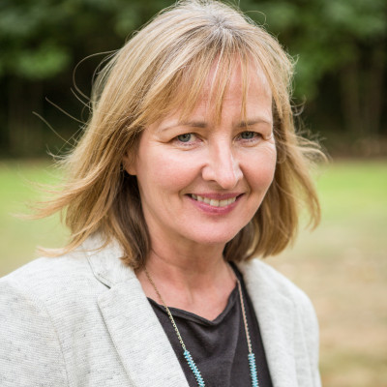
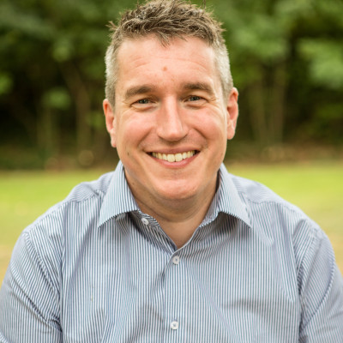
The Diversity Mark project has been a thoroughly valuable process for my journalism modules. Rachel engaged in depth with my programmes of study, going well beyond the reading lists to look at my Moodle resources and weekly seminar topics. The process was always positive and constructive, and never prescriptive. Rachel put a great emphasis on highlighting the strengths of my modules and invited me to think about how to make more of them. Our conversations allowed me to see my content from a fresh perspective and often identified new and interesting ways to approach seminar topics which have always been a part of my core teaching. In my case, the Diversity Mark project was not principally about reading lists. Instead, we spoke about the diversity of content in my subject area – including how the media discusses race, gender, sexuality, and disability – and strategies for making discussions about them more inclusive. Rachel identified similar challenges in other modules within my School and set up informal discussions between module convenors to discuss them. It gave rise to new ideas for cross-module collaboration. These will be discussed further in a forum with students which Rachel is working to set up.
This has been a thoroughly positive and constructive process for the Centre for Journalism, which will have tangible benefits for our students.

ROB BAILEY – DIRECTOR OF EDUCATION

It has been a good experience doing this Diversity Mark review. It’s helpful that it was done by someone independent, outside of the department and that they looked closely at individual modules and at all resources used, not only books or academic journal articles. In practical modules for journalism, students can learn a lot by looking at the work of professional journalists, so we draw their attention to many specific reports. Rachel Gefferie did a thorough and thoughtful analysis of our modules; she took the time to hear about our experiences and brought valuable insights, encouragement and suggestions while celebrating work we are already doing.
One example of changes made to a module include short video introductions from previous students saying something about themselves and their specialism; why they wanted to do it, and to give any tips they have for next year's students.

ANGELA HARRISON – LECTURER

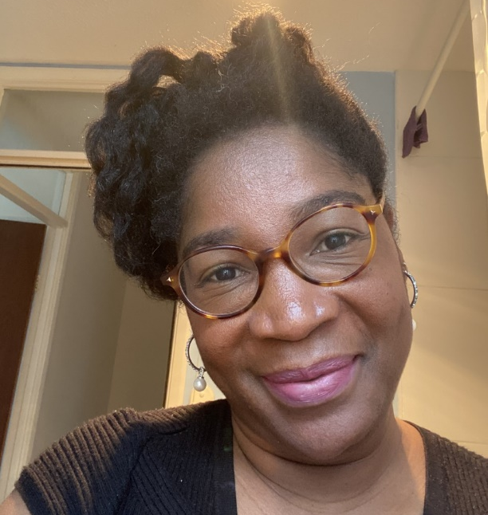
A total of 355 authors have been identified in all 7 modules. From the 355 authors, 33 are BME representatives and 322 are white.
This is a mid-project report and only reflects the work to date. A final report will be available on request.
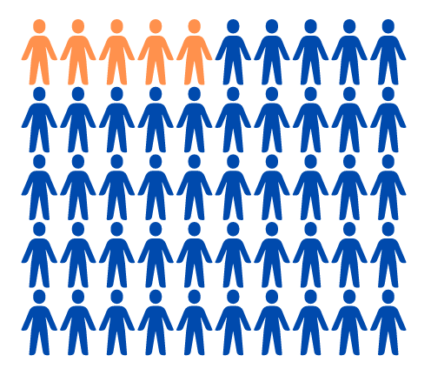
Rachel Gefferie PhD student in Social Anthropology has led the Diversity Mark work in CfJ. She has a great interest in education, cultural diversity, and sustainability programs.
“The best part is discussing my findings in a one-on-one session with the convenor and gaining their feedback on my analysis. I discuss assignments and activities that can enhance their module in representing the BME community and-or other faith based, gender-orientated students. So far, we have had amazing, constructive, cooperative feedback.”

RACHEL GEFFERIE – DIVERSITY MARK OFFICER

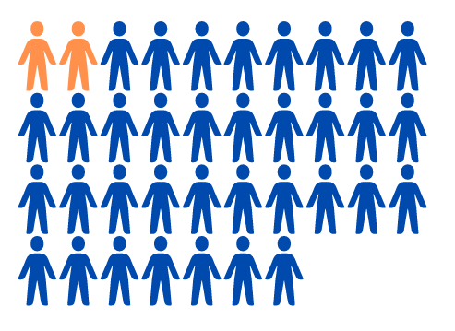
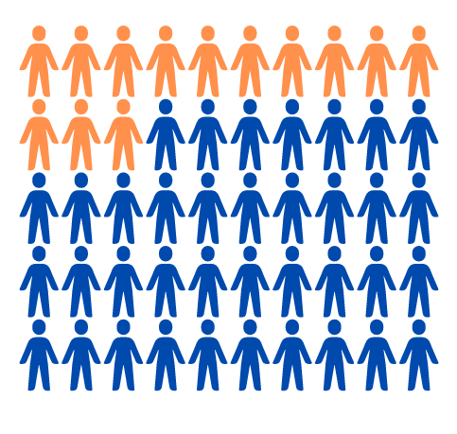
Of 355 authors 92 are female and 263 are male.

From the 92 female authors, 16 are BME representatives.
From the 263 male authors, 17 are BME representatives.

So far 7 joint modules have been reviewed. From the 7 modules, 4 contain a minimum of 40% themes and resources that promote/accommodate diversity, inclusion, and-or the voice of the students.
British law promotes Eurocentric culture as universal, therefore the shortcomings of the industry itself
do reflect on the teaching materials and availability of reading resources.
There is sometimes limited room for practical assignments and discussions.
Lack of motivation from staff to make changes and engage with why diversity is important
Limitations
It will be very exciting to take these lessons forward and make some positive changes to the curriculum. Other schools engaged in Diversity Mark include: SPS, Bio Sciences, PoLIR, Psychology, SECL, SSPSSR, KBS. Future work is being investigated in SAC, KLS and History.

The Diversity Mark project in CfJ has evolved and adapted in an amazing way. Rachel has steered the process to be reactive to the changing needs of each convenor. She is a truly dynamic and driven person, who genuinely loves a challenge. The convenors in CfJ have reacted to this opportunity and mobilised to engage in the process fully.

STUDENT SUCCESS MESSAGE

From these 4 modules, 2 may qualify for a DM award without the necessity of making changes. This means that per week the lecturer provides at least 50% or more resources, exercises, assignments that support the DM program aims.

