Electronic Submission of Exam Papers
via SharePoint

All examination papers should be submitted electronically via SharePoint. Please see below the steps you will need to take to submit your exam papers to SharePoint for Examinations 2022.

If you do not have the link to your Division folder on SharePoint or your Division permissions need updating please email exams@kent.ac.uk

Please Note:
- You must only use SharePoint on Internet Explorer
- Papers must be uploaded as PDF only

- Once in your Division folder, navigate to the sub-folder you require, you will be able to add new papers – note you need to be in ‘Documents’ on the left hand menu – not ‘Home’.

- Click on “Library”

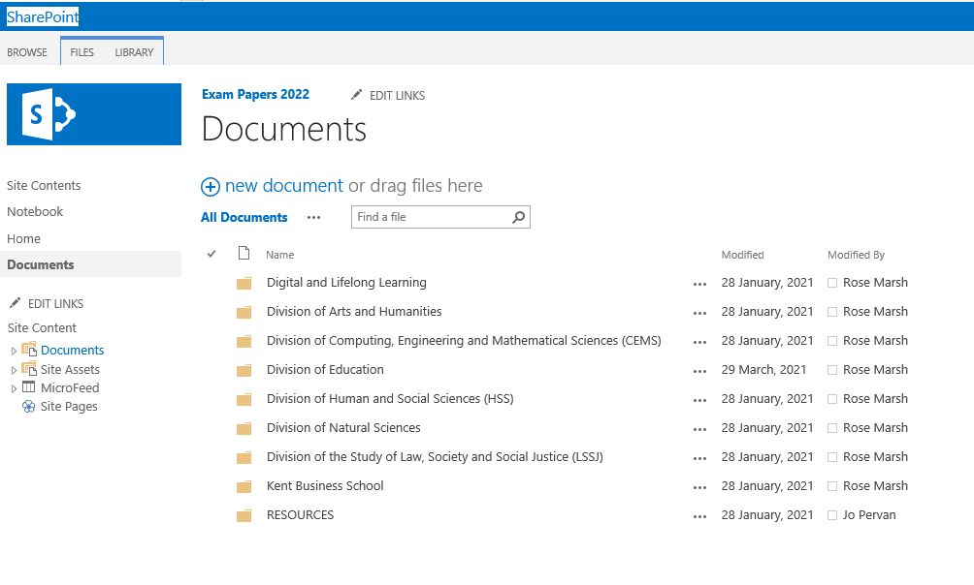

- Then “Open with Explorer”

- At this point it may ask you to enter your UKC login details
- A pop up of your chosen folder will appear as Files Explorer
- Open a separate Files Explorer and locate the papers you want to move over onto SharePoint
- Drag and drop the papers (PDF only) into the SharePoint Files Explorer.
Your Files Explorer Folder
SharePoint Files Explorer

- To ensure a smooth upload from SharePoint to Moodle all papers must be named as:

Canterbury Papers Standard: e.g. ECON3050_2022
Special Versions: e.g. ECON3050_SpecialVersion_2022
Supplementary Material: e.g. ECON3050_SupplementaryMaterial_2022

Medway Papers Standard: e.g. BUSN3025_Medway_2022
Special Versions: e.g. BUSN3025_Medway_SpecialVersion_2022
Supplementary Material: e.g. BUSN3025_Medway_SupplementaryMaterial_2022

- Once you have moved your papers, close the File Explorer folders. Go back to SharePoint and refresh the page. Your papers will then appear.

- Papers will be securely stored in your Division folder which can only be accessed by designated staff in your department, and the staff in the Examinations Office. Once the documents have been uploaded, we will receive an automated email to let us know they are ready to log.
- If at any stage you realise that you have uploaded the incorrect file, or there is an error on a document, please email exams@kent.ac.uk and we will delete the old version ready for you to upload the new.

If you have any problems at all, please feel free to contact exams@kent.ac.uk

