Student Support and Wellbeing
December Newsletter

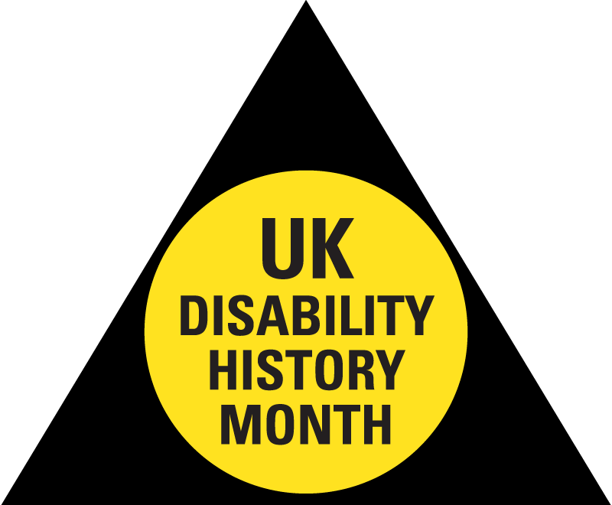

Disability History Month

Disability History Month is a yearly nationwide celebration from 18 November to 18 December, started by UKDHM to celebrate the lives of disabled people; challenge disablism or stigma around disability; and achieve equality.
At Kent we are celebrating with a full programme available on the Kent Union website, some highlights include: a virtual exhibition, with TED Talks, documentaries and recommended films that explore the themes of the month; Accessible Film Club screenings; Staff and Student sessions on support mechanisms for people with hidden disabilities; and Accessible sport sessions.
Check out #DHMKent21 on social media, and read up on Disability History Month reading lists and personal experiences from students and staff in the Student Services News.

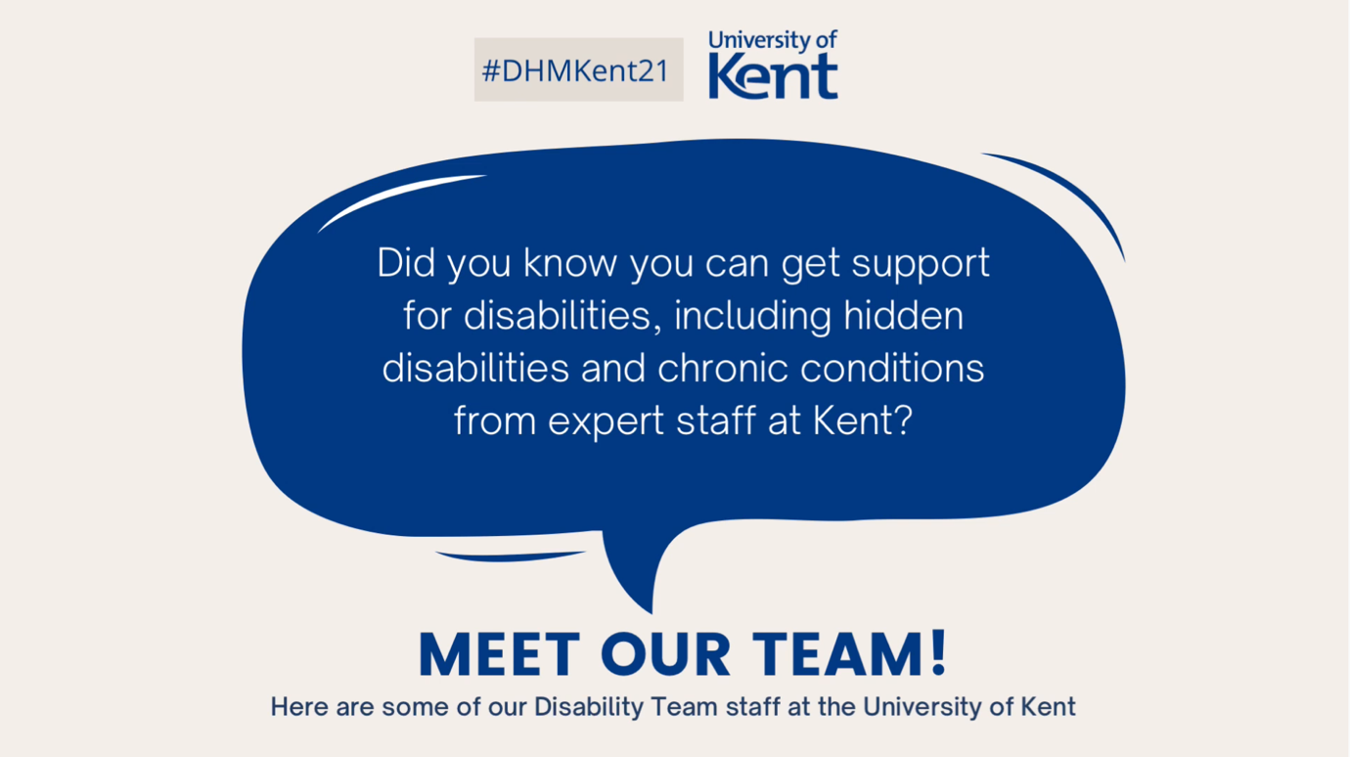
Watch this short video to meet some of the Disability team within Student Support and Wellbeing.

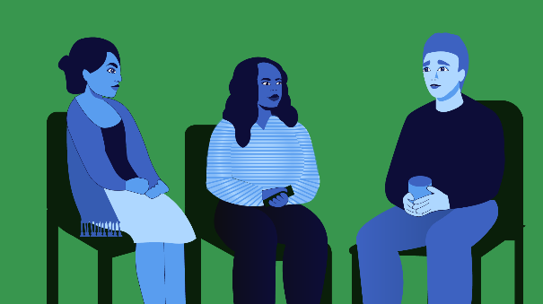

Weekly Groups

Monday: Wellbeing Cafe
Tuesday: UoKA
Wednesday: Mindfulness in person or online, Autism Modelling Club, Autism Social Board Games Group
Thursday: International Wellbeing Group
All Week: Just Coffee and Walking Buddy - Canterbury
Just Coffee and Walking Buddy - Medway
All peer support groups will run until the last week of term, unless specified by the facilitator in advance.

Top up your Wellbeing Toolkit: Upcoming Workshops

Wednesday 1st December 2pm - 4pm Online: How to Work on Your Self-Esteem
Wednesday 1st December 2pm - 3:30pm Online: Resilience in a Post-Covid World (will be repeated next term)
Wednesday 8th December 2pm - 4pm Online: Finding Friends and Coping with Loneliness at University
Togetherall Courses that you can access online for free at any time:
Improve Your Sleep | Assertiveness Training | Stop Procrastinating | Balance Your Thinking | Managing Health Anxiety

You don't have to grieve alone

The 2 - 7 December is national Grief Awareness Week, and if you're coping with loss, it can be really helpful to take some time to think through it with others - there are still some spaces available on the next Understanding Your Bereavement workshop on 14 December, which focuses on your support system. If you'd like to look at something in your own time, you could watch this Bereavement presentation. Take a look at this blogpost on grief detailing more support available at Kent and beyond.

Support over the Christmas Break

Student Support and Wellbeing offices are open after the end of term until Tuesday 21st December. We are closed from Wednesday 22nd December and re-open on Tuesday 4th January 2022. During this closure, there are lots of contacts available for emergency support you wherever you find yourself during vacation. To connect with others and find out what's on remotely and on our campuses, take a look at the Kent Christmas webpage.

The Support and Wellbeing Blogposts give advice on coping with difficult moments during vacation, and more information and resources will be posted throughout vacation on our Twitter, Facebook and Instagram accounts - follow @UniKentSSW ​to help you stay well and connected.

24/ 7 Support from Spectrum Life

If you are experiencing a mental health crisis, or need emergency crisis support outside of Student Support and Wellbeing working hours, our external partners Spectrum Life can offer you online, text and telephone support from qualified counsellors and mental health professionals.
Spectrum Life will work with you in getting initial support and help during your crisis and the University Student Support and Wellbeing teams will contact you on the next working day.
- Spectrum Life is available on Monday to Friday evenings from 8pm till 8am, and on weekends and Bank Holidays.
- Telephone: 0800 0318227 or Text ‘Hi’ to: 00353 87 369 0010
- Search for the Spectrum Life app from the app store and follow the log in instructions

