Student Support and Wellbeing

February Newsletter

LGBT+ History

Month

LGBT+ history month gives a national focus to raise awareness of the prejudice that can still exist, but also to raise up role models, celebrate achievements, and build a more just community. At Kent we aim to open doors for more dialogue and visibility for everyone in our diverse university community.

You can find the Kent LGBT+ History month programme of events on the Kent Union website, featuring both online and in person activities open to all. Look out for exhibitions, book clubs, or try some hands-on activities such as tie dye t-shirt printing and pronoun badge making. Student Support and Wellbeing are running a therapeutic 'Reflect, Recover and Empower ' workshop explicitly for LGBTQ+ students on 21 February, 7-8.30pm with a particular focus on the personal impact of Covid-19 and coping with future change.

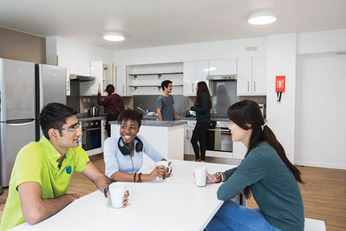
Want to stay on campus?

Apply for accommodation now!

You can now apply to live on campus for the next academic year via the University’s accommodation website. All students who require University accommodation on medical grounds will be offered accommodation, so please declare your medical condition / disability on your application form, and say what type of accommodation you would need. Please note that rooms are allocated on a first come, first served basis, so please make your application as soon as you can to get the best chance of getting your preferred accommodation.
If you have any questions when applying, please email the Accommodation Office at accomm@kent.ac.uk.

3 February:
'Open Access'

EDI Forum

Do you have an Equality, Diversity or Inclusion matter you would like to raise or discuss? The EDI Forum is the place to do this.
The EDI Forum provides an open-access channel for any member of the University (staff or student, regardless of location) to discuss an idea, issue, good practice initiative or concern relating to equality, diversity and inclusivity at Kent.
All meetings will be held virtually via Microsoft Teams. The first meeting is taking place via Teams on Thursday 3 February from 14.00-15.30. If you’re interested in attending, please go to the EDI Forum webpage where you will be able to link directly through to the meeting.
You can also find out more about the EDI Forum on the EDI Forum webpage.
If you have any questions please email becky.lamyman@kent.ac.uk.

9 February: Celebrating Consent Day!

Kent aims to be a sex-positive university, championing a culture of education, respect and consent.
Join us in Darwin Conference suite for whichever of these activities appeal to you - Book your place via Eventbrite using your Kent logins.
13:00-14:00 The World of Online Dating: find your perfect partner and stay safe.
14:15-15:15 Sex & Empowerment with Ruby Rare.
15:30-17:00 Crafting Consent: a collaborative artwork.

Weekly Groups

Monday: Wellbeing Cafe is now back!
Tuesday: UoKA
Wednesday: Mindfulness in person or online, Autism Modelling Club, Autism Social Board Games Group
Thursday: International Wellbeing Group
All Week: Just Coffee and Walking Buddy – Canterbury
Just Coffee and Walking Buddy – Medway
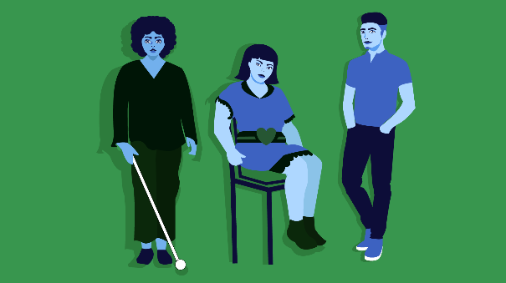
Fancy a funded

masters course?

Are you a final year disabled student who is ambitious, talented and driven to affect change? Then this scholarship might be for you!

What's available?
Up to £30,000 non-repayable funding for 12 students: up to £15,000 towards your fees and a £15,000 allowance while studying.
Who can apply?
Disabled students (both national and international) looking to do any master's course at a UK University starting in 2022/2023.
When do I have to apply?
Applications close on 1st April 2022.

Interested?
Find out more details and apply for Snowdon Masters Scholarships online.

Top up your Wellbeing Toolkit: Upcoming Workshops

Wednesday 2nd February 2pm-3:30pm in KS4 or Online: Resilience in an ever changing world

Tuesday 8th February 2pm-3:30pm Online: Understanding Your Bereavement - Holding On, Letting Go

Wednesday 9th February 2pm - 3:30pm in KS4 or Online: Resilience in an ever changing world
Monday 21st February 7pm - 8:30pm Online: Resilience in an ever-changing world

Weekly drop-ins
Tuesday 2pm-5pm: Drop in with Forward Trust: Advice and support for difficulties relating to drugs and alcohol.

Thursday 2pm-4pm: Drop-In for East Kent Rape Crisis Centre.

Togetherall Courses that you can access online for free at any time:
Managing Panic | Problem Solving | Managing Social Anxiety | Managing Phobias | Stop Procrastinating | Managing Depression and Low Mood

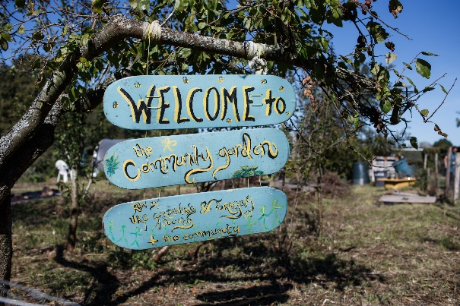
Time for some fresh air!

The Kent Community Oasis Garden (KentCOG), is a collection of students, staff and community members working to create a sustainability hub centred around growing food. There is no need to book a session to attend, simply turn up!

Every Wednesday and Friday 10am - 2pm: Gardening for Everyone.

Saturday 26th February: Wellbeing Session - East Kent Mind Coping with Depression: Colour and Smell session.

Please email kentcog@kent.ac.uk if you have any questions.

24/7 Support from Spectrum Life

If you are experiencing a mental health crisis, or need emergency crisis support outside of Student Support and Wellbeing working hours, our external partners Spectrum Life can offer you online, text and telephone support from qualified counsellors and mental health professionals.
Spectrum Life will work with you in getting initial support and help during your crisis and the University Student Support and Wellbeing teams will contact you on the next working day.
• Spectrum Life is available on Monday to Friday evenings from 8pm till 8am, and on weekends and Bank Holidays.
• Telephone: 0800 0318227 or Text ‘Hi’ to: 00353 87 369 0010
• Search for the Spectrum Life app from your app store and follow the log in instructions

