Student Support and Wellbeing

March Newsletter

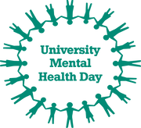

University Mental

Health Day 2022

Thursday 3rd March is University Mental Health day, and to celebrate the theme of 'wellbeing and green spaces', we are giving away free pot plants to any student who wants to come onto one of our campuses and grab one! We'll be outside Templeman Library in Canterbury from 12-3pm on Thursday 3rd March, and outside Drill Hall Library in Medway from 12-2pm on Thursday 10th March. Take a plant to nurture, and a flyer on lots of ways you can nurture yourself and boost your mental health with a variety of outdoor and indoor activities to connect with yourself and others.

Look out for #UniKentWellbeing on the socials and read this let's make mental health a university-wide priority blogpost for more info. Check out this podcast with Lee Fellows, Head of Student Support and Wellbeing, for more on what Kent is doing about student mental health.

Could you use professional help for your mental health? Check out our webpages for details of free support available to you.
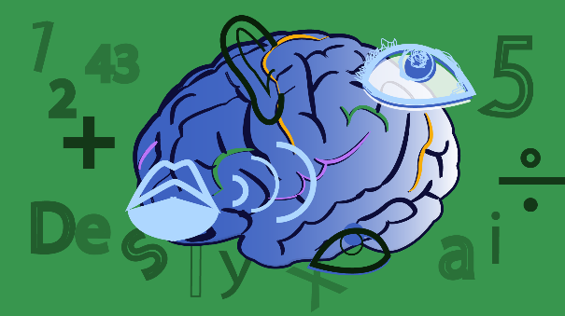

ILP Exam

Arrangements Deadline

Remember that disability-related exam arrangements must be agreed by 7 April, so if you need a change to your ILP, make an appointment to speak to your Student Support and Wellbeing Adviser as soon as possible.
This year, exams will be online and most courses will have a 24-hour time window for completion. An online guide for exams outlines the courses with timed exams, and gives detail on other aspects of preparing, including technical guidance, and mitigation of extenuating circumstances.

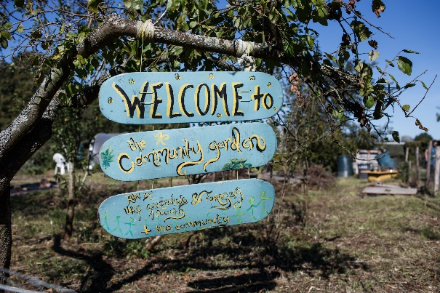

Time for some fresh air!

The Kent Community Oasis Garden (KentCOG), is a welcoming green space on the Canterbury campus, where students, staff and community members work together to create a sustainability hub centred around growing food - listen to a recent podcast to find out more. There is no need to book a session to attend, simply turn up! Please email kentcog@kent.ac.uk if you have any questions.
Coming up this month...
Every Wednesday and Friday 10am - 2pm: Gardening for Everyone.
Sunday 20th March: Seasonal Session: Bee Walks
Saturday 26th March: Wellbeing Session - East Kent Mind Mood and Food; Food tasting session.

Weekly Groups

Monday: Wellbeing Cafe
Tuesday: UoKA
Wednesday: Mindfulness in person or online, Autism Modelling Club, Autism Social Board Games Group
Thursday: International Wellbeing Group
All Week: Just Coffee and Walking Buddy - Canterbury
Just Coffee and Walking Buddy – Medway

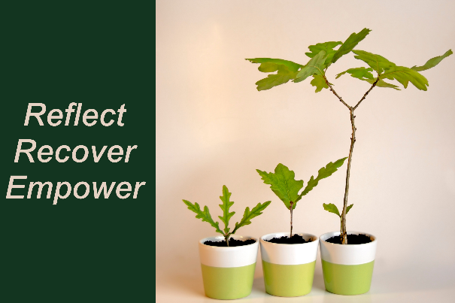

Top up your Wellbeing Toolkit:

Top up your Wellbeing Toolkit: Upcoming Workshops

Tuesday 1st March 7pm-8:30pm Online: Recover, Reflect and Empower: workshop for PhD students

Thursday 3rd March 7pm-8:30pm Online: Recover, Reflect and Empower: workshop for BAME students

Thursday 10th March 2pm-3:30pm KS12 or Online: Recover, Reflect and Empower: workshop for Neurodivergent students

Tuesday 15th March 7pm-8:30pm Online: Recover, Reflect and Empower: workshop for International students

Weekly drop-ins
Tuesday 2pm-5pm: Drop in with Forward Trust: Advice and support for difficulties relating to drugs and alcohol.

Thursday 2pm-4pm: Drop-In for East Kent Rape Crisis Centre

Togetherall Courses that you can access online for free at any time:
Managing Panic | Problem Solving | Managing Social Anxiety | Managing Phobias | Stop Procrastinating | Managing Depression and Low Mood

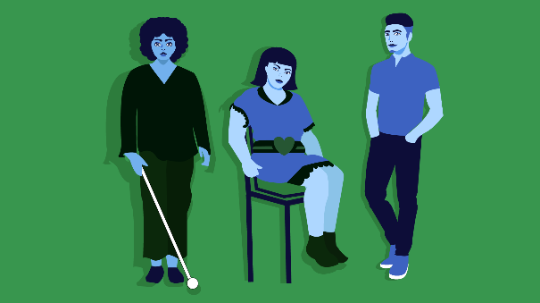
Fancy a funded

masters course?

Are you a final year disabled student who is ambitious, talented and driven to affect change? Then this scholarship might be for you!

What's available?
Up to £30,000 non-repayable funding for 12 students: up to £15,000 towards your fees and a £15,000 allowance while studying.
Who can apply?
Disabled students (both national and international) looking to do any master's course at a UK University starting in 2022/2023.
When do I have to apply?
Applications close on 1st April 2022.

Interested?
Find out more details and apply for Snowdon Masters Scholarships online.

24/7 Support from Spectrum Life

If you are experiencing a mental health crisis, or need emergency crisis support outside of Student Support and Wellbeing working hours, our external partners Spectrum Life can offer you online, text and telephone support from qualified counsellors and mental health professionals.
Spectrum Life will work with you in getting initial support and help during your crisis and the University Student Support and Wellbeing teams will contact you on the next working day.
• Spectrum Life is available on Monday to Friday evenings from 8pm till 8am, and on weekends and Bank Holidays.
• Telephone: 0800 0318227 or Text ‘Hi’ to: 00353 87 369 0010
• Search for the Spectrum Life app from your app store and follow the log in instructions

