Student Support and Wellbeing
May Newsletter

Support services – your views

Would you like to win one of 4 Love2Shop vouchers worth £50 each? Or £50 added to your KentOne card? Simply spend 5 minutes filling out our online survey about your experiences of Student Support and Wellbeing services this year, and help us continually improve our offering for current and future students.

How are you feeling about exams?

As many of you prepare for exams, check out our YouTube video below from our Support Staff with tips on managing exam stress and keeping calm. The Exam Calm webpage has resources to help you revise and study, as well as a calendar of Exam Calm events including lots of great ways to have energising or calming breaks, such as mindful breathing, gardening, library activities and ecotherapy.

Watch this short video to see Student Support and Wellbeing staff giving advice on managing exam stress.
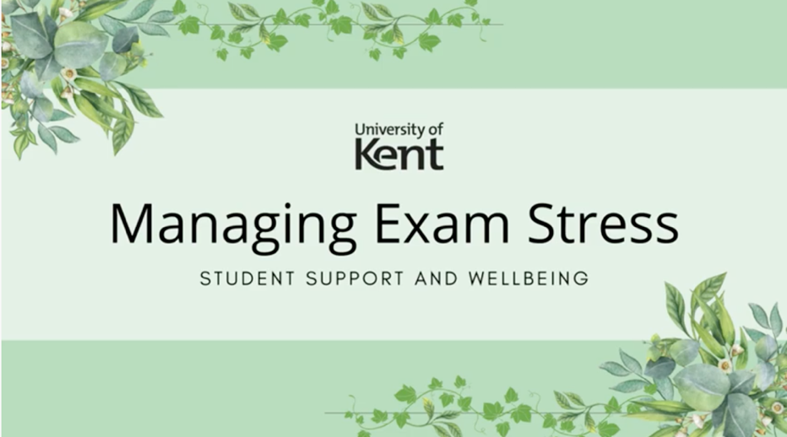

Enhancing your mental health this summer term
Whether you're preparing for exams, working on your dissertation, postgraduate studies, or starting to think about moving house and looking for jobs, there can be a lot happening this summer term! Check out this blogpost with some ideas for boosting your mental health and making the most of this time.

Weekly Groups

Monday: Wellbeing Cafe
Tuesday: UoKA
Wednesday: Mindfulness in person or online, Autism Modelling Club (FYI NEW LOCATION), Autism Social Board Games Group (FYI NEW LOCATION)
Thursday: International Wellbeing Group
All Week: Just Coffee and Walking Buddy - Canterbury
Just Coffee and Walking Buddy – Medway

Drop ins & Anytime Online Courses

Weekly drop-ins
Tuesday 2pm-5pm: Drop in with Forward Trust: Advice and support for difficulties relating to drugs and alcohol.
Thursday 2pm-4pm: Drop-In for East Kent Rape Crisis Centre
Togetherall Courses that you can access online for free at any time:
Managing Panic | Problem Solving | Managing Social Anxiety | Managing Phobias | Stop Procrastinating | Managing Depression and Low Mood

24/7 Support from Spectrum Life

If you are experiencing a mental health crisis, or need emergency crisis support outside of Student Support and Wellbeing working hours, our external partners Spectrum Life can offer you online, text and telephone support from qualified counsellors and mental health professionals.
Spectrum Life will work with you in getting initial support and help during your crisis and the University Student Support and Wellbeing teams will contact you on the next working day.
- Spectrum Life is available on Monday to Friday evenings from 8pm till 8am, and on weekends and Bank Holidays.
- Telephone: 0800 0318227 and press option 1 or Text ‘Hi’ to: 00353 87 369 0010
- Search for the Spectrum Life app from your app store and follow the log in instructions

