Student Support and Wellbeing
June Newsletter

As the end of term comes into view, take a look at some summer support options, and don't forget to let us know how you'd like to see our services evolve for the vacation period and the next academic year!

Last chance: share your views on support at Kent

Our online survey closes this week! You can be in with a chance of winning one of 4 Love2Shop vouchers worth £50 each, or £50 added to your KentOne card, as well as helping us continually improve our offering for current and future students. Simply spend 5 minutes filling out our online survey - whatever your experiences of Student Support and Wellbeing services have been this year, we want to hear it!

Summer support at Kent

Remember that Student Support and Wellbeing staff continues to be open throughout vacation times - our offices are only closed on weekends and bank holidays, including 2nd and 3rd June.
You can still book online or face to face appointments with specialist support staff from 9-1pm and 2-5pm throughout the summer as long as you're a registered student at Kent. Contact us at KentSSW@kent.ac.uk for Canterbury students, and MedwaySSW@kent.ac.uk for Medway students to arrange summer support.

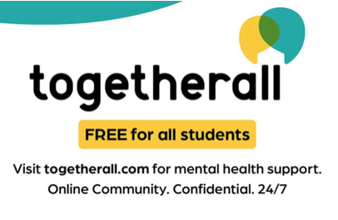
Leaving the area? Stay connected

All Kent students have free access to the Togetherall online platform for mental health support. If your usual friendship and study groups are breaking up for the summer, why not see whether you might join an online group where you can join chats, take online courses, or find a group of like minded individuals facing and discussing similar challenges?

Weekly Groups

Monday: Wellbeing Cafe (last one on 13th June)
Tuesday: UoKA (last one on 14th June)
Wednesday*: Mindfulness in person or online, Autism Modelling Club (Now in Rutherford Extension), Autism Social Board Games Group (Now in KS4)
*Last one for all groups above on 15th June
Thursday: International Wellbeing Group (throughout the summer)
All week and throughout summer vacation:
Just Coffee and Walking Buddy - Canterbury
Just Coffee and Walking Buddy - Medway

Drop ins & Anytime Online Courses

Drop in with Forward Trust: Advice and support for difficulties relating to drugs and alcohol
Tuesday 7th and Tuesday 14th June from 2pm-5pm: then suspended for vacation, returning in September.
Drop-In for East Kent Rape Crisis Centre:
Thursdays throughout the year 2pm-4pm
Togetherall Courses that you can access online for free at any time:
Managing Panic | Problem Solving | Managing Social Anxiety | Managing Phobias | Stop Procrastinating | Managing Depression and Low Mood

24/7 Support from Spectrum Life

If you are experiencing a mental health crisis, or need emergency crisis support outside of Student Support and Wellbeing working hours, our external partners Spectrum Life can offer you online, text and telephone support from qualified counsellors and mental health professionals.
Spectrum Life will work with you in getting initial support and help during your crisis and the University Student Support and Wellbeing teams will contact you on the next working day.
- Spectrum Life is available on Monday to Friday evenings from 8pm till 8am, and on weekends and Bank Holidays.
- Telephone: 0800 0318227 and press option 1 or Text ‘Hi’ to: 00353 87 369 0010
- Search for the Spectrum Life app from your app store and follow the log in instructions

