Student Support and Wellbeing
Summer Newsletter

Support services are still here for you

Remember that Student Support and Wellbeing continues to be open throughout vacation times - our offices are only closed on weekends and bank holidays.
You can still book online or face to face appointments with specialist support staff from 9-1pm and 2-5pm throughout the summer as long as you're a registered student at Kent. Contact us at KentSSW@kent.ac.uk for Canterbury students, and MedwaySSW@kent.ac.uk for Medway students - it's not too late to arrange an Inclusive Learning Plan to support your studies.
Do you use social media? Follow @UniKentSSW on Instagram for advice and information on staying well and connected throughout the summer.

Postgrad Summer 2022 programme

Postgrad Summer is a joint Kent Union and University of Kent initiative, created to bring together all parts of the PG community here at Kent.
We know that the summer months can be isolating for PG students, so we have put together a range of events, trips, support opportunities and wellbeing activities to help you feel connected and have some fun this summer!
There are lots of events taking place in July, including a walk to Whitstable, theme park trip, online murder mystery, and bushcraft session.
There is also a range of events to further your academic career, such as sessions on publishing in international peer-reviewed journals (online), professional headshot photography for LinkedIn, and online academic writing workshops.

View full PG Summer calendar

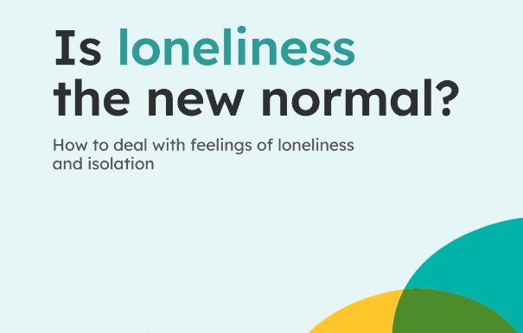
Use your Kent login to access wellbeing courses and community support

Student Support and Wellbeing at the University provides free access for students to the Togetherall online platform for mental health support.
If your usual friends and colleagues aren't around, why not see whether you might join an online group where you can join chats, take online courses, or find a group of like minded individuals facing and discussing similar challenges?
Togetherall Courses that you can access online for free at any time:
Managing Panic | Problem Solving | Managing Social Anxiety | Managing Phobias | Stop Procrastinating | Managing Depression and Low Mood

Enhancing your mental health this summer

Whether you're researching, writing or working, don't forget to take time to connect with others, with yourself and your surroundings. There are opportunities such as bush craft and mindfulness walks on the Canterbury campus, check out this blogpost with some ideas for boosting your mental health and making the most of this time.

24/7 Support from Spectrum Life

If you are experiencing a mental health crisis, or need emergency crisis support outside of Student Support and Wellbeing working hours, our external partners Spectrum Life can offer you online, text and telephone support from qualified counsellors and mental health professionals.
Spectrum Life will work with you in getting initial support and help during your crisis and the University Student Support and Wellbeing teams will contact you on the next working day.
- Spectrum Life is available on Monday to Friday evenings from 8pm till 8am, and on weekends and Bank Holidays.
- Telephone: 0800 0318227 and press option 1 or Text ‘Hi’ to: 00353 87 369 0010
- Search for the Spectrum Life app from your app store and follow the log in instructions

