Room booking process
Index
Terms and conditions
Licencing
External speakers
Fire safety regulations

Terms and conditions

- When booking a room, the event organiser is responsible for ensuring that the room is suitable for all. Events which are open to all must be held in accessible rooms.
- The event organiser is responsible for undertaking risk assessments where necessary.
- As the organiser, you must comply with university fire regulations.
- Rooms should be left clean and tidy for subsequent users. This includes cleaning boards and carefully rearranging any moved furniture after use to the standard layout, ensuring no damage to either room or furniture (ie by dragging the furniture). Furniture must not be removed from rooms.
- Noise should be kept to a minimum and must not disturb users of neighbouring areas. Amplified music is not allowed in teaching rooms.
- Food and drink is not permitted in any teaching rooms.
- Teaching begins at five minutes past the hour and finishes at five minutes to the hour, allowing time to travel between rooms for consecutive classes. Please show courtesy and promptness when using a booked room.
- Any issues are reported immediately, such as damage to the room or equipment.
- No equipment is to be connected to audio visual (AV) equipment other than via the standard laptop input. Under no circumstances should existing AV equipment be moved or disconnected, nor should PCs be turned off.
- All events must adhere to Kent Union's policies
- Rooms booked under a society may not be offered to another society without first receiving written permission from the Timetabling Office.
- The room may not be used for any commercial purposes.
- Footwear that can mark or damage the hardwood floor in Eliot Hall is not permitted.
- The organisers will compensate the University for the cost of the following:
  - injury to persons, damage to university property or any expenses incurred by the University as a direct consequence of the function
  - any work, including staff costs, in connection with the function that may by prior agreement be done by the staff employed by the University before, during and after the function.
- If an event is cancelled for any reason the room booking should be cancelled at the earliest opportunity.

If you breach the terms and conditions
Any breach of the terms and conditions or other information on this webpage will result in the cancellation of all existing bookings by that student and/or society, and they will not be able to book any rooms from any of the below departments for the remainder of the academic year.

Licencing
Certain events may need a licence under the terms of the Licensing Act 2003 (England) and you cannot advertise your event until the licence has been obtained.
Those booking the space should determine whether the event requires a licence, and to obtain one as necessary (see below). We recommend that you contact the Kent Union Student Activities Centre to discuss your requirements. See page three for a flowchart to help you to determine if you need a licence.

What activities need licences?
- The sale of alcohol
- The supply of alcohol by a society to a member
Society budgets are generally not permitted to be spent on alcohol for members. Check with the Student Activities Centre if necessary.
- The provision of regulated entertainment (eg music, dancing or indoor sporting events)
- The provision of late-night refreshment (hot food or drink after 23.00)

What is regulated entertainment?
The following entertainments are regulated and require a licence when there is an audience present and the event is open to the public or has a charge of any kind (including an obligatory charitable donation):
- Performance of a play or similar
- Showing of a film
- Indoor sporting events
- Boxing or wrestling
- Live music
- Recorded music
- Performance of dance
- Entertainment similar to music or dance
The provision of facilities allowing participation in making music or dancing, including karaoke, again where the event is open to the public or has a charge of any kind, also requires a licence; the absence of an audience does not exempt these events.
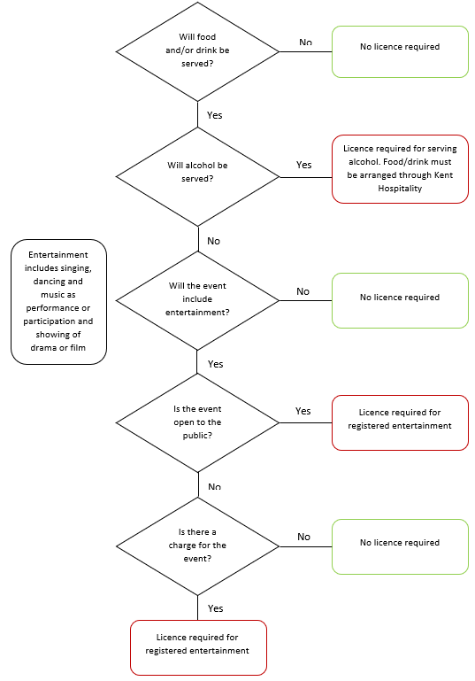

How to obtain a licence
Licences can be obtained from Emma Marsh on e.j.marsh@kent.ac.uk or 01227 824705.
Normally, a Temporary Events Notice (TEN) will be suitable. This is notification of the event to the council and police when an event requires a temporary licence because the event is occurring in a location without an existing licence. Obtaining a TEN through the Kent Union activities team requires a minimum of 28 working days’ notice. If you do not obtain a licence or TEN when one is required, your event cannot take place. Restrictions on a TEN include ensuring your event has fewer than 500 people at any one time and that it last no more than 168 hours (seven days).
The TEN application for the event must go through Kent Union and you should not apply directly.

External speakers
Any external speakers must be approved by externalspeakers@kent.ac.uk at least three weeks prior to submitting a booking request. When making the request, please include:
- The speakers name
- The organisation the speaker represents
- The subject of the discussion
- Any available webpages/other information to support the request
The event cannot be advertised until permission has been granted.

Fire safety regulations

In the event of fire or the alarm sounding, it is imperative that there is no delay, under any circumstances, in all occupants leaving the building.

We all have a degree of responsibility to ensure the safety of others. In the event of a possible fire, all persons present need to have sufficient awareness, and supervision/assistance, if necessary, to escape safely. In the event of a fire the University must also confirm to the Fire and Rescue Service, wherever practicable, that areas of buildings are fully evacuated. Those who booked the event should familiarise themselves with fire safety features at each location. This need only be very brief and simple but should include escape routes and fire alarm call points.

Safety announcements at the start of each event

At the start of the event, all attendees must be briefed regarding action in the event of fire or the alarm sounding:
- The need to evacuate immediately
- The shortest escape route (following the most immediate signs should suffice)
- The assembly point (these are shown on Fire Action Notices near all fire alarm call points)
Those who booked the events must take reasonable care to ensure that all attendees respond and evacuate immediately, to account for them, and to report this (or otherwise) to a Fire Marshal or Security Officer outside the building – but without putting themselves in any danger in order to do so.
Particular attention should be paid to the possibility that certain persons, such as those with hearing impairments or cognitive/psychological conditions, may not be able to perceive the alarm or respond to it appropriately.

Means of escape

- Room doors/fire exits must not be obstructed at any time
- Furniture from rooms must not be placed in corridors
- Signs on designated fire doors must be complied with at all times ie fire doors kept shut, or kept clear if automated

