Our place in disability history
  - Timeline created for Disability History Month 2022 at the University of Kent.

1965: Kent welcomes first students.
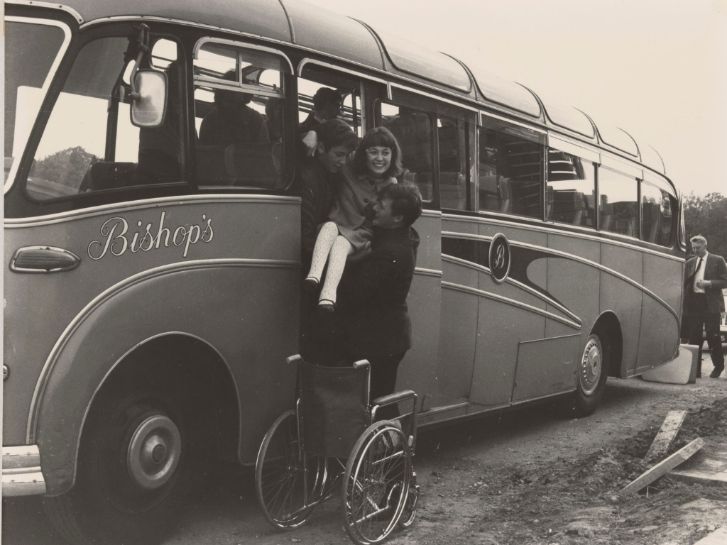
On 11 October 1965, the first 500 students arrive at the University of Kent, including Ann Smith, a wheelchair user. The unprepared university hastily adds infrastructure to increase accessibility, including grab-rails in her room.
Rutherford and Eliot aren't designed with people with restricted mobility in mind at all. Of Darwin and Keynes, which are still at the design stage, only the latter will be equipped with a lift, ramps and a few low-level payphones.

1970: New laws for equal access.
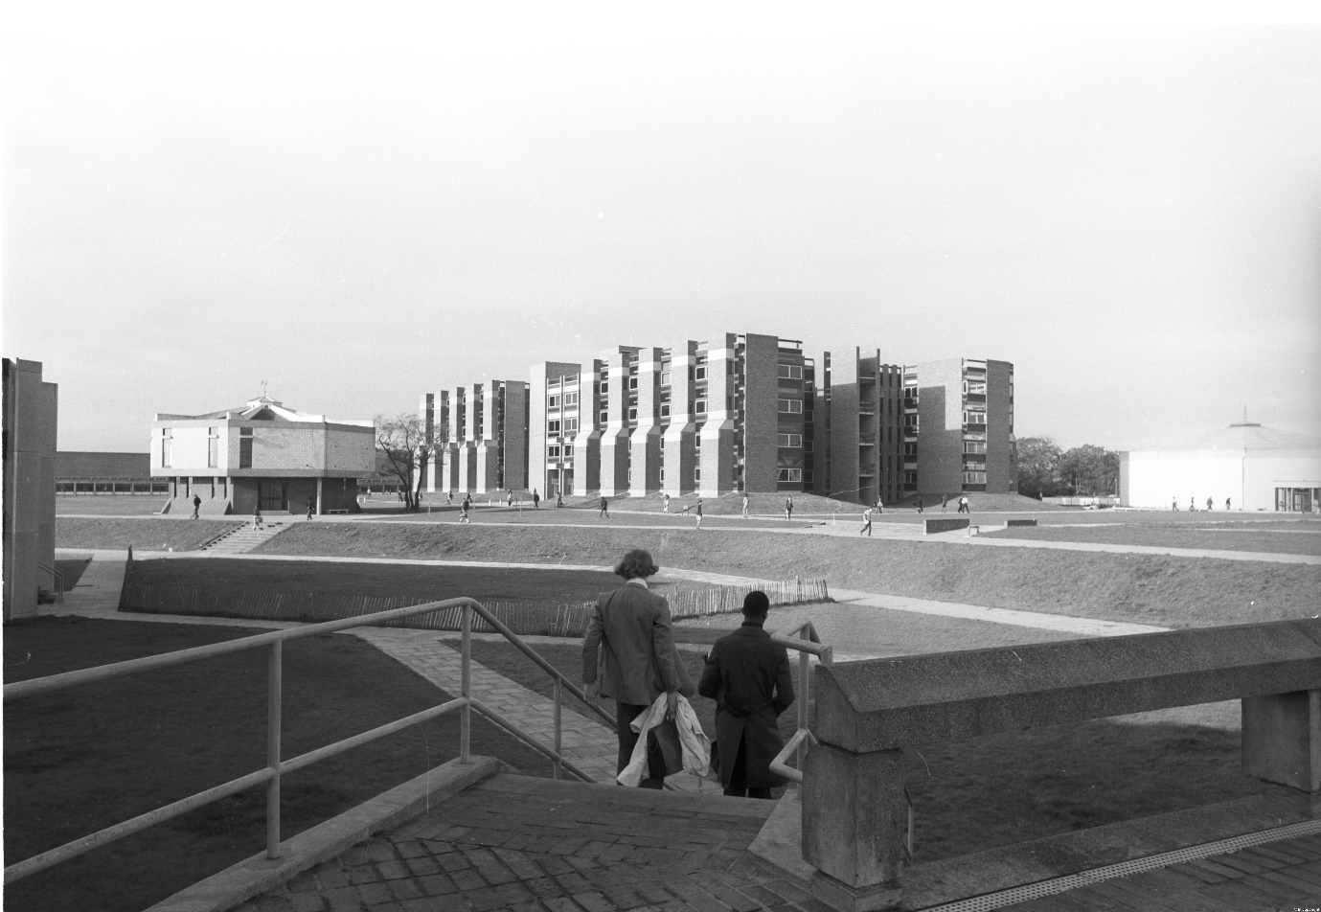
The Chronically Sick and Disabled Persons Act 1970 is a breakthrough for disability rights. Local authorities must now provide equal access to educational facilities. This leads to the addition of some disabled parking on campus in 1971.
Admissions staff at Kent realise that the Act will result in an increase in the number of disabled people applying to study at the University, and that significant improvements will need to be made to increase accessibility.

1975: Disability in prospectus.
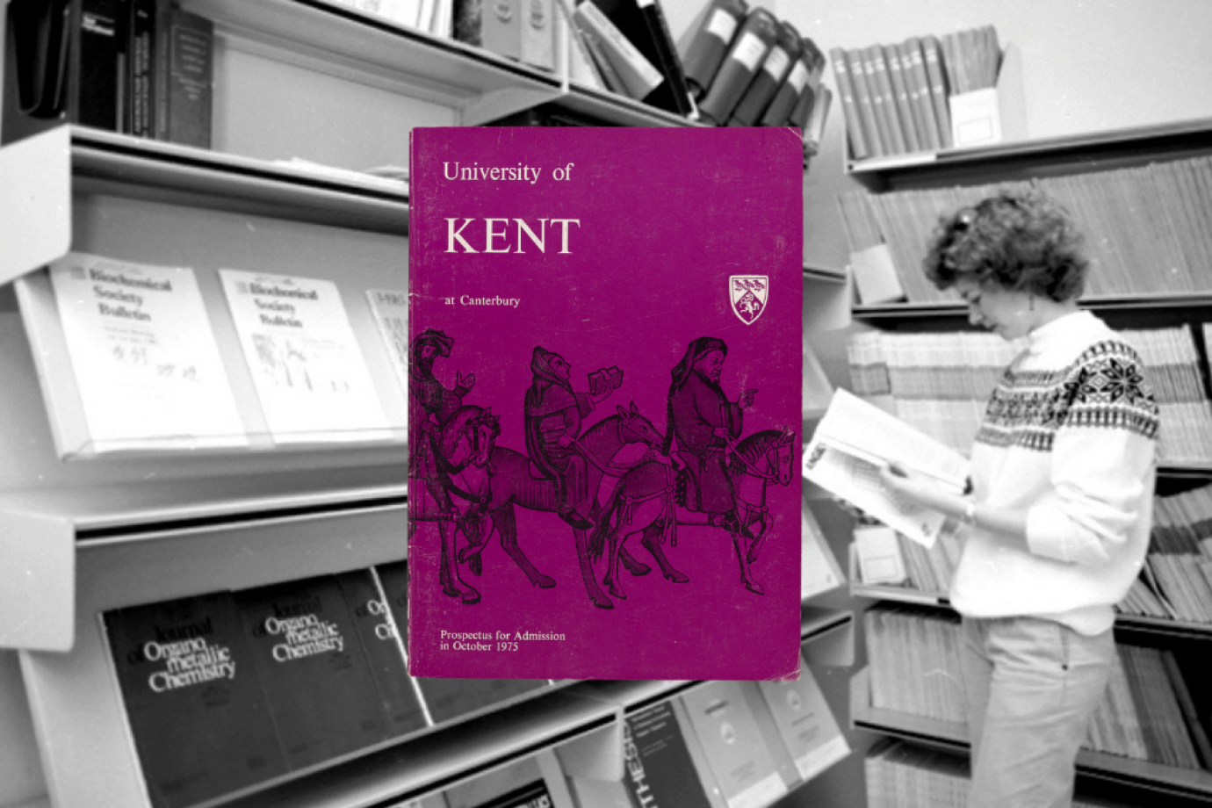
At the time of its first mention in a prospectus, the admissions process for disabled students seems to be based on the medical model of disability: where the disabled person's body is viewed to be the barrier.
The 1975 prospectus admits that many buildings are not accessible to disabled students, and emphasises that it is the responsibility of the student to manage their disability whilst at university. It is the role of a 'Medical Officer', rather than the estates office, to think about facility accessibility.

1979: First disability advisers.
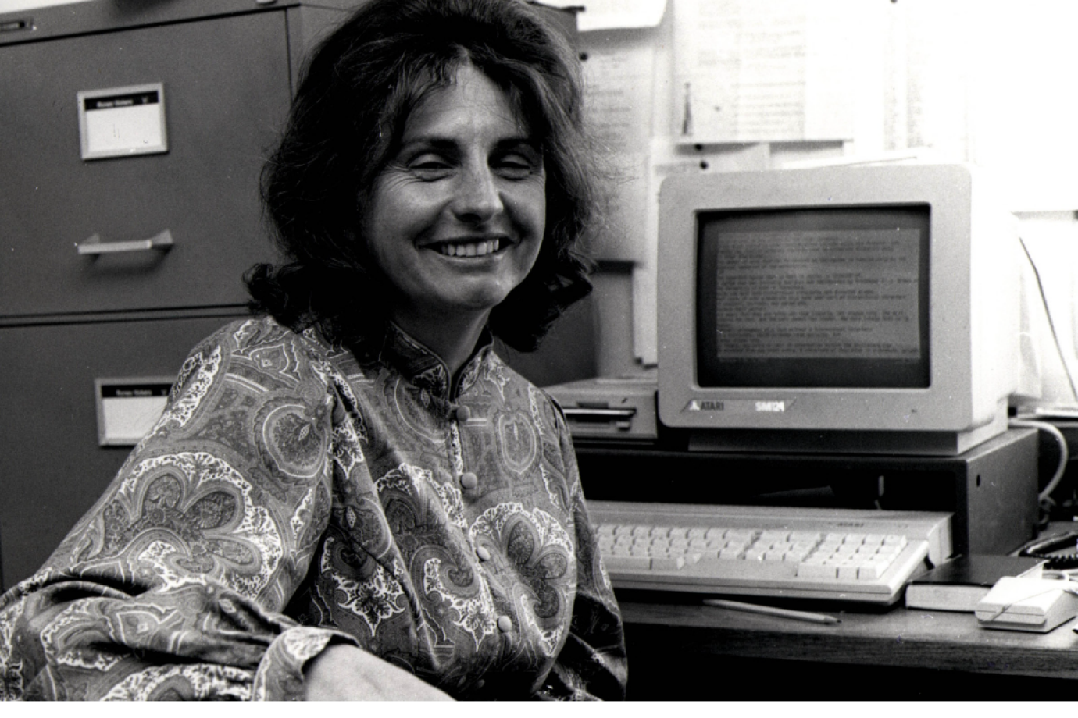
David Reason, a disabled academic, is appointed the first Adviser to Disabled Students, a role he holds on and off into the mid-1980s. Professor Reason has long advocated for disabled students, including those with hidden disabilities.
Eve Wilson (pictured) also acts as Adviser in the 1980s but later steps down because the workload expected of one staff member becomes unreasonable owing to the increasing numbers of disabled students at Kent.

1983: Social model of disability.
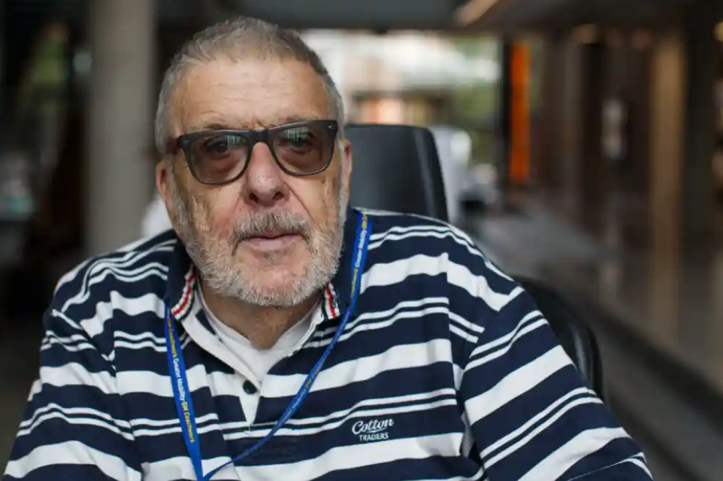
In his 1983 book Social Work with Disabled People, Kent alumnus and lecturer Professor Mike Oliver (pictured here in 2018) develops the 'social model of disability', a new way of thinking after years of a 'medical model'. This now widely accepted idea puts much of the difficulty of being disabled down to societal failure to adapt for disabled people.
Professor Oliver leads Kent's MA in Social Work with Disabled People, the very first course in what would later became known as Disability Studies.

1980s: Progress on campus access.
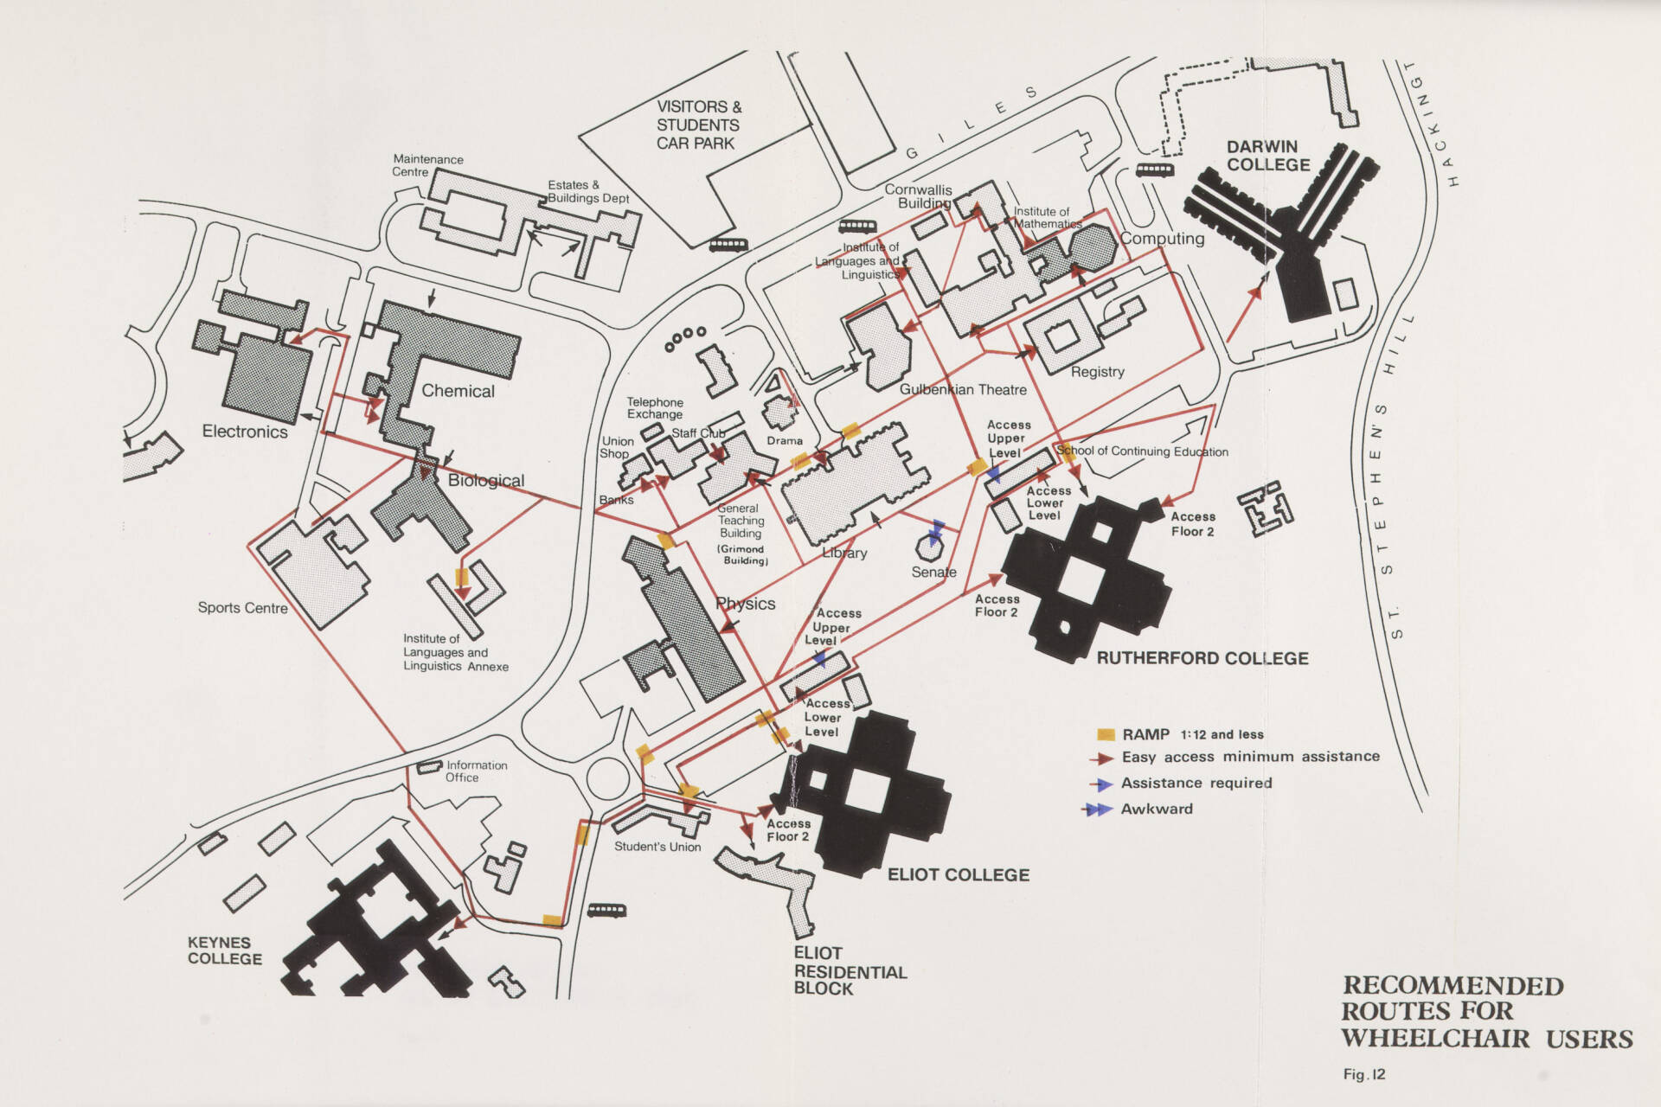
Throughout the 1980s there is a sharp increase in the rate at which funding is allocated and works are carried out to increase physical accessibility across campus.
Over the course of the decade, funding commitments include: outside alterations including road crossings, ramps outside Eliot, the Senate, the Medical Centre, and Careers Service, and alterations in the Library, Cornwallis and Sports Centre to provide accessible toilets.

1993: Disabled Students’ Allowance (DSA).
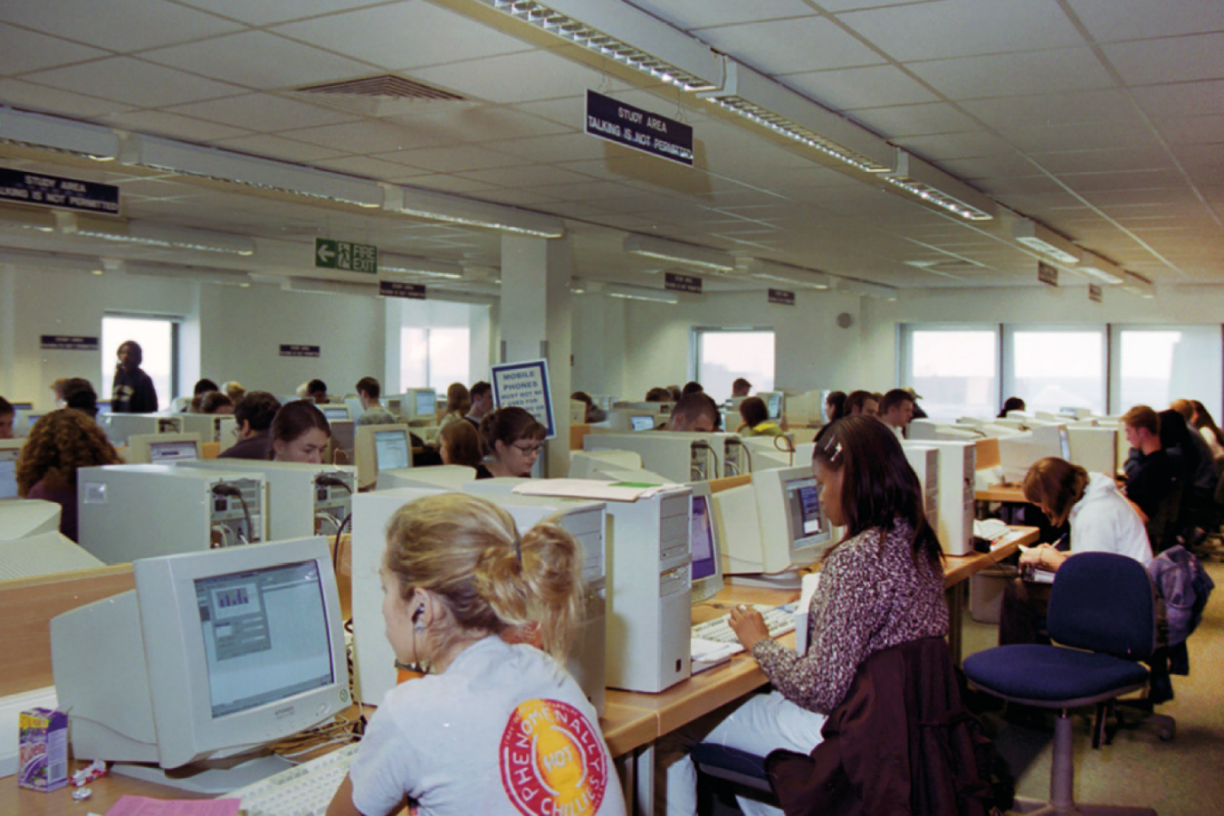
The Disabled Students' Allowance (DSA) is established to help disabled full-time students cover equipment, non-medical helpers and general costs. However, part-time students will not become eligible for the DSA until 2000.
This funding now enables the Student Support and Wellbeing department to recruit sessional staff to provide study skills tuition, mental health mentoring, and accompaniment to lectures, seminars and the library.

1995: Support unit created.

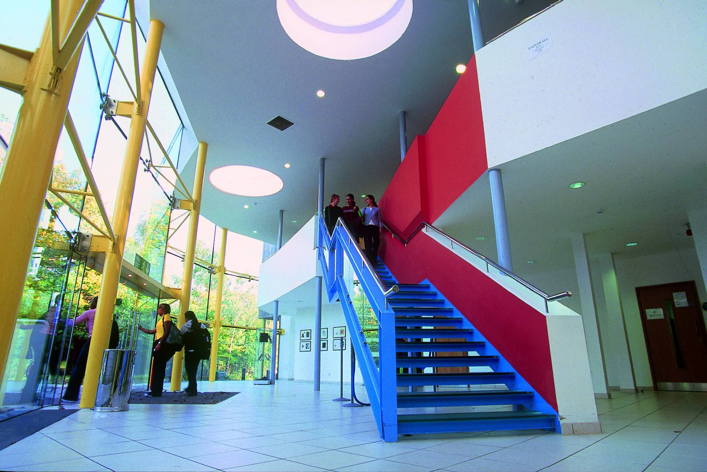The Disability Discrimination Act 1995 gave rights to disabled people to prevent discrimination on the grounds of disability, including in an education context. In 2000 the Disability Rights Commission is established to uphold it.
This law change, combined with the increased awareness of the inadequacy of having a single Disability Adviser, leads Kent to decide that a dedicated team is needed. The first Disability Support Unit takes shape around this time.

2004: Formalised review process
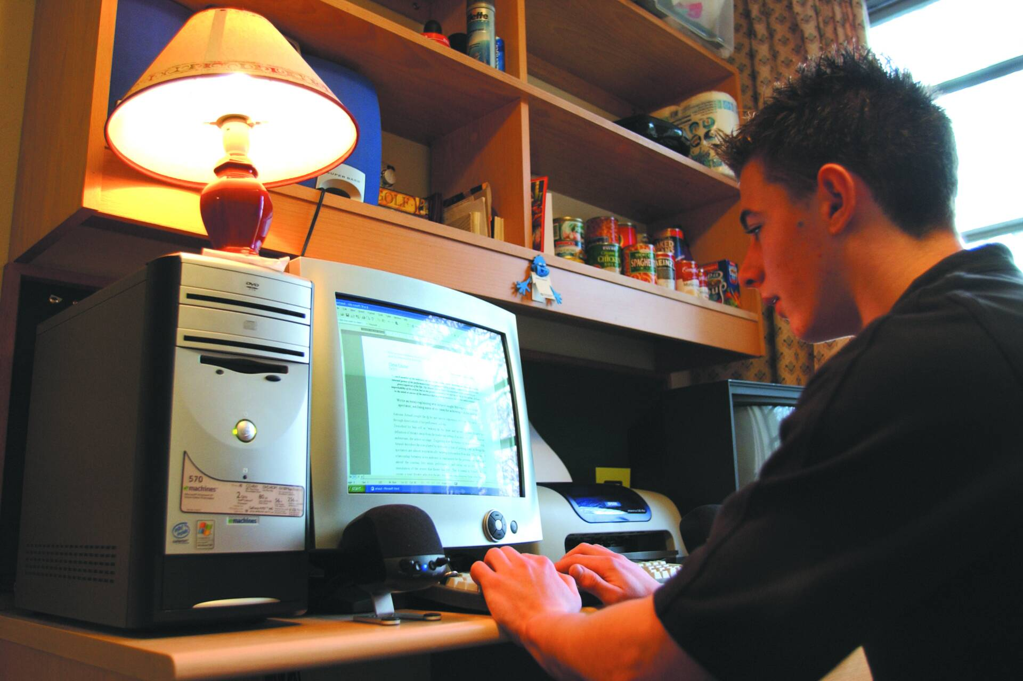
New legal requirements for reasonable adjustments to make buildings accessible come into effect in 2004. Two working groups subsequently gain new importance, leading Kent to consider merging them to form one review body:
- The Disability Support Network Group (DSNG) discusses and informs the University of disability-related issues that need addressing.
- The Disabled Access Working Party (DAWP) reviews plans for new building projects, and reviews existing buildings to identify access issues.

2015: Disability to accessibility

Physical accessibility:
In 2015, Kent partners with DisabilityGO (now AccessAble) to create an online accessibility guide to campus buildings.

Academic accessibility:
From 2017, the Kent Inclusive Practices (KIPs) make teaching more accessible by anticipating the needs of disabled students, minimising need for retrospective adjustments and thereby also improving the learning experience for all Kent students.

2017: DHM: raising awareness.
In 2017, Kent staff and students start collaborating to celebrate Disability History Month (DHM), inviting Professor Mike Oliver who comes out of retirement to deliver a lecture. Student Accessibility Network members organise many events and initiatives to raise awareness of disability yearly.
For DHM in 2018, Kent students create a film series called 'People are Weird', which humorously describes some odd attitudes towards disabled people. The project screens in the Gulbenkian cinema on the Canterbury campus.

2018: Kent leads on accessibility.
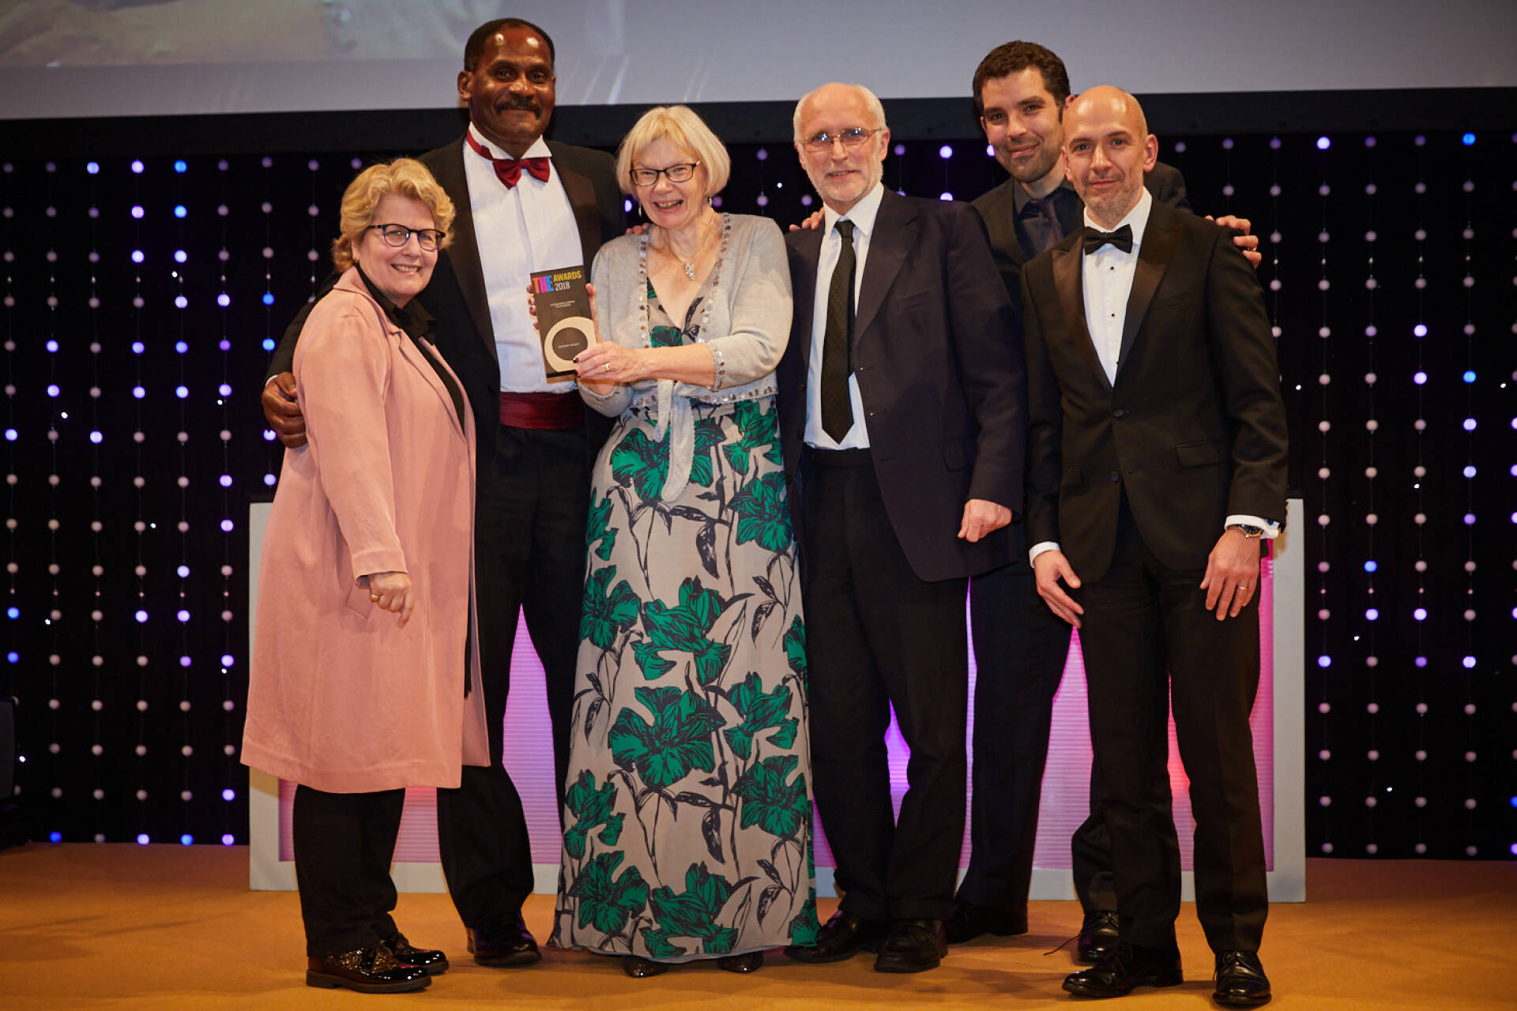
Kent wins a prestigious Times Higher Education award for Outstanding Student Support, recognising the innovative OPERA project (Opportunity, Productivity, Engagement, Reducing barriers, Achievement), which pioneers a proactive rather than reactive approach to access requirements.
In 2019, Kent continues to lead in this sector through its preparations to satisfy new web regulations. The University partners with local public sector bodies to host the first widely attended Digital Accessibility Conference.

2022: Honorary graduates.
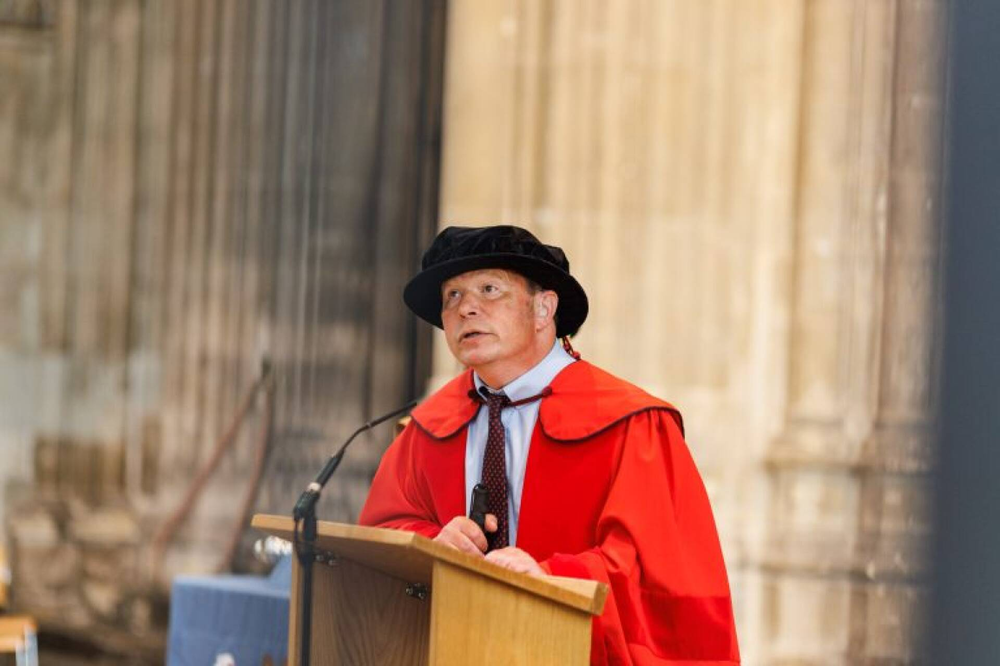
Among many notable alumni who have contributed to improving society for people with disabilities, this year:
- Dr Howard Leicester is awarded Doctor of Science for contributions to the provision of accessible information, notably in the NHS, and social justice advocacy.
- Kush Kanodia is awarded Doctor of Science for his career as a disability rights champion and social entrepreneur.

2022: Integrated support.
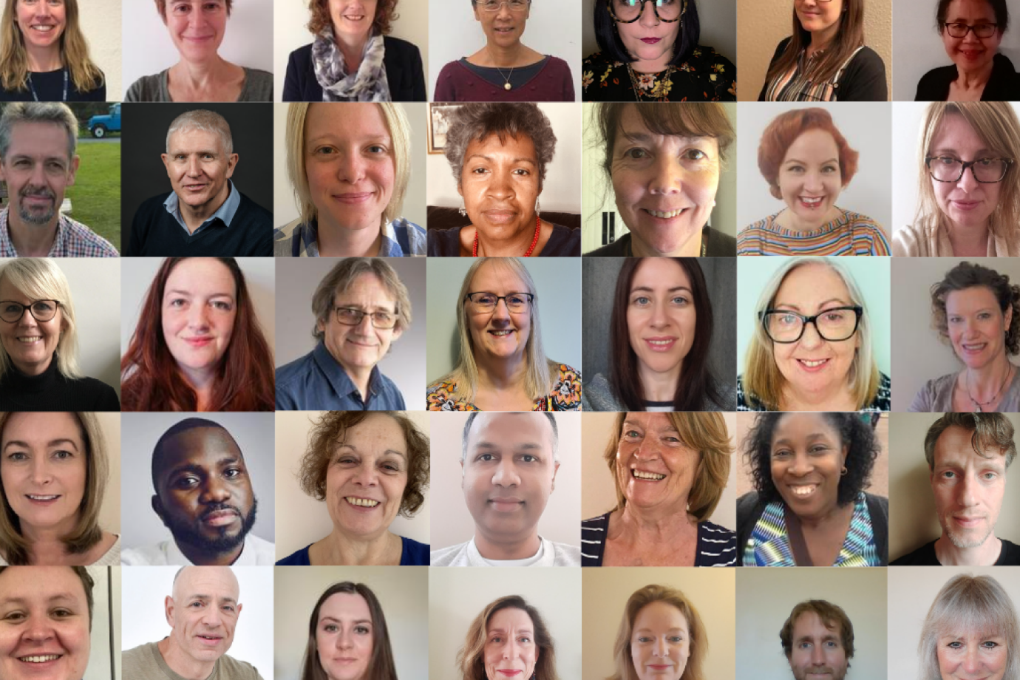
From the mid-2000s, the Disability Support Unit (DSU) began to broaden its scope to include hidden impairments. Dyslexia was added to the title to make it the DDSU, and mental health provision was slowly incorporated, having previously been the responsibility of the College Masters.
In 2011, the DDSU became Student Support and Wellbeing (SSW), with around 40 full-time and sessional staff. A decade later in 2022, SSW has grown to over 70 staff.

This is where we are today. Now let's shape tomorrow.

The future belongs to all of us. Email EqualityAndDiversity@kent.ac.uk to share your stories, ideas, and expertise.

