Outcomes from the Diamond Jubilee Orchard ‘Plan your space’ activity
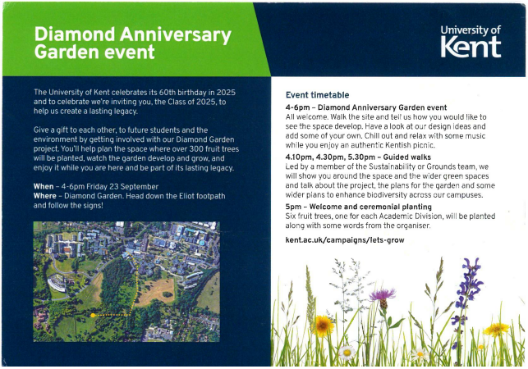
Kent’s newest undergraduates will graduate in 2025, the University's Diamond Anniversary year, so this winter we are planting an orchard of over 300 fruit trees on the Southern slopes of the campus, to celebrate their legacy. We hope that over their time at University, the class of 2025 will be able to enjoy the orchard space, help it to develop, and watch it grow with them, with the aim that by the time they graduate it will be a flourishing area of biodiversity and a social space to connect students with nature on campus.

Methodology
On the evening of Friday September 23rd, we held the official launch event for this project. This special event invited students of the class of 2025 (as well as any others who want to be involved) to help us to plan the orchard space. We gave each attendee a sheet showing the space we have available, and asked them to draw and make notes of where they would want us to place the trees, and what other features they would like to see, such as paths, ponds, seating areas, shelters etc. We also asked how they would ideally like for the space to be used, for example as a teaching area, for events or recreation, for relaxation and meditation, or whether we should prioritise creating new habitats for wildlife.
The original intention was to hold the event at the future orchard site so attendees could really get a feel for the space and explore it before coming up with ideas, but due to poor weather the event was held on campus instead, so it is important to consider that not all plans will be realistically possible with the size, shape and topography of the area.
We received a total of 31 submissions from the activity, each planned in varying levels of detail and using different amounts of the space, with some utilising just one triangle of the area shown and some the whole area. We took the time to carefully assess each submission, for each one listing all the features they suggested and how they wanted the space to be used. With every submission expanded on in one document, we were then easily able to see the most frequently occurring words e.g. trees, pond, wildlife, to work out the most popular ideas for the space, and then tally exactly how many of the submissions had suggested each one. This allowed us to see not only the top requested physical features, but also identify the key themes and patterns amongst the submissions, and distinguish between those who want the space to be mainly for people’s use, those who want to prioritise wildlife, and those who valued both of these.
Key Findings
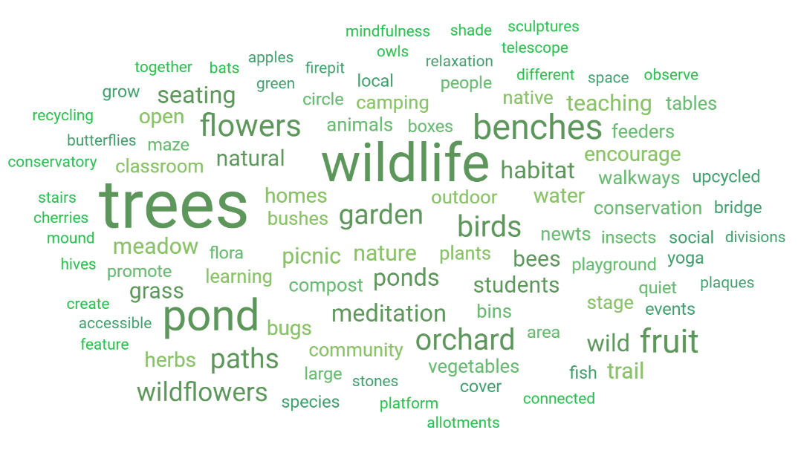
Word Cloud showing 100 of the most common words in the submissions we received, sized depending on frequency, with the most frequently repeated words appearing largest.

Some of the most frequently used words throughout the submissions:
(Bracketed number signifies how many submissions mentioned them. Green words more nature-oriented ideas, yellow more people-oriented, though there is overlap):
Trees (21) Wildlife (19) Flowers (16) Pond (17) Benches (11) Paths (11) Fruit (9)
Wildflowers (9) Orchard (8) Garden (8) Seating (8) Birds (8) Meditation (7)
Bugs (7) Bees (6) Meadow (6) Habitat (6) Vegetables (5) Grass (5) Natural (5)
Classroom (5) Students (5) Picnic (4) Social (4) Herbs (4) Trail (4)
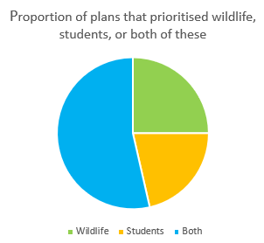

For each submission we assessed the suggestions and categorised it as either focusing on wildlife, students, or both. This pie chart shows the proportion of submissions that fell into each category.

Specific ideas suggested:
- Vegetable patches, greenhouses, herb garden, tool sheds
- Wildflower meadow for pollinators, different gardens areas for different types of wildlife, specific flower gardens e.g. a rose garden, flower beds to line pathways or around seating
- Stairs to make the areas multi-levelled
- Ponds, a couple suggested water features, bridges over them
- Wetland areas to encourage birds, wilderness area completely unmanaged, natural hedgerows
- Bird houses and feeders, bird observation stations, binoculars
- Hedgehog homes, bat and owl boxes, bug hotels, bee hives, hibernaculum, with information plaques
- Pavilion, pergolas, picnic area, anything that can act as a social outdoor space (with some shelter, some suggested a type of conservatory)
- Outdoor furniture e.g. benches, tables
- A small hedge maze, or topiary area
- Outdoor classrooms, perhaps mounds to teach from and whiteboards installed
- Meditation / yoga space
- Nature inspired art installations, trails through the trees (with artwork or sculptures)- “conservation trail”, “art trail” suggested
- Outdoor platform or stage, potential for outdoor cinema/theatre
- Playground and sport areas for community
- Telescope, stargazing area
- Camping area, yurts/tepees, fire pit
- Frequent bins to prevent any littering, recycling points, composting
- Solar panels / turbines to run any events hosted at orchard space
- Focus on upcycled features such as water butts, benches, sculptures, bird feeders

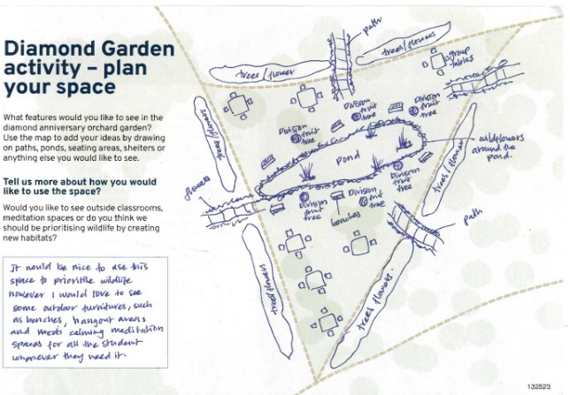
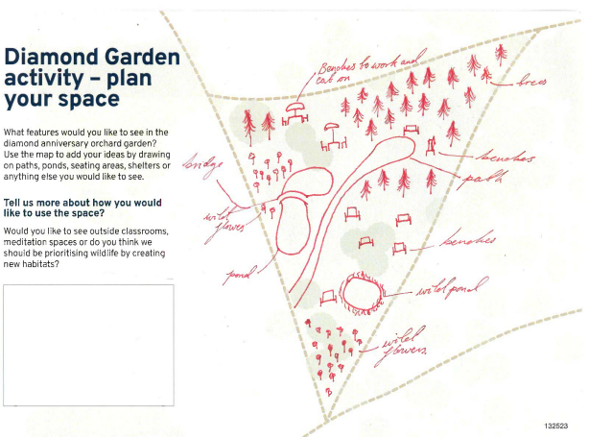
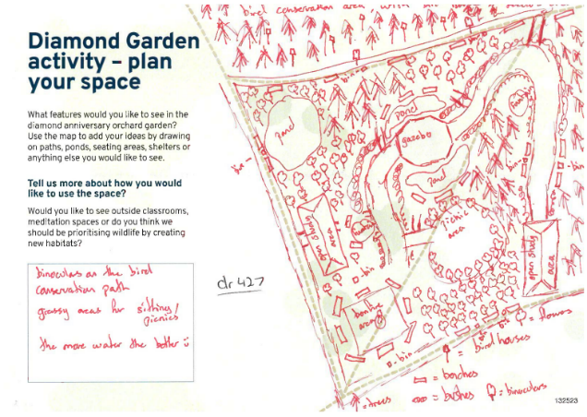
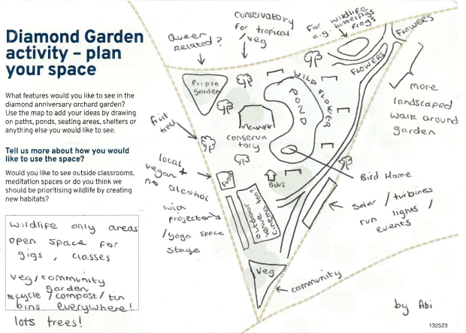
Some standout designs:
Recommendations:
Though there were some students who seemed to want to mainly focus the orchard area on people’s use (wellbeing, teaching, recreation) and some who wanted it to be primarily a space for nature (completely unmanaged, wilderness, creating biodiverse natural habitats) the majority mentioned both features for wildlife and for people and wanted a complete mix of both. Many seemed to feel that a focus on nature and encouraging wildlife could be used to the advantage of people anyway and help with wellbeing and provide recreational opportunities, through outdoor meditation areas, nature walks, bird watching etc.
The features most frequently requested that we recommend for the space would be ponds (several, and with areas for bird watching/binoculars nearby, potentially a bridge over one), lots of pathways around the garden, at least one wildflower meadow area, an outdoor seating/picnic area, an outdoor classroom, a circular meditation area, a herb garden, bird feeders/bird houses, hedgehog homes, bat and owl boxes. Some other ideas that were suggested a few times that we really liked are nature inspired artwork or sculptures (perhaps in a trail amongst the trees or lining a pathway), a potential outdoor cinema area (someone suggested for nature documentary or spring watch viewings), a topiary area with animal shaped bushes, and solar panels to power events. We also liked the suggestions of having different garden areas for different types of wildlife / types of flowers, with stairways or stepping stone paths between them - lots of illustrations reflected this idea, with a central seating area / classroom and pathways leading into it from different garden areas. We also thought the suggestion for an outdoor conservatory area to sit in when the weather is bad and listen to rain amongst nature was lovely.

