Joint Agency Group Supervision (JAGS) was initiated in Norfolk in 2021, this was in response to learning from local Child Safeguarding Practice Reviews. Where the learning identified that professionals need ringfenced time as a multiagency network to reflect on challenges and barriers to intervention in complex cases, including their own emotional response to the presenting safeguarding issues and their needs for support and containment. The initiative was piloted throughout 2020 and is now underpinned by a multi-agency policy endorsed by the Norfolk Safeguarding Children Partnership.
JAGS provides a reflective space for joint analysis of assessment information, an opportunity to explore what professionals know about the lived experience of the child and supports the relationship between professionals who are working together with families to secure the best outcomes for children. The purpose of joint supervision across partner agencies is to provide a mechanism to reflect on cases which are very complex, feel ‘stuck’, or are drifting. The principles of JAGS are to support learning across agencies in the best interests of families to ensure that children and their families receive the right levels of support and interventions at the right time, in accordance with the Norfolk Safeguarding Children Partnerships Threshold Guide.
The following framework below can illustrate how multiagency professionals are supported in Norfolk to ensure that their practice is collaborative, curious, reflective and supportive of good quality decision-making in the best interests of children.
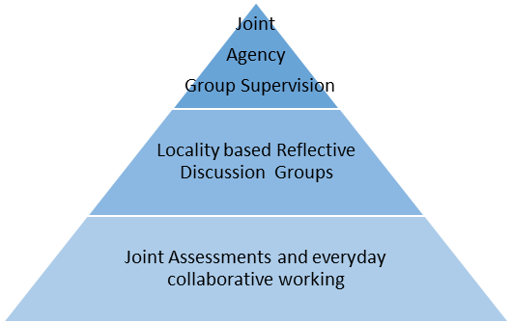

JAGS do not replace statutory processes in decision-making, and we should always be working transparently with children and families. However, this should not prevent professionals meeting for group supervision, to reflect on the progress of a child’s plan and what they might do differently to improve outcomes for the child.
To gain an understanding of the impact of JAGS a formal evaluation was completed in February 2022. While there has been much positive feedback and anecdotal evidence of demand for JAGS, there continues to be challenges in terms of how we quantify and qualify JAGS to gain evidence of how this is improving outcomes for children and their families.
The JAGS evaluation working group undertook 1-2-1 interviews with a range of professionals from children’s social care, health, education and police. This included both frontline workers and JAGS supervisors. All people interviewed cited complexity of the case as the reason for calling the JAGS with additional descriptors of ‘drift’, ‘professionals being stuck’ and ‘avoiding/understanding professional disagreement’ as the most common responses. Participants were also asked to choose three words to describe how they were feeling before and after the JAGS, please see below: -
- BEFORE: ‘helpless’, ‘frustrated’ and ‘worried’; a theme was lack of direction
- AFTER: ‘confident’, ‘contained’; one person reported feeling ‘enthusiastic, calmer, knowledgeable

From the evaluation it was also identified that JAGS provided opportunities for better multi-agency working and understanding each other’s roles, access to resources, and better joined up planning. In addition to this JAGS were thought to improve communication, reduce risk of drift and have an ability to better advocate for the child.

