Orchard Planting Event
The University of Kent celebrates its 60th birthday in 2025. To celebrate the anniversary and the class of 2025, we are planting an orchard of 300 fruit trees. Our hope is that students can help to develop the orchard and watch it grow with them over their time at university, and that by 2025 it is a fully complete and flourishing space, leaving a lasting legacy.

Planting
To help us plant the 300 trees and we are running two planting sessions on Wednesday 25th January to get them all in the ground.

The morning session will run from 10am -12.30pm and the afternoon session from 1pm-3.30pm. Each session will begin with a briefing about the project and a quick tutorial on how to plant the trees, in pairs or small groups you will dig, plant and secure the trees in pre-determined spots to create the orchard design. After the session, volunteers will be given a voucher to redeem for a hot drink in Dolche Vita.

Places are limited so please s﻿ign up to be part of this exciting project using the Eventbrite links below.

Morning session - https://www.eventbrite.co.uk/e/481635724417
Afternoon session - https://www.eventbrite.co.uk/e/481648051287

Guided walk
If you don’t have the time to participate in the planting but would like to know more we are running a lunchtime guided walk of the site at 1pm on the planting day (Wednesday 1st Feb). Hear from Sustainability and Landscape and Grounds staff about the project, why we are planting an orchard and how we hope the space will develop in the future.

Please use the Eventbrite link below to sign up for the guided walk

https://www.eventbrite.co.uk/e/walking-tour-at-the-diamond-anniversary-orchard-tree-planting-day-tickets-489626374667

Finding the site
T﻿he planting site is on the Southern Slopes of the University of Kent Canterbury Campus and you can see a map below. - Follow Eliot path down the hill, turn right after the bomb crater and follow the path to the planting field. Google map ref: 51.292068, 1.068540
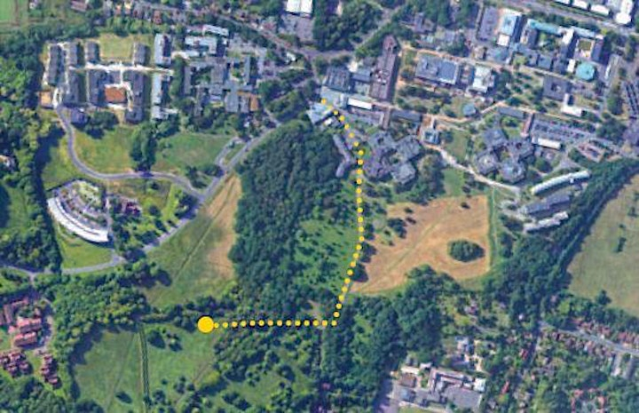

Accessibility information

The site is on rough ground on a slope so may not be suitable for all. The planting and walk will take place whatever the weather so please dress accordingly and consider your footwear.
If you have any specific accessibility queries or needs, please contact the Sustainability team at sustainability@kent.ac.uk to discuss your requirements.

Plans for the future

The Southern Slopes provides an ideal setting for a semi-natural orchard and meadow that will not only be a beautiful space for students, staff and community members to enjoy, but also provides a complex habitat that will boost biodiversity in the area. Over the next few years students will get to be part of a developing project that leads up to and celebrates the University’s Diamond Jubilee in 2025.
Step one is planting the fruiting trees, which once mature, will provide future students wit fruit and nuts that they can harvest and enjoy. Later this year we will be seeding wildflower seeds to create an understory orchard that we will cut swathes through proving a peaceful space to walk through and enjoy.
Because this orchard will be a mosaic of trees, grasses, shrubs, wildflowers and a pond, it will support a wide range of wildlife. As fruit trees age quickly, they create the perfect habitats for invertebrates and birds, such as the lesser spotted woodpecker and the rare noble chafer beetle.
This unique habitat will also feature key elements for our human community bring people and nature together. Accessible pathing so everyone can enjoy the space; seating with a view for meditation, rest or socialising; an outdoor teaching area; and a bird hide to spot nature from a quiet vantage point.
All the elements will be tied together with a central point that marks the six academic divisions that make up our learning community, celebrating all the students that will be our class of 2025 and beyond.
