SAMPLE REPORT
WE STAND FOR AMBITION.
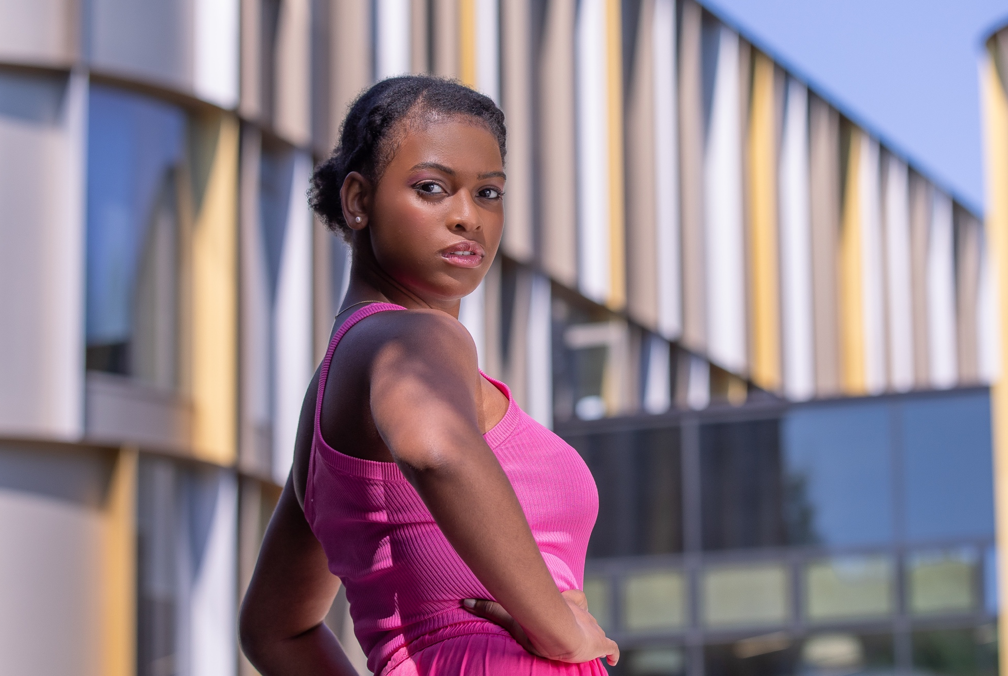
2023
Contents
Heading 1 – Section title 3
This is Overpass heading 2 3
This is Overpass heading 3 3
This is Overpass heading 2 4
This is Overpass heading 2 4
Heading 1 – Section title 5
This is Overpass heading 2 5
Heading 1 – Section title 6
This is Overpass heading 2 6
This is Overpass heading 3 6
This is Overpass heading 3 6
Heading 1 – Section title 7
This is Overpass heading 2 7

Heading 1 – Section title

This is Overpass heading 2
Body – Gulosus quadrupei pessimus divinus suffragarit quinquennalis apparatus bellis. Augustus spinosus senesceret parsimonia cathedras. Zothecas deciperet lascivius catelli, ut concubine comiter senesceret fragilis ossifragi. Zothecas fermentet pretosius ossifragi. Fiducias agnascor perspicax agricolae, quod verecundus ossifragi infeliciter deciperet apparatus bellis, etiam satis saetosus rures corrumperet catelli.

This is Overpass heading 3
Body – Gulosus quadrupei pessimus divinus suffragarit quinquennalis apparatus bellis. Augustus spinosus senesceret parsimonia cathedras. Zothecas deciperet lascivius catelli, ut concubine comiter senesceret fragilis ossifragi. Zothecas fermentet pretosius ossifragi. Fiducias agnascor perspicax agricolae, quod verecundus ossifragi infeliciter deciperet apparatus bellis, etiam satis saetosus rures corrumperet catelli.

This is Overpass heading 4
Body –Gulosus quadrupei pessimus divinus suffragarit quinquennalis apparatus bellis. Augustus spinosus senesceret parsimonia cathedras.
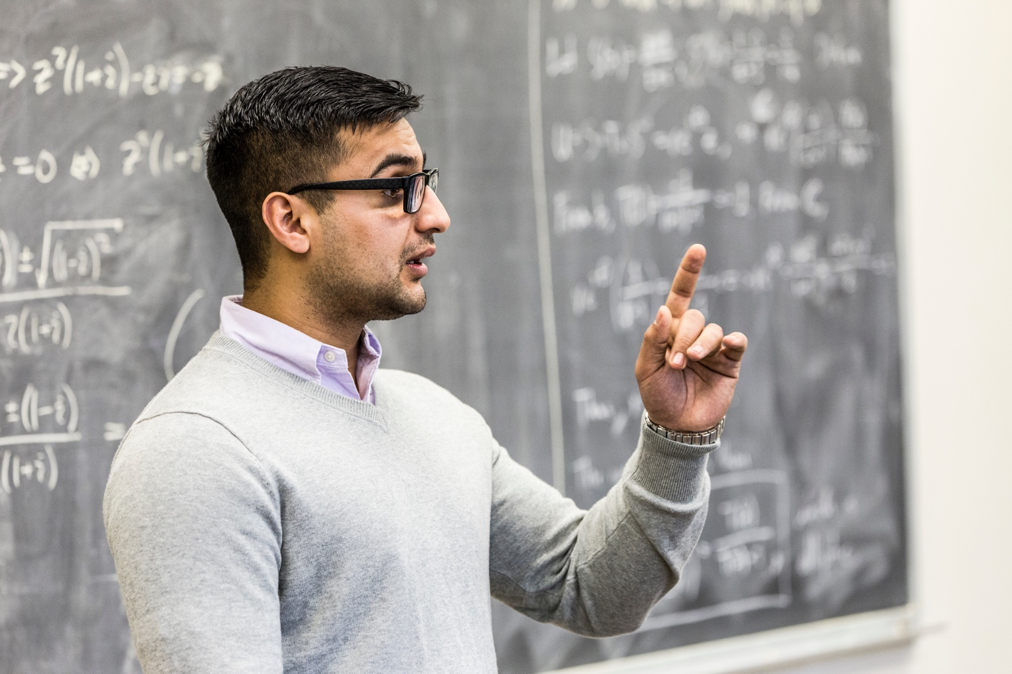

This is Overpass heading 2
Lorem Ipsum is simply dummy text of the printing and typesetting industry. Lorem Ipsum has been the industry's standard dummy text ever since the 1500s, when an unknown printer took a galley of type and scrambled it to make a type specimen book. It has survived not only five centuries, but also the leap into electronic typesetting, remaining essentially unchanged. It was popularised in the 1960s with the release of Letraset sheets containing Lorem Ipsum passages, and more recently with desktop publishing software like Aldus PageMaker including versions of Lorem Ipsum.
Lorem Ipsum is simply dummy text of the printing and typesetting industry. Lorem Ipsum has been the industry's standard dummy text ever since the 1500s, when an unknown printer took a galley of type and scrambled it to make a type specimen book. It has survived not only five centuries, but also the leap into electronic typesetting, remaining essentially unchanged. It was popularised in the 1960s with the release of Letraset sheets containing Lorem Ipsum passages, and more recently with desktop publishing software like Aldus PageMaker including versions of Lorem Ipsum
- This is Overpass Heading 2
- This is Overpass Heading 3
- This is Overpass Heading 4
- This is Overpass Heading 5
“This is a call-out quote. Use curly quotes with call-outs.”

This is Overpass heading 2
Lorem Ipsum is simply dummy text of the printing and typesetting industry. Lorem Ipsum has been the industry's standard dummy text ever since the 1500s, when an unknown printer took a galley of type and scrambled it to make a type specimen book. It has survived not only five centuries, but also the leap into electronic typesetting, remaining essentially unchanged. It was popularised in the 1960s with the release of Letraset sheets containing Lorem Ipsum passages, and more recently with desktop publishing software like Aldus PageMaker including versions of Lorem Ipsum. Lorem Ipsum is simply dummy text of the printing and typesetting industry. Lorem Ipsum has been the industry's standard dummy text ever since the 1500s, when an unknown printer took a galley of type and scrambled it to make a type specimen book. It has survived not only five centuries, but also the leap into electronic typesetting, remaining essentially unchanged. It was popularised in the 1960s with the release of Letraset sheets containing Lorem Ipsum passages, and more recently with desktop publishing software like Aldus PageMaker including versions of Lorem Ipsum

Heading 1 – Section title

This is Overpass heading 2
Lorem Ipsum is simply dummy text of the printing and typesetting industry. Lorem Ipsum has been the industry's standard dummy text ever since the 1500s, when an unknown printer took a galley of type and scrambled it to make a type specimen book. It has survived not only five centuries, but also the leap into electronic typesetting, remaining essentially unchanged. It was popularised in the 1960s with the release of Letraset sheets containing Lorem Ipsum passages, and more recently with desktop publishing software like Aldus PageMaker including versions of Lorem Ipsum. Lorem Ipsum is simply dummy text of the printing and typesetting industry. Lorem Ipsum has been the industry's standard dummy text ever since the 1500s, when an unknown printer took a galley of type and scrambled it to make a type specimen book. It has survived not only five centuries, but also the leap into electronic typesetting, remaining essentially unchanged. It was popularised in the 1960s with the release of Letraset sheets containing Lorem Ipsum passages.
“This is a call-out quote. Use curly quotes with call-outs. This is a call-out quote. Use curly quotes with call-outs. This is a call out quote.”

Heading 1 – Section title

This is Overpass heading 2
Lorem Ipsum is simply dummy text of the printing and typesetting industry. Lorem Ipsum has been the industry's standard dummy text ever since the 1500s, when an unknown printer took a galley of type and scrambled it to make a type specimen book. It has survived not only five centuries, but also the leap into electronic typesetting, remaining essentially unchanged. It was popularised in the 1960s with the release of Letraset sheets containing Lorem Ipsum passages, and more recently with desktop publishing software like Aldus PageMaker including versions of Lorem Ipsum. Lorem Ipsum is simply dummy text of the printing and typesetting industry. Lorem Ipsum has been the industry's standard dummy text ever since the 1500s, when an unknown printer took a galley of type and scrambled it to make a type specimen book. It has survived not only five centuries, but also the leap into electronic typesetting, remaining essentially unchanged. It was popularised in the 1960s with the release of Letraset sheets containing Lorem Ipsum passages.

This is Overpass heading 3
Lorem Ipsum is simply dummy text of the printing and typesetting industry. Lorem Ipsum has been the industry's standard dummy text ever since the 1500s, when an unknown printer took a galley of type and scrambled it to make a type specimen book. It has survived not only five centuries, but also the leap into electronic typesetting, remaining essentially unchanged. It was popularised in the 1960s with the release of Letraset sheets containing Lorem Ipsum passages, and more recently with desktop publishing software like Aldus PageMaker including versions of Lorem Ipsum. Lorem Ipsum is simply dummy text of the printing and typesetting industry. Lorem Ipsum has been the industry's standard dummy text ever since the 1500s, when an unknown printer took a galley of type and scrambled it to make a type specimen book. It has survived not only five centuries, but also the leap into electronic typesetting, remaining essentially unchanged. It was popularised in the 1960s with the release of Letraset sheets containing Lorem Ipsum passages.

This is Overpass heading 3
Lorem Ipsum is simply dummy text of the printing and typesetting industry. Lorem Ipsum has been the industry's standard dummy text ever since the 1500s, when an unknown printer took a galley of type and scrambled it to make a type specimen book. It has survived not only five centuries, but also the leap into electronic typesetting, remaining essentially unchanged. It was popularised in the 1960s with the release of Letraset sheets containing Lorem Ipsum passages, and more recently with desktop publishing software like Aldus PageMaker including versions of Lorem Ipsum. Lorem Ipsum is simply dummy text of the printing and typesetting industry. Lorem Ipsum has been the industry's standard dummy text ever since the 1500s, when an unknown printer took a galley of type and scrambled it to make a type specimen book. It has survived not only five centuries, but also the leap into electronic typesetting, remaining essentially unchanged. It was popularised in the 1960s with the release of Letraset sheets containing Lorem Ipsum passages.

Heading 1 – Section title

This is Overpass heading 2
Lorem Ipsum is simply dummy text of the printing and typesetting industry. Lorem Ipsum has been the industry's standard dummy text ever since the 1500s, when an unknown printer took a galley of type and scrambled it to make a type specimen book. It has survived not only five centuries, but also the leap into electronic typesetting, remaining essentially unchanged. It was popularised in the 1960s with the release of Letraset sheets containing Lorem Ipsum passages, and more recently with desktop publishing software like Aldus PageMaker including versions of Lorem Ipsum. Lorem Ipsum is simply dummy text of the printing and typesetting industry. Lorem Ipsum has been the industry's standard dummy text ever since the 1500s, when an unknown printer took a galley of type and scrambled it to make a type specimen book. It has survived not only five centuries, but also the leap into electronic typesetting, remaining essentially unchanged. It was popularised in the 1960s with the release of Letraset sheets containing Lorem Ipsum passages.

Department, Building,
University of Kent, Canterbury, Kent CT2 ???

kent.ac.uk

