Valuing Everyone
2021-22 Annual EDI Report

Foreword
Over the last few months, we have made some substantial changes around our approach to Equality, Diversity, and Inclusion (EDI) at Kent, with a view towards more transparency, institutional accountability, and embedding continual change. In 2020, the resurgence of the Black Lives Matter movement captured global attention following the tragic murder of George Floyd. At the same time, evidence began to emerge showing that the coronavirus – and measures to tackle it – has unequal health, social, and economic impacts for those with protected characteristics. Alongside this, the continual societal erosion of Trans rights has made the need for an actively and visibly inclusive community increasingly urgent. These issues have prompted us to reconsider our priorities as a University, highlighting that we must focus more on racial inequality and the fallout from Covid-19.
This report highlights that we have much to be proud of, and it highlights our achievements in 2020-21. At a time of substantial organisational change, this work has focused heavily on a change in Governance, Management and Culture around EDI – laying the foundations on which we can build an inclusive and visibly welcoming community.
More broadly, EDI has been an area of development at the University and has become increasingly embedded and important to our community at Kent. We have focused on mechanisms which will allow us to harness the range of activities and enthusiasm of our colleagues and students to facilitate transformational change. The need for a clear route for members of our community to input this area is key to promoting an inclusive environment and we have undertaken substantial work on both the government and management of EDI at Kent. Following findings from the EDI Task and Finish Group, we have revised our EDI governance structure to ensure that:
- strategy and objectives can be agreed and monitored
- agreement of priorities and a work plan with appropriate action owners
- co-ordination of EDI operations across both staff and students, and
- meaningful engagement with networks on EDI issues.
Importantly, the new EDI strategy group has a clear reporting line to University Senate and a broad membership (including representation from the JSNCC, Kent Union, and Council).
The review also raised the need for dedicated EDI support across all our communities at Kent and I am delighted that after a period with an interim role holder, we have a Head of Equality, Diversity and Inclusion who will work directly with me to address issues that cross our community. This role will be pivotal for removing structural barriers and accounting for systemic biases, particularly with those in our community who experience multiple structural disadvantages. We all have a responsibility to embed the values of equality and inclusion in our work. I am confident that focused leadership in this area will help us to do so and provide the tools, resources, coordination, and engagement to keep this priority front and centre – a golden thread – for all our activity.
I take this opportunity to extend a huge thank you to everyone involved in making our community at Kent more diverse and inclusive – from those who have published and taught on these topics, to community group chairs, those who have run events, the EDI reps, the HR and student services operational teams, and every member of our community who has raised institutional structural issues, reviewed a reading list or module outline with a diversity focus, challenged behaviour, educated themselves on issues that others face, or run an accessibility check on a document.
I feel privileged to have the opportunity to coordinate our efforts and work with you in safe and open spaces to share experiences, discuss inequality, and take action to confront and address our own biases – conscious and unconscious. With perseverance and hard work, we can foster an environment where all are supported to thrive and meet their potential.
Professor Georgina Randsley de Moura | Deputy Vice Chancellor – Academic Strategy, Planning and Performance

Introduction

The University is committed to fostering an environment where everyone can bring their whole selves to campus and flourish, without the need to diminish who they are or what they aspire to achieve. We believe that when people feel accepted, included, and valued, they are more engaged, work more collaboratively with others, and deliver better outcomes for our staff and students.
Whilst previous iterations of the annual EDI report have been recognised as being highly detailed and informative, the 2019/20 report was stripped back following feedback from University Council and other readers that it was too long and difficult to navigate. The shorter, more strategic-focused report was supported by the new EDI webpages which provide ongoing, live information of EDI-related events, activities, developments, and initiatives, ensuring a regular flow of information for staff and students. The new report was approved by University Council on 27 March 2020.
University Council recommended further development work be undertaken on the report, with the aim for an entirely web-based format in the future. Work towards this recommendation is ongoing, with a variety of format options being explored that will fulfil the triple needs for compliance with the Public Sector Equality Duty legislation, meaningful data analytics linked to strategy and impact, and providing useful, regular information to the student and staff population. University Council also recommended that:
- the format should be less dense and should meet recognised standards for accessibility.
- there should be a clearer focus on achievement against the previous year’s ambitions and on the challenges to be addressed.
- in addition to a recognition of achievements there should be more reflection.
- further consideration could be given to the use of images to ensure that they support the promotion of EDI.
Formulating strategy

Our leadership, management, and ownership structure
The University’s Vision and overarching institutional strategy is to be internationally known for a transformative student experience and employability outcomes, regardless of background. Our education and research and the talents of staff and students will support social, economic, cultural, intellectual, and public life in ways that will make Kent one of the leading civic universities. Principles of equality, diversity and inclusivity are fundamental to Kent’s purpose and to the achievement of this vision.

Kent is based on equality, diversity, respect and valuing each other. It is with equality at the heart that the University’s EDI agenda is formulated.

Strong ownership and leadership to move the EDI agenda forward
All members of the University’s community have a role to play in driving forward and acting upon Kent’s EDI agenda. Several groups and individuals are particularly involved in promoting and embedding an EDI culture at Kent:

Council
The broader aim of building a diverse and inclusive university that fosters equality of opportunity is supported at the highest levels of the institution, including University Council. Council regularly considers matters pertaining to EDI, in addition to receiving, discussing, and endorsing this report, and views EDI as integral to the Lay Nominations Committee and the business of Council.

Executive Group (EG) EDI Champions
See Pillar 1 on page 6 for update.
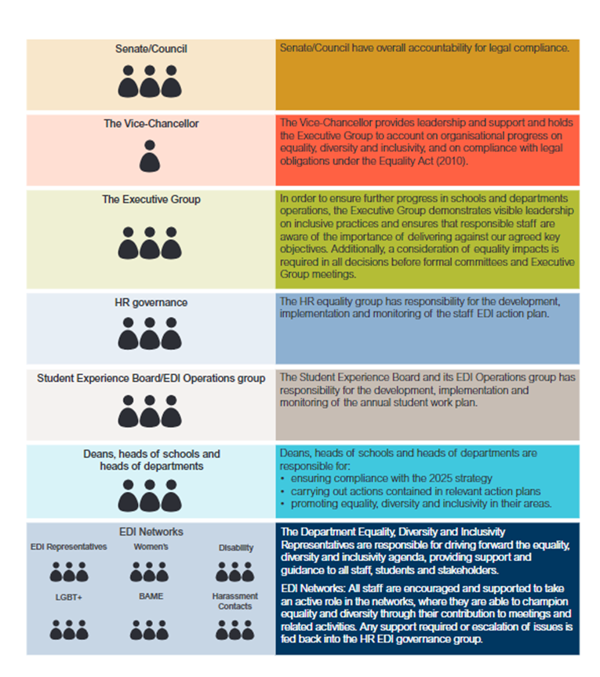

The following sections will outline the progress that has been made against our strategic objectives, review the data associated with this for both staff and students and then outline where we are going and how we will continue to ensure EDI is embedded and is part of the university culture
- Progress against our strategic objectives

- Our staff and student profile

- Looking ahead - Our continued commitment to inclusivity

1, Progress against our strategic objectives
This section introduces the work that has informed and contributed to the development and advancement of the University’s Equality, Diversity, and Inclusivity (EDI) strategy and includes examples of key projects or activities that have contributed to formulating strategy are introduced in this section

Pillar 1
EDI review – from strong leadership and ownership to a framework for EDI in an ever-changing environment.
- Implement robust structures, processes, and policies to ensure consistency of messages and actions

What we said we would do
- Implement central governance and structures with clear guidance on the role of each committee.
- Implement a central approach to equality impact analysis.
- Create a University EDI Risk Register.
- Plan to undertake the Equal Pay Audit (EPA) in 2021/22 while exploring intersectionality between gender and ethnicity pay gaps.
- Continue to support Research Excellence Framework 2021 application.
- Review the role of the Executive Group as EDI Champions, considering recent changes in roles and the expansion of EG.
- Create a University-level externally facing EDI website combining staff and student information.

What we have done
The central approach to equality impact analysis was completed in June 2021 with approval received from Joint Staff Negotiating and Consultation Committee, training on how to complete an impact analysis was created and made available for all staff. It is now an expectation that any new or revised process or procedure have an impact analysis completed and the completed analysis to be submitted to JSNCC with the proposed process/policy for review.
Work was undertaken on developing a central University EDI Risk Register throughout 2020/21, however this work will now be included within the wider Risk Review that the University is undertaking in 2021/22.
The University EDI website was created and launched in March 2021 on the fully accessible Site Editor platform, engagement with networks and key stakeholders was completed and feedback to date has been positive.
Work on The Equal Pay Audit began in 2021/22, with a target of completion by July 2022. A Working Group will be created to involve and consult Trade Union and staff reps. The final report will be presented to Executive Group and JSNCC in the summer of 2022.
Equality Impact Analysis for REF 2021 was submitted along with the REF 2021 application in July 2021, with the results of the application to be released in May 2022.

Success Story: A New Governance Structure
Throughout 2019 and into 2021 a full EDI Governance Review was completed, evaluating every level of the EDI decision making process and benchmarking against other institutions. A new structure was approved in 2021 and will be monitored for effectiveness throughout 2021/22. The Governance Review has also placed the University in position to be able to register for the Race Equality Charter. As part of the EDI Governance Review and Organising for Success, a full review of the role of the EG Champions for protected characteristics was completed. EG Champions for each protected characteristic were removed and an Executive Lead for EDI (Professor Georgina Randsley de Moura) was established. The aim is to provide a unified approach and focus to the EDI agenda across the Institution, bringing together the various work streams and ensuring that EDI is intrinsically embedded throughout all we do.

Impact, Reflection and Further Challenges
The EDI Governance Review has led to a fundamental shift in the approach to EDI at Kent, with the work no longer operating within a silo and a greater sense of cohesion and purpose across both the staff and student agendas working towards a fundamental, unified goal. Both the staff and student voice has been integrated into every level of the decision-making process and the introduction of the EDI Forum has ensured that on-the-ground issues and concerns have a direct route to the EDI Strategy Group.
Further work needs to be undertaken on developing the staff resource and structures to support and underpin the EDI Governance work and ensure that an EDI Strategic Plan is developed that brings together all EDI work flows across the institution. Future consideration needs to be given as to how EDI is embedded into the day to day working of all staff and students at the University to generate the fundamental culture shift the Institution is aiming for.

Pillar 2
Lead the way in the development of an environment that is free from harassment
- Understand the extent and nature of harassment against all characteristics so that a robust prevention strategy can be created.
Since 2018 the European Human Rights Commission (EHRC) have published several papers in relation to harassment, “Turning the Tables – Ending Sexual Harassment at Work”, EHRC’s “Report on Racial Harassment“, EHRC’S “Technical Guidance on Sexual Harassment“and “Harassment at Work“. All reports provided recommendations around steps to take to prevent and respond to harassment and victimisation. They also provided advice to individuals to help them understand the law and areas to prevent harassment and victimisation, or how complaints should be responded to.

What we said we would do
- Understand the extent and nature of harassment against all characteristics.
- Develop a risk-based approach to all forms of harassment.
- Enhance reporting capabilities for harassment for staff.
- Develop a robust prevention strategy, e.g., Inclusive Allyship programme.
- Embed policies and practices into institutional culture.
- Communicate existing support.
- Establish a Racial Harassment Steering Group to monitor incidents of racism and harassment at Kent and provide recommendation for improvements.
- Increase knowledge of the support and reporting mechanisms in place for students.
- Promote and increase engagement of the updated ‘Expect Respect’ module.

What we have done
In March 2021, an online form was developed and launched to all staff, with the ability to not only anonymously report harassment but all other forms of unacceptable behaviour in line with the updated Dignity at Work procedure. The procedure became part of the staff induction checklist, so all new staff are aware of the expected behaviours and the way to report if subjected to such behaviour.
In February 2021 in collaboration with Inclusive employers and in partnership with London City University and Liverpool John Moores University an inclusive allies programme was created and delivered to forty members of staff, 10 from each partnership university and 20 from the University of Kent. The allies are to challenge poor discriminatory behaviour, signpost Kent’s racially minoritised staff to support when and if required and support the anti-racism strategy created by consultancy firm Nous.
The Racial Harassment Steering Group proposal is being revisited to see where it will fit within the current structures. The current proposal is to replace it with a Discrimination and Harassment Prevention Steering Group.
The Expect Respect module has been fully reviewed, with new segments on Ageism, Accessibility, Challenging Racism, Bystander Intervention, Homophobia and Transphobia included. Reporting and support information is also included along with access to further learning and education resources. This will be launched in September 2021. It is expected that all students will complete the module as part of their induction and orienteering information and will be included on all student Moodle dashboards.
Discrimination and Harassment and reporting information webpages have been developed within the new EDI website.

Success Story: Report and Support
Significant work has been committed to developing a new Report and Support reporting tool for students affected by issues of harassment, discrimination, bullying or victimisation, including sexual assault and harassment, and this will be launched for the 2021/22 academic year. A communications campaign in 2021/22 will take place promoting the new Report and Support reporting tool.

Success Story: Inclusive Managers Training Programme
In 2021 an Inclusive Line Managers Training programme was developed in conjunction with Inclusive Leaders with the aim of empowering all staff with line management responsibility to develop their inclusive management skills and make a genuine impact on their staff and the university’s organisational culture.

Impact, Reflection and Further Challenges
For 2021/22 the Inclusive Allies were assigned projects to create a Respect Charter, promote training, identify further resources for the EDI website and communicate the network and support available impact from this will form part of the next report.
Developing a new Discrimination and Harassment Prevention Steering Group will allow for a holistic approach to identifying and addressing issues of discrimination, harassment and bullying within both the staff and student communities as well as providing a central avenue to assess data and analytics relating to cases.
Further work needs to be undertaken on developing staff and student confidence in our reporting systems and structures, with a focus on proving that the University will take reports seriously and act on them, as well as addressing fundamental concerns with regards to University culture. Further work also needs to be undertaken on reviewing and developing the Expect Respect module for students, including within the areas of Age, Sexuality, Gender Identity, Race and Religion and Belief. Some work should also be undertaken on communicating why the University feels that the module is important and the how it is helping to create the inclusive culture we are striving towards at Kent.

Pillar 3
Provide an open and supporting culture for all, create a culture where health, wellbeing is as important as anything else we do in a day
- Gain a greater understanding of mental health amongst all our staff and students so that we can identify and act on trends
Mental health issues have a significant impact on wellbeing and are a major cause of long-term absence. We all have mental health, just as we all have physical health. Both change throughout our lives, and like our bodies, our minds can become unwell. The World Health Organisation describes mental health as ‘a state of wellbeing in which every individual realises [their] own potential, can cope with the normal stresses of life, can work productively and fruitfully, and is able to contribute to [their] community.’
The Covid-19 pandemic has raised serious concerns about people’s mental wellbeing. The fear and uncertainty about the risk of infection many feel for themselves, and their loved ones is exacerbated by many other pressures on people. Many employees and students were isolated because of the lockdowns, while others faced income or job loss. Parents had to juggle caring responsibilities, work, or study. These concerns are a severe test of people’s resilience, and the future also holds a lot of uncertainty with the need for physical distancing likely to continue.

What we said we would do
- Produce, implement, and communicate the Thriving at Work strategy, which promotes good mental health of all employees and outlines the support available for those that need it.
- Develop mental health awareness among employees by making information, tools, and support accessible.
- Encourage open conversations about mental health and the support available through the complete employee life cycle.
- Provide employees with good working conditions and ensure that they have a healthy work-life balance.
- Promote effective people management to ensure that all employees have the opportunity for a regular conversation to discuss their health and wellbeing.
- Routinely monitor employee mental health and wellbeing, understanding the data available and acting on risks.
- Increase transparency and accountability and provide visible leadership commitment.
- Understand the requirements to implement the Student Minds Mental Health Charter with a view to implementing it in 2021/22.
- Undertake the Diverse Cyrmu Certificate in BAME Mental Health to increase the mental health support provision for students from BAME backgrounds, with the process starting in spring 2021.
- Continue to consult and collaborate with students’ unions and associations, and particularly with students with mental health difficulties, when formulating and implementing student mental health-related policies and procedures and identifying areas for improvement.

What we have done
The staff Thriving at Work Group have continued to make progress to communicating and implementing support available for all staff across the university.
To date the following has been implemented:
- Securing Visible leadership support
- The creation of a communication plan to better signpost current resources and support available
- Provision of additional training sessions for managers and an eLearning programme for staff that focus on a holistic approach towards mental health within the prevalent work cultures in higher education
- The creation of a one stop shop for all mental health guidance and support on the SharePoint platform
- Creation of Health & Wellbeing Yammer Channel so staff can share local and site wide initiatives on mental health and wellbeing
- Regular Health and Wellbeing blogs as part of Kent Sport Wellness Wednesday which are often then used in all staff communications
- The creation of a mental health ally network and role description
Work has been started on registering for the Student Minds Mental Health Charter and it is anticipated that an external consultant will be employed by Student Services to assess our current position.
Workshops were run for all staff in Student Support and Wellbeing by Diverse Cyrmu to increase cultural competency within the Department. Work stopped short of applying for the Certificate in BAME Mental Health as it is anticipated that this work will be rolled into the Student Minds Mental Health Charter.

Success Story: Mental Health Ally Network
As many as 1 in 4 individuals may experience distress but struggle to have a conversation with someone about mental health and how they are feeling. The Thriving at Work Project established a network of staff Mental Health Allies as the important next step in implementing the Stevenson / Farmers Report’s recommendations in relation to Core Standard One: ‘Produce, implement and communicate a mental health at work plan that promotes good mental health of all employees and outlines the support available for those who may need it. The Mental Health Allies are staff members who take action to raise awareness around mental health and challenge stigma. They receive training and support individuals by signposting to relevant support services and resources available, as well as challenge negative perceptions of mental health if they feel safe and able to do so. To date there are 31 Mental health Allies at Kent.

Impact, Reflection and Further Challenges
2021-22 will see the planning of Phase 2 of the staff Thriving at Work Action Plan and will look to:
- Create a long-term communication strategy around the Thriving at Work Standards and ongoing campaigns
- Understand and address the issues to provide a culture of openness with the aim to remove the stigma around mental health
- Creating a process for the collation analysis and action planning using data
- Implement and promote the mental health allies
It is anticipated that considerable progress in registering for and applying for the Student Minds Mental Health Charter will take place in 2021-22 with a holistic, whole-university approach being adopted.
Reducing the stigma around mental health and opening up discussions in a safe and supportive environment continues to be an ongoing challenge and further tools and techniques to unlock this will be explored as part of both the Thriving at Work and Student Minds Mental Health Charter work.

Pillar 4
Identify and remove barriers in relation to all forms of accessibility
- Increase the extent to which staff and students can participate in all areas of the University
Accessibility refers to the design of products, devices, services, or environments to be usable by people with disabilities. The concept of accessible design and practice of accessible development ensures both "direct access" (i.e., unassisted) and "indirect access" meaning compatibility with a person's assistive technology (for example, computer screen readers).

In September 2018 The Public Sector Bodies (Websites and Mobile Applications) Accessibility Regulations (2018) (PSBAR) became law. These require websites and mobile applications created by Public Sector Bodies to meet accessibility standards so that people who use assistive technology or have added needs can access services and information. The University’s work to meeting the PSBAR regulations overlaps with the ongoing work of the OPERA (Opportunity, Productivity, Engagement, Reducing barriers, Achievement) project. The University’s response to the regulations involves all stakeholders and necessitates a universal strategy of best practices and clearly defined workflows and support. These have been developed by building upon the existing strategies of the OPERA Project (such as the Kent Inclusive Practices) and the formation of a working group, Kent Digital Accessibility Working Group (KDAWG).

The University has taken a proactive stand in relation to accessibility and has a history of defining practices which are adopted by other institutions across the Sector. In keeping with this ethos, a lot of the work being done at the University is being shared with other institutions to help identify consistent processes and to help provide answers for questions which have not been fully addressed by the government’s guidance.

What we said we would do

Increase the extent to which all members of the University can access and participate in all areas of the University.
- Improve the physical environment of the campus so that all members of the University can take advantage of the facilities and services provided.
- Improve the delivery of digital information to all members of the University in line with PSBAR 2018.
- Ensure fair recruitment, retention, and development practices, in line with the Disability Confident scheme.
- Review approaches to Unconscious Bias training practices considering changes to public sector thinking in this area.
- Investigate technology support options for students to increase accessibility to online teaching and learning.

What we have done
The approach to unconscious bias was reviewed and agreed to continue to roll out the eLearning to all new staff. The classroom training that is currently delivered by the School of Psychology is planned to move across to the Central Training & Organisational Development team and be used as part of the proposed new programme on inclusive recruitment to ensure that unconscious bias is highlighted at the start of the employee journey.
As part of the EDI Governance Review, both the OPERA and KDAWG working groups were dissolved and a new Accessibility Steering Group was created that would guide the University along its accessibility journey. The group met for the first time in April 2021 and focused on reviewing the Student Journey in relation to accessibility and learning outcomes during Covid-19.
The second Accessibility Conference was held in April 2021.

Success Story: Site Editor
Throughout 2020-21 most of the University digital estate was transferred to Site Editor, creating a digital landscape with built in accessibility as standard. This has meant that most the University’s digital estate is fully WCAG 2.1 AA Standard compliant and, more importantly, is fully accessible to all students, staff, and visitors. The move to Site Editor has been a gradual process, starting in 2015 with a discovery phase through beta testing in 2016 and the key launch in 2017. Site Editor was selected as the replacement for Dreamweaver as a more content-focused and open-source editing tool.

Success Story: One Hour Degree
The One-Hour Degree developed by the Student Success Project won the Guardian University Award 2020 for Digital Innovation. Launched in 2019, the One Hour Degree is an online simulation game designed to provide the complete university experience for those contemplating taking the three-year academic route. Created by the Student Success Project, it enables potential students to take an immersive series of “quests” designed to give authentic insight into the university experience, all within one hour. The One Hour Degree was developed in collaboration with a number of specialists across the University. Within its first 24 hours it had been played in over 40 countries. Not only will the One Hour Degree provide insight for potential students, it also serves to remind current students of the facilities, services, and opportunities available to them as Kent students.

Impact, Reflection and Further Challenges

The move to hybrid learning for students and hybrid working for staff has created a new set of accessibility challenges that will need to be continually monitored and risk assessed to ensure that staff or students are not negatively impacted by these new ways of working and learning. A new University of Kent Digital Accessibility Policy will be launched in 2021-22 and a new University of Kent Digital Accessibility of Thesis policy is also to be agreed.

Embedding inclusive practice into the day-to-day life of all staff, mainstreaming accessibility and creating a culture whereby inclusive practice is the responsibility of all continues to be an ongoing challenge and a priority area.

Pillar 5
Continue to raise our profile as an employer and education provider through accreditation and investment in key strategic projects
- Raise our ambitions for recognition in equality charters and projects, including our journey with Athena SWAN and the Race Equality Charter and understand and benchmark our level of inclusion via external assessment.
The University of Kent participates in several Equality Charter Marks, benchmarking activities and awards to support and accelerate the agenda regarding protected equality characteristics. The Awards and Charter Marks that the University is currently signed up to are:
- Athena SWAN Charter
- Race Equality Charter
- Disability Confident
- Stonewall Diversity Champion
- Inclusive Employers
The University also have specific project teams that are part of the Access and Participation plan and embedding solutions for accessibility.
- The Student Success project is a priority agenda at the University of Kent which promotes student equality, diversity, and inclusivity. The Student Success Team was set up in 2015 to address the sector-wide and institutional factors and barriers that trigger lower rates of attainment, continuation, and progression amongst students from low socio-economic groups, those with disabilities and students from Black and minority ethnic (BME) groups.
- The OPERA project (Opportunity, Productivity, Engagement, Reducing barriers, Achievement) was a university-wide project that aims to pilot a range of initiatives and monitor their impact on the development of a more accessible environment for students at the University of Kent. The project investigated approaches to mainstreaming accessibility (reasonable adjustments) in Higher Education to demonstrate the productivity potential of inclusive design in education. The project has now been expanded and blended with the Kent Digital Accessibility Project (focused on ensuring Kent’s compliance with the Web Content Accessibility Guidelines: WCAG 2.1) to provide an institution-wide focus on all forms of academic accessibility, led by the Accessibility Steering Group.
- Part-time, Mature, Commuting and Students with Caring Responsibilities (PMCC). University data shows that these students are less satisfied with their education and student experience than those in Kent’s overall student population. Kent is committed to understanding the additional challenges faced by these cohorts and to identify barriers to attendance, engagement, progression, performance, and graduate outcomes.

What we said we would do
- Athena SWAN
    - Establish Athena SWAN in new organisational and EDI structures.
    - Increase the proportion of female STEMM researchers.
    - Support our researchers in developing an academic career at Kent.
    - Understand motivations of staff leaving or planning to leave.
    - Maintain efforts to provide sector-leading family-friendly offerings and support a culture where everyone feels comfortable to talk about their caring responsibilities.
    - Establish a new Talent Strategy to continue strengthening the career development support available to academics, professional services, and technicians.
    - Embed EDI principles into everyday behaviours and work.
- Participate in the Inclusion Matters partnership with Nottingham and Lincoln University.
- Implement project team for the Race Equality Charter.
- Review Stonewall WEI.
- Complete Inclusive Employers Foundation Assessment.
- Complete feasibility of Disability Confidence Level 3 and ensure the University remains at Level 2.
- Promote institutional projects to ensure student equality, diversity, and inclusivity, e.g., Student Success and OPERA.
- Work to support our mature student population, investigating the support required and available to these groups.

What we have done
In June 2021, the University was awarded Athena SWAN Institutional Level Silver status.
On 29 September 2020, the University of Kent formally joined the Race Equality Charter and committed to completing our self-assessment within the two-year timeframe.
Recruitment for the new Race Equality Charter Coordinator and EDI Data Specialist went live during summer 2021.
In June 2021 the Athena SWAN team, in conjunction with the University of Nottingham as part of the Inclusion Matters partnership, published a report on more inclusive recruitment language and practices. The report, its findings and guidance will be made available to anyone working in resourcing.
Considerable progress has been made throughout 2020/21 on completing the Inclusive Employers Foundation Assessment, with work moving into the review and consultation stage before final submission to Inclusive Employers in autumn 2021.
In July 2021 we revalidated our Disability Confident Level 2 and completed a feasibility study on achieving Level 3 Status (Leader); further work is required on the collation and analysis of data as well as supporting other organisations in their journey to achieve this level.

Student Success (EDI) Project highlights:
Impact on degree outcomes: Awarding gaps significantly reduced in 2020, predominantly as a result of the move to online exams due to the Covid-19 pandemic. The reduction was maintained in the 2020/21 academic year, exceeding our annual targets in most of our key areas. Our data continues to indicate that gap reductions were greater in academic schools engaging with Student Success work, whether that was through subject-specific interventions, e.g., cultural competency training for staff, or through involvement in University-wide initiatives, e.g. Diversity Mark, use of Progress Profiles, or signposting students to the One Hour Degree.

Student Success Research highlights from the academic year 2020-21
Academic Excellence Scholarship Longitudinal Project: 2020/21 saw our undergraduate students enter their second year of study, and their experiences were captured through two rounds of extended interviews in autumn 2020 and summer 2021. During this time, we shared our findings on the differential impact of the COVID-19 lockdown and transition to remote learning with the EDI Operations committee, and the LSSJ (Law, Society & Social Justice) Education and Student Experience Committee.
Student Success Moodle Hub: The Moodle site was developed to be the main repository for internal staff-facing Student Success information. In addition to the original tiles, a further tile has been added called ‘Read One Thing’. The ‘Read One Thing’ section contains links to resources to read, watch or listen to that are all related to Equality, Diversity and Inclusivity (EDI) and Student Success.
MOSAIC was launched in September 2020, to run alongside the One Hour Degree. It provides an animated mosaic montage of video clips, each lasting approximately 10 seconds, to provide information, advice, details and introduction to processes affecting students at Kent relating to transition, attainment and belonging. The video clips are a mixture of new students filmed in Welcome Week, stage 2 or 3 students, students on graduation day and Kent staff.
Inspirational Speakers: In 2020/21 Divisions engaging with Student Success held thirteen Inspirational Speaker events. With the move to online delivery, it was possible to make available recordings of sessions to increase the numbers of staff and students able to access the talks.
Student Success University Network: The Student Success University Network (SSUN) was initiated in March 2021 and meets termly covering topics such as: Best Practice in Student Success, Expectations Surveys, Widening Participation, Evaluation, Academic Advising and Interventions Impact, as well as showcasing collaborative work with Student Learning Advisory Service, OPERA, research partners and staff from the academic divisions
Work via the PMCC Group has paused in 2020/21 due to staff shortages and changes in university systems and structures but this work should be relaunched in the 2021/22 academic year.

Student Success (EDI) Priority Actions
Degree Outcomes
- Continue to evaluate the impact interventions that work to reduce certain gaps institutionally.
- The Student Success Evaluation Framework will be released in 2021/22.
Priority research areas 2021/22
- Work on BAME access and participation at postgraduate research level has become a strategic priority following our OfS research bid in 2021. To this end, SS will be working closely with the Graduate and Researcher College on improving the access and monitoring of student data, including awarding of scholarships. SS have also secured funding for Leading Routes to provide paid consultancy on improving recruitment for Black PGR scholars.
- Completion of AES project: Most of our students are expected to graduate in summer 2022. From this point SS will start to write up findings as reports as well as work on a book contract and other publications.
- Student Success and STEM: work with colleagues from Kent & Medway Medical School to explore options for collaborative research on the experiences of BAME students in STEM subjects.
- British Sociological Association (BSA) tender success: The place of race and ethnicity in British Sociology: Identifying and creating best practice in the field of race and ethnicity for the British Sociological Association. Dr Barbara Adewumi, Dr Triona Fitton and Dr Alexander Hensby have been awarded funding by the BSA to gather and collate teaching and recruitment policy resources across British universities. This project will produce a repository of best practice resources guided by Student Success EDI principles to support ‘the place of race and ethnicity in British Sociology’.
- Student Success paper accepted at the Social Research in Higher Education (SRHE) Conference: Dr Alexander Hensby and Dr Barbara Adewumi’s paper ‘Unequal uncertainties – the differential impact of the Coronavirus lockdown on high-potential BAME students at a UK university’ will be presented at the online conference in December 2021.
- Student Success and CSHE paper accepted at the Social Research in Higher Education (SRHE) Conference: Dr Barbara Adewumi from Student Success, and Professor Kathleen Quinlan and Dr Miyoung Ahn from CSHE’s paper ‘Diversifying curricula: how are racial minorities represented in lecture slides?’ will be presented at the online conference in December 2021.
Diversity Mark
Diversity Mark is a collaboration between the Student Success Central Team (SSCT), students, and library services designed to include more BAME perspectives in the formal curriculum, making it more culturally sensitive. This work builds on the extensive research carried out by SS Research Associates in 2020/21 across twenty-one modules in SSPSSR, analysing reading lists and the core reading items on Moodle.
In 2021/22, SSCT will employ four Diversity Mark Officers (Work Study Students) who will work extensively alongside multiple module convenors to gain their Diversity Mark award. A key area of work will be to refine the process and outline the key steps required to meet Diversity Mark excellence. The first modules will be awarded Diversity Mark in March 2022, with awards presented at this years’ Teaching Excellence awards in June.
A collaborative team from Student Success and the Centre for the Study of Higher Education will liaise with TASO (Transforming Access and Student Outcomes in Higher Education) to assess the impact of Diversity Mark to evaluate the pilot of the University of Kent’s “Diversity Mark” initiative, an approach to address continuation and awarding gaps between white/BAME students. TASO is an independent organisation, established to provide an evidence base for eliminating equality gaps in Higher Education.
Inspirational Speakers
A repository will be developed as a guide to speakers covering EDI themes.
In 2021/22 with increased numbers of subject areas participating in SS activities, the SSCT will support Divisions to run an increased number of Inspirational Speaker events. Focus areas for talks will include ‘Hopelessness to hopefulness: strategies for achieving your life goals’, ‘Decolonising ‘Safe Spaces’: Talking race, faith and culture in post-race eduscapes’, ‘Achieving your academic best’, and ‘Black heroes of mathematics’.
Virtual Laura
Virtual Laura will be a student-facing Moodle module. The aim is to provide Student Success advice to students and offer a space for students to feedback to their peers or the University in a flipped advising capacity. It is anticipated that development of the module will take place in 4 stages:
- Development of stage specific zones for students to view guidance on the Academic Advising process, to complement the Academic Advisers’ training module, and provide some pre-meeting preparation resources
- Provision of Student Success materials that have been shown to have a positive impact on student success in previous project phases
- Development of stage specific reflective area for students to start to explore their journey through HE
- Development of wider cultural identity, belongingness resources through discussion boards, quizzes etc to share information and knowledge with peers and AA staff

Success Story: Athena SWAN Institutional Level Silver Award
In June 2021 the University was awarded Athena SWAN Institutional Level Silver Award status. The Athena SWAN Charter, launched in June 2005, was first implemented to advance the representation of women in science, technology, engineering, medicine and mathematics (STEMM). In 2015, the charter was expanded to also include arts, humanities, social science, business and law (AHSSBL) disciplines as well as professional and support roles, and for trans staff and students. By being part of Athena Swan, Kent is committing to a progressive charter, adopting the principles of Athena SWAN within University policies, practices, action plans and culture. The University achieved its first institutional Athena SWAN Bronze award in April 2014 and renewed it in 2018. It is continuing to establish policies and practices which will create a better working environment for all staff.

Success Story: Disability Confident Level 2
The University is a Disability Confident Employer. In July 2021 the University revalidated its Level 2 of the Disability Confident Grading Scheme, retaining our accreditation as a ‘Disability Confident Employer'. Through Disability Confident, the University works to ensure that disabled people and those with long-term health conditions have the opportunities to fulfil their potential and realise their aspirations. Recognition of this scheme helps us to recruit and retain from the widest possible pool of talent and helps develop our valuable skills and experience. As a Level 2 Disability Confident Employer we have committed to all elements of Level 1 and commit to:
- Getting the right people for our business
- Keeping and developing our people
Disability Confident Employers are recognised as going the extra mile to make sure disabled people get a fair chance. The certification is valid for 2 years and the University is now working towards achieving Level 3 status.

Impact, Reflection and Further Challenges
There is a significant amount of work taking place across several priority areas for the University in relation to EDI and maintaining focus and ensuring effective communication between them is going to be crucial to ensure that work is not duplicated, and schemes can learn from and benefit each other.
There is an urgent need to re-establish a new Academic Lead for Athena SWAN and re-establish the Athena SWAN Stat to ensure that the excellent progress, especially at an Institutional level, does not stall. Resourcing of this area and effective central support for the Academic Divisions in their action plans remains an ongoing challenge.

Pillar 6
Other Areas of Significant progress
Understand and interrupt structural racism within the HE environment
- Implement the Challenging Racism programme and action plan
As part of this work preparing to register for the Race Equality Charter, the external consultancy company, Nous, were employed to undertake an internal review of the University of Kent in relation to race and ethnicity and in July 2021 the University of Kent Anti-Racism Strategy was created. This will be formally approved in autumn 2021. (See Success Stories for more details)

What we said we would do
- Improve understanding and knowledge across the organisation on racism.
- Implement the Tackling Racism strategy and action plan.
- Explore opportunities for mentoring as a tool to help break down any barriers.
- Start to implement REC requirements.

What we have done
Collaborated with Inclusive Employers to create a programme of activity to improve knowledge across the organisation
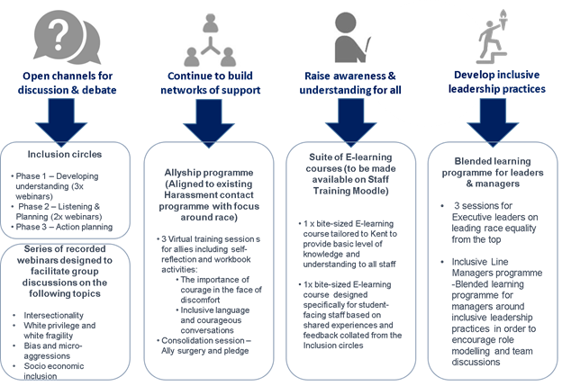
Phase 1 – developing understanding | Webinar 1: The History of Race in the UK  - A condensed history of Black and ethnic minority people in the UK – including some information on the UKs role in enslavement and the British Empire  - A brief history of how and when Black people came to the UK and their experiences and rights  - The effect of Britain’s history on today’s inequality  - Why it is important to understand Black British history
Webinar 2: White privilege – what is it and how does it affect society.
- What is privilege?
- What is white privilege?
- How does white privilege effect white and non-white people?
- What can we do to change the privilege and power structures?
- How to be a white ally

Webinar 3: Let us talk about race
- Understand why talking about race is difficult
- Why we need to talk about race and the impact of silence on Black, Asian, and ethnic minority people
- Discuss what we can all do to encourage and improve conversations around race
- Language and saying the ‘wrong’ thing
- Top tips for starting conversation about race
Number of attendees
 | Kent | LJMU | City | Other | Total
W1 | 112 | 113 | 62 | 26 | 313
W2 | 197 | 150 | 103 | 95 | 545
W3 | 128 | 138 | 90 | 110 | 466
Total | 437 | 401 | 255 | 231 | 1324
 | Total views | Live Views
W1 | 616 | 349
W2 | 441 | 300
W3 | 275 | 221
Total | 1332 | 870

In spring 2021 all members of the Executive Group undertook bespoke anti-racism training and met with the BAME staff network to listen to the experiences, worries and challenges BAME staff have at Kent.
The all-staff Challenging Racism Elearning Module is now also available.
New Challenging Racism webpages were developed to bring together all the work taking place across the Institution to tackle and break down racial inequalities for both staff and students at Kent.
30 Line Managers attended the Inclusive line manager training and completed the eLearning
The Expect Respect all-student module was reviewed and enhanced to include a comprehensive section on (Anti) Racism, Xenophobia and White Privilege and new segments on Bystander Intervention. This will go live in September 2021.
The BAME staff network provided guidance and input into the development and running of BAME inclusion circle discussions where BAME staff shared experiences of belonging and Black Lives Matter, health and wellbeing. The network also provided guidance and feedback on EDI digital online training. In 2020 the network undertook a survey as part of a wider piece of research aiming to understand the culture of the University of Kent, on issues of racial equality. By staff sharing their opinions they are contributing to the knowledge of the University of Kent and helping the BAME Staff Network identify priority issues to focus on and work with the senior management team to achieve improvements within the institution. The network co-chairs also provided vital input and staff research findings to help develop the Antiracism Statement.

Success Story: Antiracism Strategy
As part of Kent’s commitment to effectively challenge and break down systemic racist structures at the University, work was undertaken collaboratively across the Institution to develop an effective and powerful antiracism strategy. This work has been facilitated by Nous, an external consultancy, which has provided a team of experts and a critical external eye. The project was guided by a steering group, chaired by Professor Georgina Randsley de Moura, with representation from Student Services, HR and Communications. The strategy development has been led by a wider reference group that included Kent Union, and academic, professional services (divisions and PSD), and commercial services colleagues.
Key areas that have developed over the course of the project are:
- An active emphasis on antiracism over racial equality – changing this from a ‘Race Equality Strategy’ to a much more proactive ‘Antiracism Strategy’
- Explicit orientation towards continuous action and learning for staff and students – recognising that this is not something we can achieve and finish; rather it is a continually evolving position in a continually evolving national and international picture with a focus on ongoing change
- Emphasis on accountability for change, particularly with the University leadership team
This strategy will enable the University to prioritise the actions needed, to focus on the continual change needed, and to challenge accepted thinking and ways of working in all areas of work. This is essential work to create a more inclusive community.

Success Story: Race Equality Charter
In January 2021 the University of Kent formally registered for the Race Equality Charter which aims to improve the representation, progression and success of minority ethnic staff and students within higher education. The Charter will provide the University with a framework through which institutions work to identify and self-reflect on institutional and cultural barriers standing in the way of minority ethic staff and students. REC is underpinned by five fundamental guiding principles:
  - Racial inequalities are a significant issue within higher education. Racial inequalities are not necessarily overt, isolated incidents. Racism is an everyday facet of UK society and racial inequalities manifest themselves in everyday situations, processes and behaviours.
  - UK higher education cannot reach its full potential unless it can benefit from the talents of the whole population and until individuals from all ethnic backgrounds can benefit equally from the opportunities it affords.
  - In developing solutions to racial inequalities, it is important that they are aimed at achieving long-term institutional culture change, avoiding a deficit model where solutions are aimed at changing the individual.
  - Minority ethnic staff and students are not a homogenous group. People from different ethnic backgrounds have different experiences of and outcomes from/within higher education, and that complexity needs to be considered in analysing data and developing actions.
  - All individuals have multiple identities, and the intersection of those different identities should be considered wherever possible.

Impact, Reflection and Further Challenges
- To implement the Antiracism Strategy plans are prosed to sponsor several staff to attend the StellarHE programme in 2022 and design a deliver a bespoke programme for Kent.
- Work continues with the creation of an eLearning programme for student facing roles.
- The BAME staff network all staff survey report will be published at the beginning of 2022. The network will conduct Phase 2 BAME staff case studies on the lived experiences on the issues of racial equality and staff progression. This will begin in April 2022.
- To recruit the REC Academic Lead and members of the SAT to translate the work required into action and structural change at Kent
Generating faith, confidence and trust in the Institution, particularly from staff and students from minoritised backgrounds, will be a priority area. Trust will need to be built from a fragile base and the actions and commitments taken by the Institution will need to be considered. Proactive, honest and open communications will be crucial to building this trust. Research to unpick the needs and requirements of our communities, particularly those with intersectional identities, will be a complex piece of work but will be necessary to ensure that the University has an in-depth understanding of the needs, requirements, and barriers facing staff and students in a meaningful way.
Understand the EDI impact of Covid-19 on university processes and protected groups
- Create processes to ensure that the impact of Covid-19 and long Covid has been considered
Throughout 2020/21 there was still a great deal of uncertainty with regards to the ongoing impact of the Covid-19 pandemic on working, studying and research patterns at the University of Kent. Stringent efforts were made throughout the year to ensure that staff and students felt safe, supported and well informed with regards to any proposed changes or alterations to work and study patterns and how the University would be interpreting government issued guidance as the pandemic continued to evolve and develop.

What we said we would do
- Identify policies for review, update, and issue to the organisation
- Understand and address the disproportionate impact of Covid-19 on particular cohorts of students.

What we did
- Developed a suite of Coronavirus webpages where key information, support packages and other essential updates would be communicated on a regular basis to our staff and student communities
- Held an HR conference in November 2021 on ‘Remote Working in the age of Covid-19'
- Held vaccination clinics on campus for staff and students
- Provided free FFP2 face masks to staff who require them
- Continued to support students with remote study needs throughout 2020-21
- COPE and Future of WORK: The COPE (Collaborate, Organise, Prepare and Enable) Framework (developed in response to new and unexpected ways of working on account of the pandemic) was reviewed in summer 2021. In preparation for a gradual return to campus, the key content was incorporated into other relevant resources including a range of e-learning modules called The Future of Work, and the University’s guidance on mental health and wellbeing.
- The findings from a separate Future of Work staff survey (carried out in spring 2021) were factored into the planning for the infrastructure and support staff would need for the gradual return to campus.
- Kent collaborated with several other institutions on a wide range of research areas into the ongoing impact and effect of the coronavirus pandemic. This has included:
- Research led by the Tizard Centre into the impact of coronavirus on people with learning disabilities. The research included the impact on access to health and social care services, impact on people with profound and multiple learning difficulties and the impact on carers.
- Research by the University of Kent and the Goethe-University Frankfurt to explore why the SARS-CoV-2 Omicron variant is less effective than Delta at blocking a cellular defence mechanism against viruses. This study helps to understand why the Omicron infections are less likely to cause severe disease.
- Research by the University of Kent, University of Salford, University of Leeds, London School of Economics and Deakin University, Australia into societal attitudes to welfare claimants before and after the pandemic.
- Research by the School of Anthropology and Conservation into the coronavirus timescales
- Research by the School of Psychology and ‘Belong- The Cohesion and Integration Network’ into long term strategies for communities to recover and rebuild after Covid-19
- Research by the School of Psychology into the long-term societal impacts of Covid-19 without public policy overhaul interventions
- Research by the University of Kent, Goethe University in Frankfurt and Philipps University in Marburg into new antiviral drugs for Covid-19
- Research by the School of Social Policy, Sociology and Social Research into the role of voluntary action during the Covid-19 pandemic

Success Story: Papin Prize
Technicians at Kent were awarded the Papin Prize (the UK’s only awards dedicated to celebrating technical excellence and innovation in higher education and research) in November 2021 for their work in producing 4,990 3D printed face shields for frontline care service providers in the Kent region and the NHS. Staff from Kent’s School of Computing, School of Architecture and Planning, School of Engineering, School of Physical Science and School of Biosciences collaborated to design and supply the 3D face shields on site for 11 organisations between April 2020 and July 2020. The 3D face shield went on to successfully receive CE marking after inspection from the UK national standards body, BSI.

Impact, Reflection and Further Challenges
The Future of Work Survey findings will be used to inform the development of the University’s Hybrid Working Scheme, due to be introduced in September 2021 and open to Professional Services staff who work in roles where they are not required to be on campus all the time.

Additional areas of focus 2020-21
Characteristic* | Objective | Staff activity | Student activity
Age | To create an environment that supports staff and students of all ages
Sexual  orientation | Promote a culture of  inclusivity and reaffirm  Kent’s values – our  University is based on  equality, diversity and  respect | - Plan how to use the Lambeth Conference in 2022 as an opportunity to promote the University’s values and ethos  - Promote a programme of events to includes spouses of people attending the Conference
Sex |  | - Review and develop Women into Leadership programme.
Religion |  | - Implement and issue recommendations on the Religion and Belief policy
Gender  reassignment | Provide clear  guidance and support  for those transitioning | - Review current guidance and seek feedback on the impact of the University guidance on transitioning at work.  - Update and issue guidance.
- Only those characteristics where work is being undertaken are listed.

2 Our Staff and Student Profile
The content of this section introduces highlights and key demographics across all protected characteristics for staff and students across the University, providing comparisons from previous data and how we compare against other universities, using benchmarking data from Advance HE. Student data is taken from the 1st December census point

Staff and Student Overview

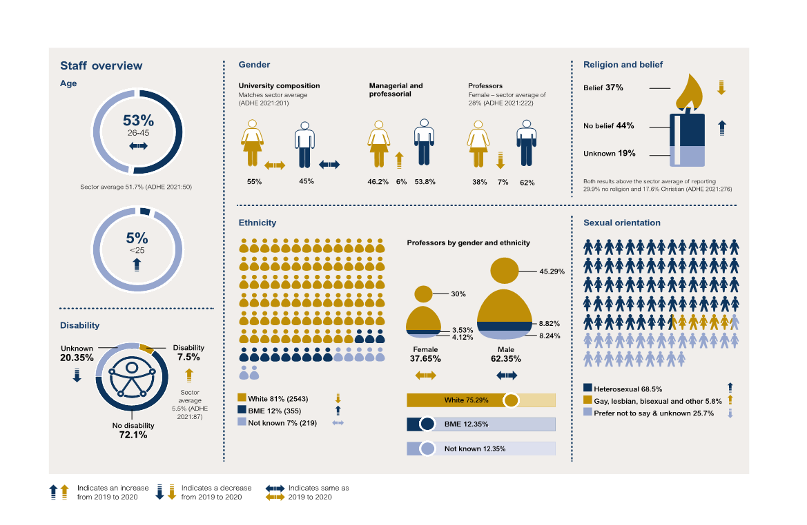

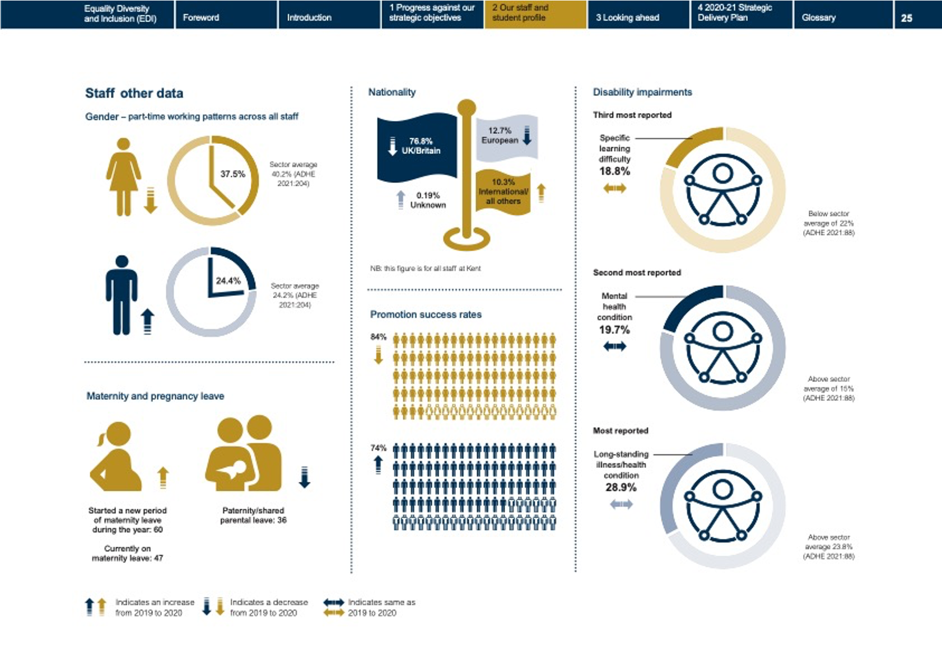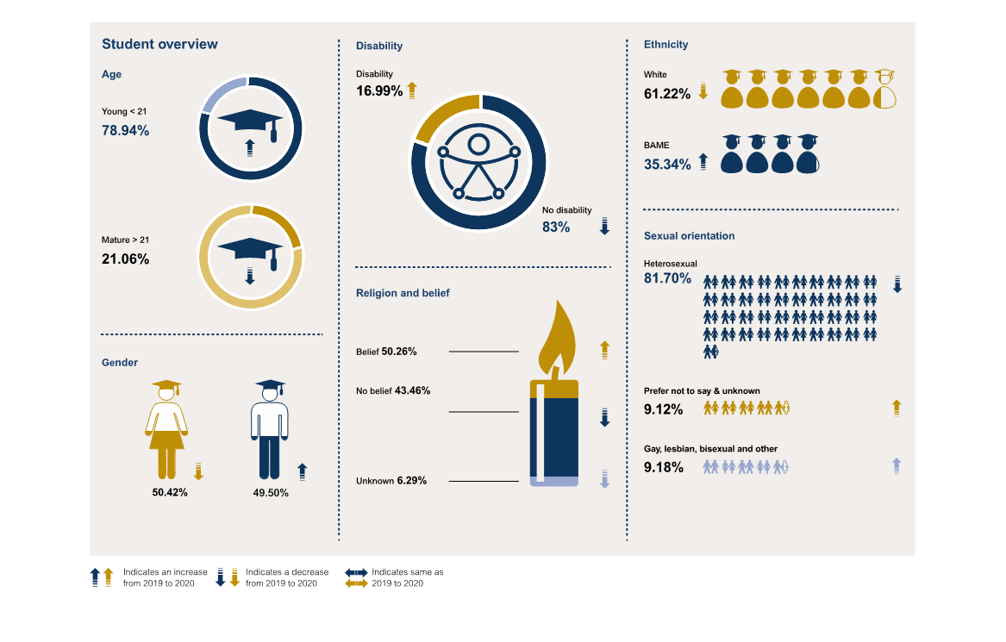

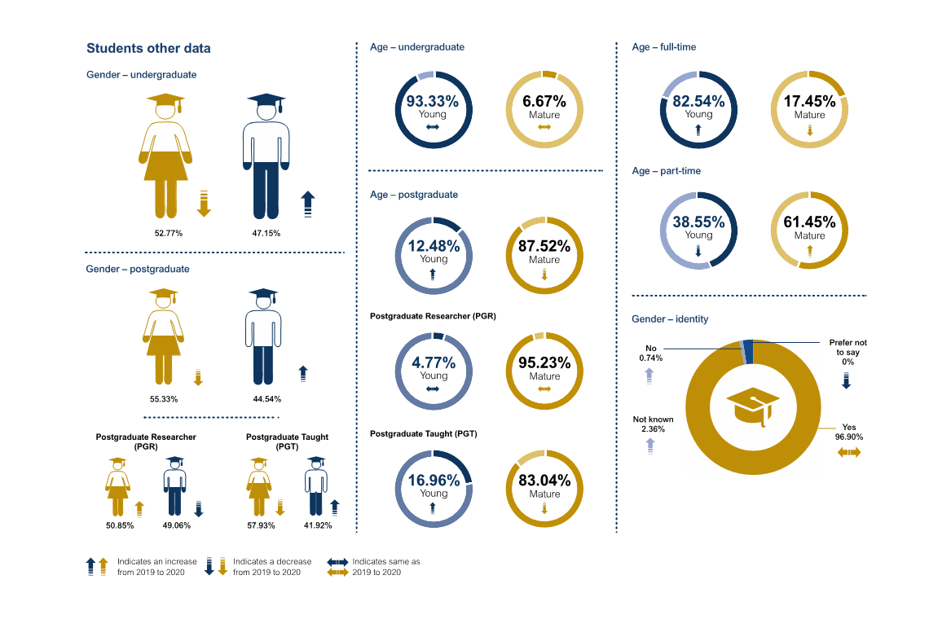

Age Strategic Targets
- The University will relaunch the Part-time, Mature, Students with Caring Responsibilities and Commuting Students Working Group to gain a better understanding of the needs and requirement of these demographics
- The University will relaunch the Menopause Café

Disability Strategic Targets
- The University will register for the Student Minds Mental Health Charter to drive good practice and change across the Institution in relation to both staff and student mental health and wellbeing
- The University will create a long-term communications strategy around the Thriving at Work Standards and ongoing campaigns.
- The University will create a network of trained Mental Health Allies to support colleagues
- The University will create a new suite of Digital Accessibility policies and procedures
- The University will continue to work towards achieving Level 3 Disability Confidence status

Sex Strategic Targets
- The University will establish a new Academic Lead for Athena SWAN and re-establish the Athena SWAN STAT to ensure monitoring and progress of the Athena SWN Strategy and Action Plan
- The University will understand whether current pay and reward procedures have a gendered outcome
- The University will increase the pipeline of leadership-ready women and the proportion of female colleagues in leadership positions
- The University will review the Student Pregnancy and Maternity Policy
- The University will increase the proportion of women securing promotion from senior lecturer to reader
- The University will increase the proportion of applications from women in STEM fields
- The University will review and develop the Women into Leadership programme
- The University will undertake work to better understand the impact of part-time working and / or career breaks

Religion and Belief Strategic Targets
- The University will agree and publish the measures taken to adopt the International Holocaust Remembrance Alliance (IHRA) Working Definition of Antisemitism
- The University will conduct further research into the support required by Black Majority Christian Faith groups.
- The University will review the Religion and Belief policy and accompanying guidelines
- The University will develop Religion and Belief eLearning modules for staff

Ethnicity Strategic Targets
- The University will establish a Race Equality Charter Academic Lead and SAT
- The University will launch the University of Kent Anti-racism strategy and ensure regular monitoring and review processes are in place
- The University will continue the Challenging Racism programme
- The University will launch the Challenging Racism webpages
- The University will sponsor staff to participate in the StellarHE programme in 2022
- The University will develop antiracism training for staff and students
- The University will identify opportunities for postgraduate scholarships for BAME students
- The University will investigate mentoring opportunities for staff and students

Sexual Orientation Strategic Targets
- The University will plan how to ensure the University’s values and ethos are clear in the run up to the Lambeth Conference in 2022

Gender Identity Strategic Targets
- The University will review the Transgender Student Support Policy
- The University will review the current staff guidance and seek feedback on the impact of the University Guidance on Transitioning at Work

3. Looking ahead - Our continued commitment to inclusivity

Strategic Delivery Plan 2021-2022
Pillar | Strategic Activities | Objectives | University Activity | Staff Activity | Student Activity
1 | EDI review – from strong leadership and ownership to a framework for EDI in an ever-changing environment | Increase visibility around our strategic priorities for EDI, maximising engagement at all levels in the University, improve accountability and help to support our aspiration to increase our diversity and foster a culture of inclusivity. | Implement the remaining EDI Governance Structures, including the EDI Operations Group and the EDI Forum  Develop an overarching EDI Strategic Plan that brings together all core EDI related workflows across the Institution in a holistic manner  Create and recruit to a new Head of Equality, Diversity, and Inclusivity role  Embed Equality Impact Assessments into all major project work including the Medway Docking Station  Ensure the ongoing review and adjustment of the Organising for Success Equality Impact Assessment
2 | Lead the way in the development of an environment that is free from harassment | Promote, review, and enhance reporting processes across Kent’s campuses to ensure that staff and students, including students on placement, feel comfortable raising concerns and confident they will be actioned and communicated clearly to those reporting the issue | Create the Discrimination and Harassment Prevention Steering Group  Investigate and invest in an Allyship programme and Network for staff and students  Agree and publish the measures Kent are taking to adopt the International Holocaust Remembrance Alliance (IHRA) Working Definition of Antisemitism | Creation of a Respect Charter by the Inclusive Allies | Launch the Report and Support student reporting tool and communications plan  Review the content and delivery of the Expect Respect module
3 | Provide a supportive and inclusive culture conducive to good health and wellbeing for all staff and students | Review the cultural competency and appropriateness of mental health support | Register for the Student Minds Mental Health Charter: complete an internal self-evaluation  Understand and address the issues to provide a culture of openness with the aim to remove the stigma around mental health  Embed EDI features in the new digital mentoring platform Aluminate  Establish Divisional Directors of EDI within each Division and develop appropriate support and representation structures | Create a long-term communication strategy around the Thriving at Work standards and ongoing campaigns  Launch the Mental Health Allies  Develop and enhance the suite of mandatory EDI training for staff members | Review and relaunch the Respect at Kent policy
4 | Identify and remove barriers in relation to all forms of accessibility | Mainstream accessibility by supporting a shift in culture from individual adjustments towards anticipatory reasonable adjustments | Launch a new University of Kent Digital Accessibility Policy  Launch a new University of Kent Digital Accessibility of Thesis Policy | Continue work towards achieving Level 3 Disability Confident Leader status
5 | Continue to raise our profile as an employer and education provider through accreditation and investment in key strategic projects | Address the sector-wide and institutional factors / barriers that trigger lower rates of attainment, continuation, and progression amongst students from low socio-economic groups, those with disabilities and students from black and minority ethnic (BAME) groups.  Improve our capacity to progress our Athena SWAN agenda and support for schools | Establish the Race Equality Charter Academic Lead and Self-Assessment Team  Establish a new Academic Lead for Athena SWAN  Re-establish the Athena SWAN STAT to ensure monitoring and progress of the Athena SWAN Strategy and Action Plan | Submit the Inclusive Employers application
6 | Understand and interrupt structural racism within the HE environment | Require senior leaders to drive, and be accountable for, antiracism across the University  Listen to, and act on, the lived experiences of racially minoritised staff and students  Dismantle barriers to racially minoritised students’ success and belonging  Decolonise University teaching, research, and partnerships  Dismantle barriers to racially minoritised staff success and belonging  Embed antiracist behaviours and practices among the University community  Advocate for antiracism locally, nationally, and globally  Provide resources to relevant staff and student networks to support collaborative working with the University to understand and address issues. | Launch the University of Kent Antiracism Strategy and ensure regular monitoring and review processes are in place  Create the Discrimination and Harassment Prevention Steering Group  Create and launch the Challenging Racism webpages  Define and communicate what decolonisation means in the Kent context and how to translate this into effective action across teaching, research, and partnerships  Define and communicate what racially minoritised means in the Kent context  Introduce a student-staff reverse mentoring scheme for staff to better understand experiences of racially minoritised students  Develop a research community on intersectional research justice and use Kent’s Public Engagement Officers to increase the impact of this work with the local and wider community  Publish decolonising work by staff across the university.  Use Kent’s Graduate Journal as a vehicle to share research of the Student Success team to advance antiracist higher education nationally and internationally.  Understand the impact of intersectional identities on feelings of belonging and community at Kent | Report data on and reduce the ethnicity pay gap.  Review staff contracts across the institution which are held disproportionately by racially minoritised staff  Sponsor staff to attend the StellarHE programme in 2022  Develop compulsory antiracism training for all staff, prioritising those in student-facing roles  Ensure inclusive recruitment, selection, progression, and promotion practices that do not exclude racially minoritised staff, including for temporary positions.  Provide leadership development opportunities and mentoring for racially minoritised staff.  Develop clear professional services pathways to create fairer opportunities for promotion for racially minoritised staff.  Build antiracism elements into the Leadership Behaviours Framework and in the implementation of Academic Career Map | Make better use of the rich data collected about the student experience through existing surveys and through the work of the Student Success team to understand racially minoritised students’ experience at Kent  Create a Challenging Racism e-Learning module for student facing roles  Review the effectiveness of Postgraduate Support Scholarships to support progression among racially minoritised students and identify further scholarship opportunities.  Develop a mentoring scheme for racially minoritised students  Establish a rolling University-wide programme to decolonise the curriculum in collaboration with Kent Union  Roll out regular compulsory antiracism training for students  Enhance the role of our students and graduates as advocates for antiracism through volunteering, employment and enterprise opportunities and developing antiracist graduate attributes through a decolonised curriculum.
6 | Understand the EDI impact of Covid-19 on university processes and protected groups |  | Review the EIA (Equality Impact Assessment) for online learning and teaching

Additional strategic objectives 2021/22
*Only those characteristics where work is being undertaken outside of strategic projects are listed
Protected Characteristic | Objective | Activity
Sexual orientation |  | Plan how to use the Lambeth Conference in 2022 as an opportunity to promote the University’s values and ethos  Promote a programme of events to include spouses of people attending the Conference
Sex | Improve career development support for researchers and increase the proportion of female lecturers  Increase the proportion of women securing promotion from senior lecturer to reader  Increase the proportion of applications from women in STEM fields  Better understand the impact of part-time working and/or career breaks  Understand whether current pay and reward procedures have a gendered outcome  Increase the pipeline of leadership-ready women and the proportion of female Heads of School | Review and develop Women into Leadership programme
Religion / Belief |  | Embed training and understanding for staff on the new definitions of antisemitism as agreed by the University  Complete a review of the impact and support needed by the Black Majority Christian faith groups on campus  Review the Religion and Belief policy and accompanying guidance  Develop Religion and Belief eLearning
Ethnicity
Disability
Marriage / Civil Partnership
Pregnancy and Maternity |  | Review the Student Pregnancy and Maternity Policy considering changes triggered by Organising for Success
Gender Reassignment |  | Review the Transgender Student Support Policy considering changes triggered by Organising for Success  Review the current staff guidance and seek feedback on the impact of the University guidance on transitioning at work
Age |  | Relaunch the Menopause Café for staff  Relaunch the Part-Time, Mature, Students with Caring Responsibilities and Commuting Students Working Group

https://www.equalityhumanrights.com/en/publication-download/turning-tables-ending-sexual-harassment-work
https://www.equalityhumanrights.com/en/publication-download/tackling-racial-harassment-universities-challenged
Link to the EHRC technical guidance on sexual harassment
Link to the EHRC report on sexual harassment in the workplace
https://www.advance-he.ac.uk/knowledge-hub/equality-higher-education-statistical-report-2020 https://www.kent.gov.uk/about-the-council/information-and-data/facts-and-figures-about-Kent/area-profiles

