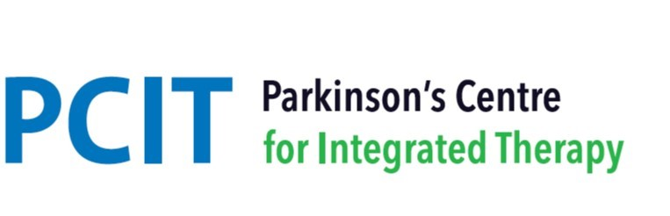
PCIT - Interim timetable of therapies – Autumn & Winter 2023/2024 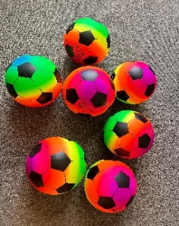
Day | Session | Therapist(s)
Monday | 1-1 Occupational Therapy - AM | Katie (OT)
 | “Arty Crafter Shakers” session - midday | Katie (OT), Sarah (PT), Francis – Pathway Champion
 | Seated Neuro-Circuit class - PM | Katie (OT), Sarah (PT)
Tuesday | Sports massage - PM | Kyra and team
 | (limited slots Oct/Nov)
 | Skylarks singing group – PM (fortnightly)
Wednesday | Speech & Language Therapy
 | re-launch – start date coming soon
Thursday | Physiotherapy assessments and follow-ups – all day | Sarah and Helen (Neuro-physiotherapists)
 | Physio-based exercise class - am | Sarah Helen
(From Thurs 7th Dec) | Zumba Gold – 6pm | Melanie
Friday | Qigong classes and Amma Massage slots | Geoff – Massage and Movements Therapist
Saturday  (From Sat 9th Dec) | Seated Dance – 10am | Melanie
New member assessments take place Tuesday - Friday

Amma Massage and Qigong – coming soon!

