University of Kent
WE STAND FOR AMBITION.

Sustainable Food Plan
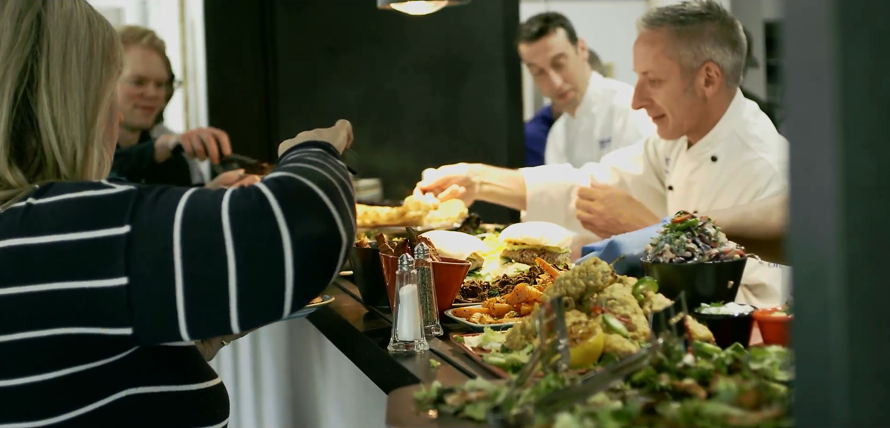
2023-25

About the Sustainable Food Plan

Purpose
The University of Kent Sustainable Food Plan sets out a roadmap to ensure that the food served on campus supports health, well-being and environmental sustainability.
This document is primarily intended for use by the catering, trading and procurement teams at the University of Kent. It builds upon, brings together and rationalises in to one document the missions and objectives related to the sustainability and affordability of food served on the University of Kent campuses and the expectation of our stakeholders currently set out in:

- The previous Sustainable Food Action Plan 2022
- The University of Kent Catering Strategy
- The Right to Food University missions
- The Kent Food Partnership action plan for catering and procurement
- The University of Kent’s progress towards SDGs 2 (Zero Hunger), 3 (Good Health and Wellbeing), 10 (Reduced Inequality), 12 (Responsible Consumption and Production) and 13 (Climate Action).

Scope
This plan covers all food outlets and internal catering operated by the University of Kent. This includes internal catering for conferences and events. Catering outlets operated by Kent Union, external companies and vending machines are excluded although sustainability requirements will be incorporated into leases, tenders and agreements where possible and appropriate.

Who is it for?
The Sustainable Food Plan aims to support:
- The health and wellbeing of staff and students by providing access to healthy, tasty and affordable food.
- Fairness and security for producers and suppliers through our procurement frameworks.
- Other regional and national HE institutions as well as schools and colleges, by sharing best practice on sustainable food through the Kent Food Partnership.

Monitoring and Reporting
This document sits within the wider University of Kent Right to Food action plan. Updates and progress against targets are reviewed quarterly by the Sustainable Food Action Steering group (SFASG).
Members of the group:
- Sustainability Manager, Sustainability Team
- Food and Beverage Manager, Gulbenkian Cafe
- Sustainability Coordinator, Sustainability Team
- Category Manager and Data Analyst, Procurement Department
- Marketing and Communications Coordinator, Commercial Services and Estates
- Right to Food Project Coordinator, Food Foundation
- Catering Operations Manager, Commercial Services and Estates
Where objectives within this plan overlap with other operational teams of the University, they will be asked to provide written updates on progress against these objectives at the quarterly meetings e.g. updates from staff with oversight of waste operations.
Progress against objectives will be reported to the Right to Food Steering Group and the Sustainability Steering Group to ensure strategic oversight and high-level commitment. The operational impact of our catering provision and the targets found within this document are also reported into the University’s Environmental Management System (EMS).
The Sustainable Food Steering group will also publish an annual update on progress against this action plan that will be publicly available.
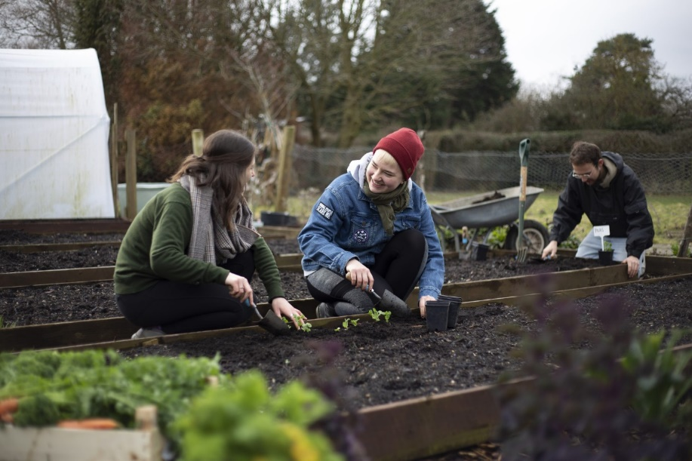
This plan will be reviewed annually and is subject to review to reflect the emerging catering strategy.
Priority Objectives

Objective 1: Guarantee the affordability and availability of healthy and sustainable food.
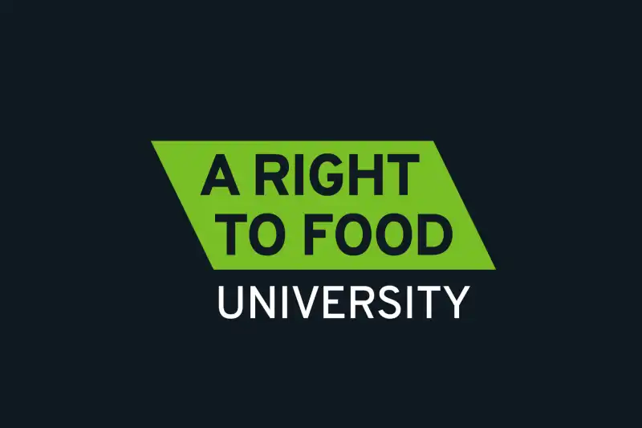
As a Right to Food University, we believe that everyone has the right to healthy and affordable food and that being able to eat regular, fresh and nutritious meals each day is fundamental to our health and wellbeing. To support this we will continue to offer a cost of living subsidised meal to students and staff, guarantee price parity or better on vegetarian and vegan meals compared to meat options and offer a price competitive cold lunch meal deal. We will proactively highlight all cost-saving promotions to ensure they are obvious and accessible to all.

Objective 2: Adopt a plant-forward approach.
As a university we are committed to a transition towards plant-based diets. As well as increasing the number of plant-based options on campus we will be working to reduce the amount of meat within dishes, promoting veg and pulses, and running plant-forward education and marketing campaigns, offering incentive schemes such a loyalty cards for choosing plant-based options and ensuring availability of plant-based milks, moving away from dairy by default.

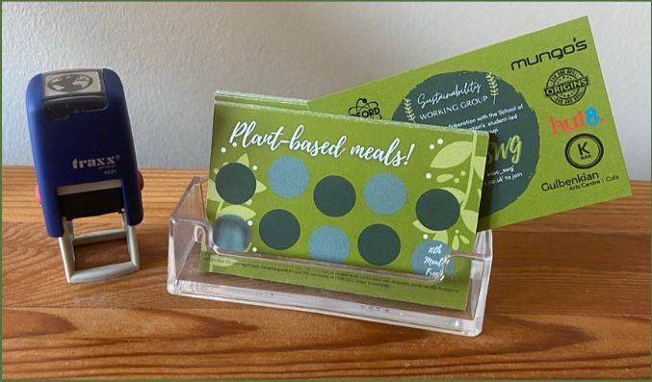

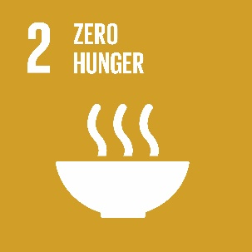
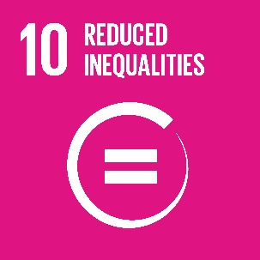
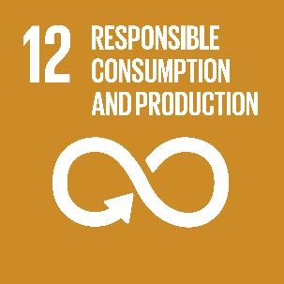

Objective 3: Reduce food waste.
Our catering teams will work in collaboration with our waste and recycling team to minimise food waste from our catering outlets and student accommodation. As well as expanding our food waste collections from catering outlets into student accommodation and trialing on site composting options we will ensure our internal production and distribution of food is responsive and efficient to minimise food waste at source. We will also explore reducing food waste across the region, working with local partners to support projects such as Gleaning and other food redistribution projects.

Objective 4: Support sustainability and local business through procurement.
We are committed to supporting sustainability and local businesses through our procurement and tenders by creating bespoke sustainability criteria and questions when tendering and choosing suppliers and ensuring access to local suppliers and SMEs. We will also ensure that the requirements of this plan as well as our minimum standards for fresh products such as meat, fish and vegetables are included so that we can ensure that our suppliers meet our expectations.

Objective 5: Connect people to food
We will create a culture around food and showcase the food produced by the region through our outlets, advertising, communications and use of local products as well as taking further opportunities to celebrate Kentish produce though events such as food markets and ‘meet the producer events’. In addition to this we will address food inequality in the region through exploring how local food entrepreneurs and food charities can use our kitchen spaces.

Objective 6: Communicate and celebrate success.
We will improve our communications both internally and externally to share best practice. We will ensure that our reporting and governance structures are effective in tracking progress and ensuring that our objectives are embedded across the University. We will Improve the Information we communicate about our menus, the provenance of our food and our sustainability successes and ensure we share our knowledge and best practice through developing partnerships across the region and through applying for awards to drive further improvements.

Action Plan and Indicators
Objective | No. | Actions | Indicator Level/Reporting
Guarantee affordability and availability of healthy and sustainable options at our outlets. | 1a | Guarantee a lower price or price parity of vegetarian / vegan meals compared to meat options | Annual menu review with progress and case studies shared through comms channels.  Audited through the EMS
 | 1b | Offer up to 2 portions of veg with every meal at Rutherford | Audited through the EMS
 | 1c | Offer a price competitive (within 10% of on-site competitor option) lunch meal deal with sandwiches handmade on site and sustainable packaging. Fruit based snack available as part of meal deal in all participating outlets. | Annual review with progress shared through comms channels.  Audited through the EMS
 | 1d | Continue to offer a cost-of-living subsidised meal to students and staff (term-time only), ensuring that these are equal in nutritional content to other menu options. | No. meals per term
 | 1e | Monitor the amount of processed meat e.g. burgers, sausages bought and set a target to reduce this. | Annual sales data
Adopt a plant-forward approach, promoting veg and pulses over meat. | 2a | Increase veg / pulse to meat ratio on our menus ensuring that a 1/3 of all main meals offered across our outlets are plant-based or customisable to be plant-based. | Annual menu review  Audited through the EMS
 | 2b | Monitor sales of meat-based meals separating out ruminant, chicken & fish creating a baseline. | Baseline sales data quarterly
 | 2c | Monitor the proportion of meat-based protein that goes into on site prepared meals | % recorded annually
 | 2d | Inform customers of availability of plant-based milks within outlets (move away from dairy by default) and review which milks we offer and pricing based on environmental impact. | Statement of what is on offer  Audited through the EMS (observed)
 | 2e | Continue, ensuring availability of cards, the loyalty card scheme that rewards customers for choosing plant based main meals. | Number of free meals redeemed  Audited through the EMS (observed)
 | 2f | Source less but better meat and dairy  - Minimum Red Tractor standard for fresh meat  - MSC Certified Sustainable Seafood  - ASC Certified farmed fish  - No purchasing of fish/shellfish on the red list  - Free range fresh eggs  - Ethically sourced Coffee, suppliers able to demonstrate transparency within supply chains | Audited through the EMS
Reduce food waste across our campuses | 3a | Ensure responsive and efficient procurement by centralising production and distribution of products, such as sandwiches and internal catering, in order to reduce food wastage in the production of meals on campus. | Food waste data provided by contractor to baseline first year of new operation
 | 3b | Segregate our food waste in outlets, monitoring our volumes sent to anaerobic digestion. | Data (aggregated or by outlet) provided by contractor
 | 3c | Trial food waste segregation in selected student accommodation with the ambition to implement a staged roll out pending review of trial. | Trial outcomes reported
 | 3d | Trial sending food waste from an on-campus source to the KentCOG Rocket composter. | Trial outcomes reported
 | 3e | Support the Gleaning Project and Kent COG by offering storage space and capacity for redistributing produce. | kg gleaning produce collected  kg KentCOG produce used on campus
 | 3f | Continue to offer free cooking masterclasses in our outlets to support food education | No. events/ term  No. students or staff reached/term
 | 3g | Redistribute surplus produce from the Gulbenkian and Grab and Go, through the Too Good to Go App and incorporate surpluses from other outlets | Transactions recorded
 | 3h | Highlight/promote how food packaging can be disposed of correctly e.g. packaging design of internally produced sandwiches. | Promotional materials/packaging design has been rolled out.
Supporting sustainability and local businesses through our procurement and tenders | 4a | Create bespoke sustainability criteria and questions when tendering and choosing suppliers to work with on our catering provisions and products. We will ensure that zero tolerance to modern slavery is always a requirement. | Audited through the EMS
 | 4b | Where the opportunities arise, we will invite students to be part of the tendering process to give their opinions on which companies/products they prefer. | No. Meet the supplier events  No. Students reached  Summary of environmental and social sustainability information was shared – reviewed by the SFASG
 | 4c | Identify and communicate how many of our suppliers are local, SMEs, B-Corps and/or Cooperative registered and monitor this figure annually. | Data provided by the Procurement Team.
 | 4d | Increase the access of lots to local SMEs of food/produce tenders and non-food consumables | Audited through the EMS
 | 4e | Create minimum standards for fresh products e.g. meat, dairy, vegetables so that our suppliers and external contracts meet our expectations. | Audited through the EMS
Connect people to food by bringing local food producers and consumers together and creating a culture around food at Kent | 5a | Map local Kentish suppliers and processing units that we purchase from | Establish baseline and set target to increase
 | 5b | Promote local produce and food offering to clients for internal and external events as well as conferencing menus. Enhance the information available on the conferencing website about sustainable food. | Review of the Internal catering menu and conferencing offering on website  Monitor uptake
 | 5c | Utilise suitable kitchens on site as a community kitchen for local food entrepreneurs | Track usage per year.
 | 5d | Offer kitchen space for local food charities to use | Track usage per year.
 | 5e | Source 50% of fresh herbs from university land growing space | % tracked
Improve our communications internally and externally to share best practice | 6a | Improve the sustainability/provenance information about our menus and dishes, utilising all existing coms platforms and POS opportunities. | Audited through the EMS
 | 6b | Apply for Awards that support monitoring and sharing our progress. | TUCO Sustainability Award 2024  Green Gown Awards 2024
 | 6c | Share best practice with Kent Food Partnership at quarterly steering group meetings. | Quarterly update within meetings
 | 6d | Produce a public annual report that showcases our progress to students and staff. | Audited through the EMS
 | 6e | Actively highlight through comms and PoS advertising, cost saving promotions available within each outlet so they are obvious and accessible. | Annual review of comms shared  Audited through the EMS
 | 6f | Design and seek out partnerships to support the delivery of a plant based and plant forward marketing campaign across our outlets. | Social media reach  Sales data annually  Customer feedback
 | 6g | Investigate carbon labelling options for our menus/dishes. | Review options at annual review.

kent.ac.uk

