Some Kind of Calm:
the music of Ólafur Arnalds

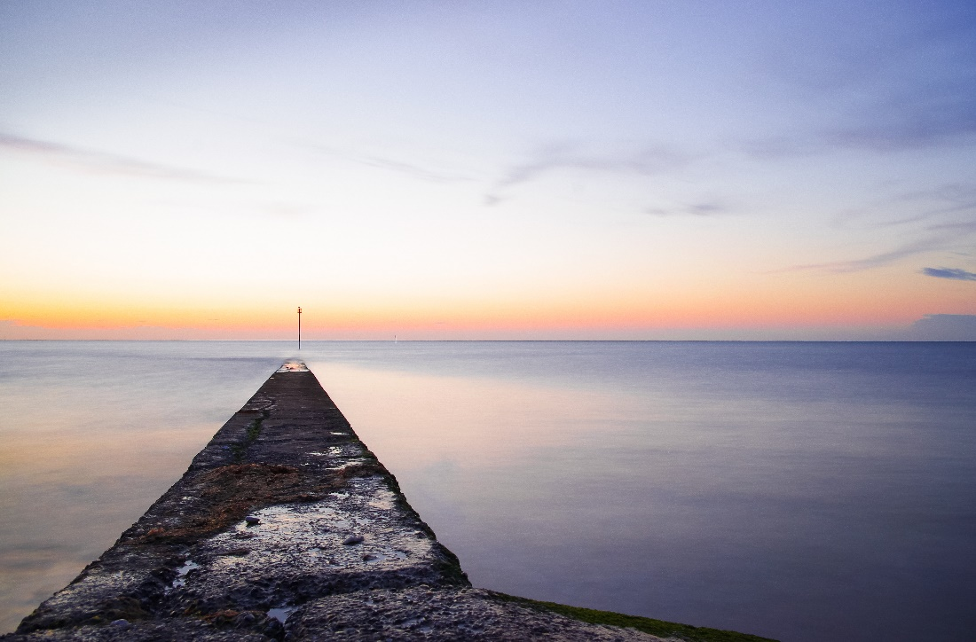

Featuring landscape photography by Molly Hollman

University Music Scholars and Award Holders
Dan Harding piano

Wednesday 27 March, 1.10pm
Colyer-Fergusson Hall

Programme

This Place is a Shelter | from Living Room Songs
Beth’s Theme | from Broadchurch
Film Credits | from Living Room Songs
Fyrsta  (First) | from Living Room Songs
Lag fyrir ömmu  (Song for Grandma) | from Living Room Songs
Near Light | from Living Room Songs
Only the Winds | from For Now I Am Winter
Loftið verður skyndilega kalt  (Suddenly the air grows cold) | from …And They Have Escaped the weight of Darkness
For Now I Am Winter | from For Now I Am Winter
Þú Ert Jörðin  (You are the earth) | from …And They Have Escaped the weight of Darkness

Composer, producer, multi-instrumentalist and winner of a BAFTA award for music to the ITV series Broadchurch; the music of the prolifically versatile Ólafur Arnalds captures the fragile, desolate yet beautiful landscapes of his native Iceland. This sequence of music explores chamber arrangements, some made by the composer himself, of some of the music from albums including For Now I Am Winter, Living Room Songs, and ‘Beth’s Theme’ from Broadchurch.
The contrast between the fragile, repeating patterns in the piano and the sustained warmth of the slow-moving string instruments evokes a haunting melancholy. Arnalds’ music is profoundly influenced by his homeland, particularly in his 2016 Island Songs project, in which he travelled to seven different locations over seven weeks, collaborating with seven different artists, releasing a new piece each week.
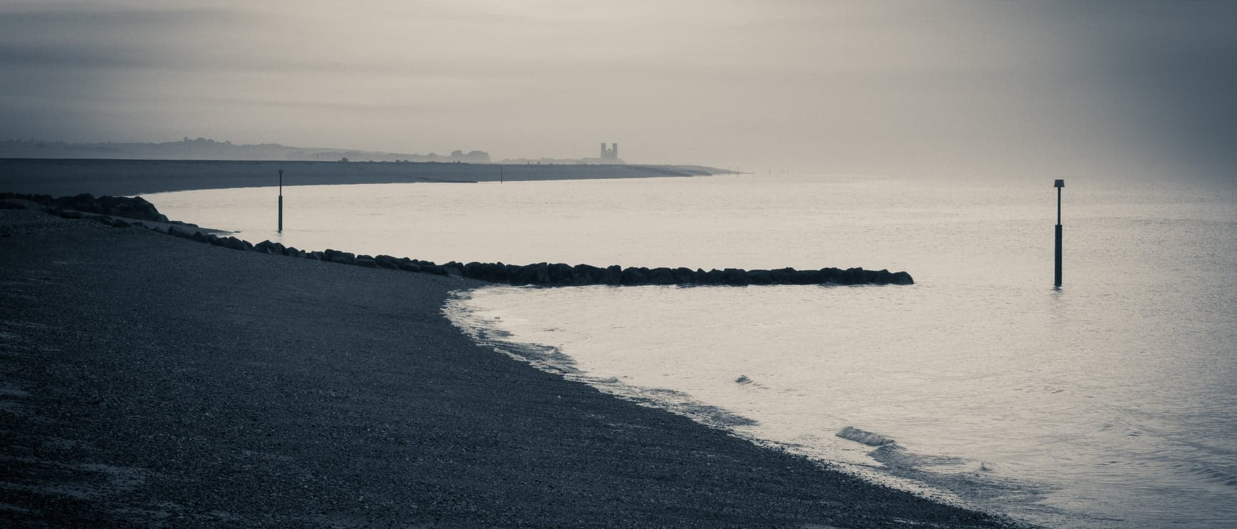
Today’s performance combines Arnalds’ exquisite and meditative music with landscape photography; an exploration of beautiful images that capture wide spaces and endless skies, rugged landscapes and tranquil seascapes, by the award-winning Kent-based photographer and musician, Molly Hollman.
Kammy Pike violin
David Glover violin
Jack Chan viola
Seb Abbott cello
Dan Harding piano

Discover more of Molly’s photography at https://mollyhollman.myportfolio.com/

