Timetable policy

Academic year 2024/2025

Contents

1. Timetable policy
   1. Purpose and scope
   2. Guiding principles

1. Implementation of policy
   1. General timetabling principles
   2. Summary of responsibilities
   3. Draft teaching timetable
   4. Teaching timetable maintenance
   5. Standard time slots
   6. Timetable publication
   7. Timetable data
   8. Non-teaching bookings
   9. University rooms
   10. Exams timetable

1. Additional information
   1. Glossary
   2. Room zones
   3. Timeline and summary of responsibilities
   4. Useful links

# 1Timetable policy

## 1.1 Purpose and scope

The purpose of this document is to:

* provide the framework of designing and implementing the teaching timetable at the University of Kent
* provide an overview of designing and implementing the exams timetable at the University of Kent
* ensure equity between Divisions and other departments and consistency of practice across all campuses
* outline the relevant functions and responsibilities of the Timetabling Office and other staff and students at the University with regards to the above.

[Staff room booking procedures](https://livekentac.sharepoint.com/sites/Timetabling/SitePages/Room-bookings.aspx)are not included in this document.

## 1.2 Guiding principles

### 1.2.1 Guiding principles of the teaching timetable

The University’s principal timetabling aims are to:

* support students in their taught activities by providing, to the best of our ability, a clash-free timetable and support staff to deliver teaching by providing a “best fit for all” timetable each year, balancing competing demands as much as possible
* optimise the use of the University’s teaching spaces
* support other functions of the University by providing accurate data
* optimise staff resources in the development, drafting and maintenance of the timetable.

CMIS, the University of Kent’s timetabling system, is deemed to be the primary and most up to date record of the timetable, which can be viewed by staff on the Online Timetable Information System (OTIS). For students, KentVision should be seen as the source of truth.

1.2.2 Guiding principles of the exams timetable

The University’s aims are:

* produce an exams timetable that spreads student exams across the designated exams period, taking into account key deadlines (such as final year marking return deadlines) where possible
* produce an exams timetable that adheres to the exam timetable principles (see 2.10) and constraints (such as space and number of Inclusive Learning Plan students)

# 2Implementation of policy

2.1 General teaching timetabling principles

## 2.1.1 The teaching year

The University operates through the year with teaching usually taking place within regular term times as advertised on the [university term time webpage](https://www.kent.ac.uk/student-administration/university-term-and-closure-dates). Exceptions to this will be advertised within course and module literature.

Weeks are numbered in accordance with the numbering system on KentVision, and as advertised on the [term weeks webpage.](https://www.kent.ac.uk/timetabling/term%20dates/termdates.html?tab=201516) Timetables in all published formats will use this system.

## 2.1.2 The teaching day

The teaching day is defined in the [student charter:](https://www.kent.ac.uk/guides/student-charter)

Normal teaching hours are 09.00 to 18.00 on Monday, Tuesday, Thursday and Friday plus 09.00 to 13.00 on Wednesday (except where courses are specifically advertised as including or being provided by evening or weekend delivery).

Teaching will not normally take place outside normal teaching hours as defined above, unless exceptionally:

1. it is necessary to timetable an event on a Wednesday afternoon (where no other timetabled slot and a venue are available). The Timetabling Office will liaise with Divisions in such instances
2. one off changes need to be accommodated (arising, for example, from illness or other unavoidable commitment of the member of staff), by agreement between the member of staff and the students concerned
3. where changes need to be made on a permanent basis. This will require the written permission of the relevant Director of Education and Student Experience/Director of Graduate Studies,
4. where a course has been specifically designed to be taught outside of these specified standard hours.

The Timetabling Office will make every effort to ensure compliance with these requirements.

Teaching times run from the hour to ten minutes to the hour to allow for smooth change over between classes.

## 2.1.3 Availability to teach

All full time staff are regarded as being available to teach throughout the regular teaching weeks and regular teaching day except where the Timetabling Office has been notified of a constraint at the appropriate time in the annual timetable planning process. Part time staff are regarded likewise, but within their contracted hours. Teaching constraints are governed by the University’s [teaching constraints policy](https://www.kent.ac.uk/governance/policies-and-procedures/documents/Teaching%20Constraints%20Policy.pdf) (approved by Senate, 2019).

Flexible working requests can be submitted in accordance with the University’s [Flexible Working Policy](https://livekentac.sharepoint.com/sites/HR/SitePages/Flexible-Working.aspx)[.](https://www.kent.ac.uk/hr-staffinformation/documents/policies/family-friendly/flexible/Our%20People%20Practies%20-%20Flexible%20Working%20-%20Policy%20and%20Procedure%20January%202017.pdf) Approved requests must be submitted to the Timetabling Office no later than **6 weeks before the start of the academic year**; it may not be possible to accommodate agreements submitted after this date. Programme Administration Manager (or their nominee) should keep a record of approved requests and update the Timetabling Office at the appropriate time in the annual cycle.

The timetabling database will hold the definitive record of all approved staff constraints. Any constraints not recorded within the timetable at the appropriate time in the planning cycle cannot be considered for exemption from teaching duties. Teaching staff are required to check, via OTIS, that their constraints have been recorded correctly at the appropriate time in the timetabling cycle.

## 2.1.4 Timetable clashes

The Timetabling Office can check for timetable clashes where at least one event involves a compulsory module but with the following conditions:

* where one or more event is being changed as part of routine timetable updates. Wholesale checks based on module diets are not possible due to the number of module combinations and exceptions
* the Timetabling Office will provide student clash check reports at appropriate times of the year once students are registered on modules
* Programme Administration teams are responsible for actioning the student clash check reports, as driven by local policies, such as requesting students change modules, or change group allocations.

Clash checking for optional modules, including quasi-compulsory modules, is not possible due to the volume of potential combinations.

Any clashes which cannot be clash checked automatically should be monitored by Programme Administration teams using local knowledge. They should work with the Timetabling Office on how best to do this with the resources available.

The timetable will not be changed to accommodate elective module choices.

## 2.1.5 Equality and diversity

The Timetabling Office, where possible, will make relevant adjustments to provide suitable central room allocations for all staff and students requiring accessible rooms or rooms with audio enhancement. Students should inform Student Support and Wellbeing and teaching staff should inform their Programme Administration timetabling administrator.

## 2.1.6 Room allocations

Central rooms allocated to teaching will be allocated using the below principles. The Timetabling Office will endeavour to meet as many principles as possible for each event but due to the variety of demands it may not be possible to satisfy all.

* **Suitable capacity**: rooms will ordinarily be between 50-100% of class size. In exceptional circumstances rooms may be allocated outside this guideline.
* **Proximity of room to the owner of the event**: zones will be used where possible and where other principles are not violated to reduce travel time for staff and students during the appropriate phase in timetable planning.[1]
* **Accessibility requirements of staff and students**: accessible rooms and rooms equipped with hearing enhancement equipment will be allocated where the Timetabling Office has been notified of such a requirement
* Equipment requirements must be submitted in the Block 2 and will be accommodated wherever possible
* **Room layout**: wherever possible, lectures will be allocated to lecture theatres or classrooms, seminars to seminar rooms, PC classes to PC rooms; other types of event will be allocated on the principles above. Specific room layouts must be submitted in the Block 2 and will be accommodated wherever possible
* Priority will be given to classes that occupy the same slot throughout the term.

Owners of private rooms are responsible for their rooms. This includes the allocation of teaching (as submitted on the Block 2), ensuring classes are of the appropriate size, that slots are clash free and usage is optimised on a par with central rooms of a similar nature.

Rooms may be changed without notice during the draft phases of the timetable. Programme Administration timetabling administrators will be informed when rooms have been confirmed for the appropriate term and any room changes after this date will be notified to the Programme Administration timetabling administrator.

2.2 Summary of responsibilities[2]

## The Timetabling Office

1. constructs and maintain the teaching timetables for Canterbury and Medway campuses
2. facilitates the timetabling of other University centres
3. facilitates the publication of timetables
4. advise on strategic provision of quantity, capacity and layout of teaching spaces on all campuses as identified through demand
5. upholds equality and diversity principles by allocating accessible or suitably equipped rooms where staff and students’ requirements have been provided, where possible
6. provides support to staff on timetabling matters
7. provides an equitable service across all non-teaching functions of the University
8. management of timetabling data and the timetable database
9. provides data for appropriate, agreed reports for Programme Administration staff (reports are provided by IS’ Data Integration team)
10. constructs the main and resit exams timetables for Medway and Canterbury.

Divisional responsibilities

## 2.2.2Directors of Education & Student Experience and Graduate Studies or nominee

1. approve or decline late changes to staff availability and teaching constraints
2. approve or decline teaching outside the regular teaching day where required under the conditions of the student charter DVC ESE
3. ensure the module offer within the Division can be timetabled at course level
4. arbitrate and resolve Divisional timetabling related challenges (ie if there is demand for the same resource).

## Heads of School/department or nominee

1. ensure teaching staff submit timetable information at the appropriate time during the timetable production cycle
2. uphold fairness to students in terms of timetable scheduling and changes
3. ensure that Module Convenors comply with the responsibilities outlined in 2.2.6
4. arbitrate and resolve Divisional timetabling related challenges
5. ensure staff clashes are minimised by adhering to deadlines for changes to teaching allocation and constraints.

## 2.2.4Programme Administration Managers

1. uphold fairness to students in terms of timetable scheduling and changes
2. facilitate the resolution of Divisional timetabling related challenges

## 2.2.5Programme Administration timetable administrators

Designated Programme Administration timetabling administrators will provide the key operational link between the Timetabling Office and teaching staff to:

1. provide information to, as requested by, the Timetabling Office at the appropriate times during the draft timetable production cycle
2. work with the appropriate academic leads and the Timetabling Office to identify reasonable optional module pathways for students and viability of compulsory module pathways
3. inform the Timetabling Office of any changes requested to the live and draft timetables, including the justification for change
4. inform students of late timetable changes (ie changes within one week) via email and undertake any necessary work to ensure the events are visible to students
5. undertake any additional work which enhances the students’ experience of the timetabling function
6. uphold the principles for changes to the current timetable as outlined in this policy, escalating to the Programme Administration Manager where required.

## 2.2.6Module convenors

1. ensure that current timetable information is comprehensive, accurate and up to date including day, time, location, module, groups, essential equipment or specialist room and teaching staff are accurately recorded
2. ensure that draft timetable information is comprehensive, accurate and up to date. This information must be submitted in the Block 2 in time for the relevant deadline and as required by both the Programme Administration timetabling administrator and the Timetabling Office
3. ensure that the module specification of delivered content matches the timetable at the point of Block 2 submission and following any subsequent changes. Inform the Programme Administration timetabling administrator of any queries at the appropriate time
4. ensure all approved constrained hours for teaching staff on the module can accommodate the delivery of the module. Work with teaching staff, the Timetabling Office and the Programme Administration timetabling administrator to find resolutions
5. ensure that contact hours are recorded and delivered as advertised in the module specification
6. provide full information to Programme Administration timetabling administrators in time for the exams timetable deadlines.

## 2.2.7All teaching staff

1. adhere to the conditions of room use as outlined in section 2.9
2. ensure that the timetable is an accurate record of what teaching is delivered by the member of staff through the draft timetable production process and as published to students
3. raise any logistical concerns for example adjacent events over different campuses with the Programme Administration timetabling administrators at the appropriate time
4. be available to teach through the standard teaching day or as advised by the course literature unless a teaching constraint/flexible working request has been approved at the appropriate time in the timetabling cycle
5. exercise best practice by referring to the published timetable in OTIS as the single point of truth rather than local static information such as module outlines, iCal and/or Moodle.

2.2.8Other university staff

1. adhere to the conditions of centrally timetabled room use as outlined in section 2.9

## 2.2.9Students

1. register for modules in line with timelines as advised by the Student Record Administration Office, Division or other responsible office
2. regularly check for timetable updates
3. notify any issues to Programme Administration team (who will forward to the Programme Administration timetabling administrator(s)), such as timetable clashes or inaccuracy of timetable information
4. be available during the standard teaching day or as advertised by course literature, in conjunction with the University of Kent’s [equality and diversity guidelines](https://www.kent.ac.uk/studentservices/files/Religion%20and%20Belief%20Guidelines.pdf)
5. refer to the published timetable in KentVision as the single point of truth rather than local static information such as module outlines, iCal and/or Moodle.

## 2.2.10Information Services

1. management of timetabling software (CMIS)
2. work with the timetabling office and relevant suppliers to maintain the timetabling system, including support for database and integration as relevant.
3. maintain and develop platform and infrastructure support for the timetable software, including outside the core timetabling system to ensure appropriate timetable visibility and availability
4. provide and maintain PCs in centrally owned PC rooms
5. maintain audio visual equipment in centrally owned teaching and meeting rooms, and notify the Timetabling Office of any issues with audio visual equipment during term time so alternative rooms can be provided for room users.

## 2.2.11Estates

1. annually provide, to the best of their ability, sufficient centrally managed teaching space to satisfy demand in consultation with the Timetabling Office, Divisions, and IS based on data driven evidence or need
2. facilitate pedagogical developments in teaching spaces in line with teaching room requirements as outlined in this document
3. notify the Timetabling Office of any issues with rooms during term time so alternative rooms can be provided for room users.

## 2.2.12 Student Record Administration Office

1. liaise with Timetabling Office regarding core course and module information required by timetabling software (CMIS)
2. liaise with the Timetabling Office on exam processes and deadlines

### 2.3 Draft teaching timetable

The Timetabling Office and related European centres are responsible for production of the new teaching timetable for the forthcoming academic year.[3]

**2024/2025 academic year’s timetable and previous academic years**

A copy of the current year’s timetable is taken (“rolled over”) each November. This forms the basis of the following year’s timetable and modules are added or removed as required. However, this does not guarantee that slots or rooms will remain the same from year to year. The new and existing teaching events are modified in CMIS in accordance with new programme and modular offers, as identified by teaching staff and reported to the Timetabling Office by the Programme Administration timetabling administrator. Changes can be made to the draft timetable until the point of publication to students, but requests should be submitted at least 6 weeks before the publication date and in accordance with divisional policy before this date to allow sufficient opportunity for the request to be actioned. It may not be possible to accommodate late changes, and it is less likely appropriate slots, rooms or equipment can be provided. Need to include what constitutes a change.

**2025/2026 academic year’s timetable and future academic years**

Once decisions have been made around Education Modernisation 25 and the future academic years at the University of Kent, we will revise this policy.

### 2.4 Teaching timetable maintenance

The Timetabling Office will aim to provide the draft timetable to staff, via OTIS, approximately 6 weeks prior to official publication on KentVision. Requested changes to the draft timetable cannot be guaranteed to be accommodated in this 6 week period. Changes after the official publication of the timetable can only be made as the result of unavoidable circumstances. These circumstances include:

* the late recruitment of teaching staff which leads to lecturer clashes or breaches an approved lecturer constraint
* to resolve student clashes for compulsory modules
* late, unavoidable fluctuations in modules registrations (ie clearing) which impact room allocations or number of sub groups
* unavoidable room maintenance issues such as broken equipment
* staff sickness (where this cannot be covered by other staff)
* unforeseen industrial action
* events that fall on a Bank Holiday
* adverse weather conditions that affect teaching
* student/staff accessibility reasons
* change in staff circumstances due to maternity/paternity
* late strategic decisions (made after publication and within that academic year)

Any requests for changes outside of the above criteria may include:

* staff teaching constraints which are not recorded in CMIS
* preferences with regards to venues or timeslots
* failure to comply with deadlines and timelines outlined in this policy

The Programme Administration timetabling administrator should determine in the first instance if a request meets this criterion. In case of query the request should be referred to the Programme Administration Manager or their deputy. In all cases, the Timetabling Office will advise on availability of resources to undertake the change, and it may not be possible to implement all change requests.

Divisions must notify students of any late changes to their published timetable by the appropriate channel.

### 2.5 Standard time slots

All bookings can only be made in full hours or multiples thereof in central rooms. For teaching bookings, the standard start times are:

* 1 hour events: start and end on the hour
* 2 hour events: start at 09.00, 11.00, 14.00 or 16.00
* 3 hours events: start at 09.00, 12.00, 15.00
* 4 hours and over: depending on room availability after other events have been scheduled

This is to facilitate flexibility of room allocations and to optimise use of university rooms. The Timetabling Office reserves the right to use other slots, as available.

**All events must start on the hour and finish 10 minutes before the end of the booking to facilitate crossover.**

### 2.6 Timetable publication

All whole cohort timetable events for the academic year are published to students at least two weeks before the start of the academic year. The remainder of the timetable, such as group events (ie seminars, tutorials) is published periodically before teaching starts as determined by module stage, student module registrations and the group allocation process. Although every effort is made to ensure that the timetable is final at the point of publication, changes may be necessary, and it is the responsibility of the Divisions to notify students of late changes and of staff and students to check their timetables and university email accounts regularly.

See section 3.2 for a schedule of the timetable planning process.

### 2.7 Timetable data

The Timetabling Office is the owner of timetable data. Use of timetable data is governed by the Timetabling Office who will ensure compliance with General Data Protection Regulation. The data may be used to support other university functions such as, but not limited to, attendance monitoring.

### 2.8 Non-teaching bookings

Teaching takes precedence in centrally timetabled teaching rooms; teaching and exam timetables takes precedence in terms of Timetabling Office staff resource.

Central rooms not in use for teaching can be booked by either staff or student societies which support other university functions.

### 2.9 University rooms

Rooms used for booked events fall into one of two categories:

* centrally timetabled
* privately booked through CMISGo

Conditions apply to all centrally timetabled room users:

* rooms must be booked through and confirmed by the Timetabling Office or appropriate office before use. CMIS will be considered the definitive source to identify authorised use in case of dispute for term time bookings and Kinnetix for vacation bookings.
* food and drink must not be consumed except where this has been provided by Kent Hospitality or sourced by university staff. Arrangements must be made with Kent Hospitality for the collection of refreshments at the point of booking within the booking period so that rooms are left clean and tidy at the end of the booking.
* rooms must be left in the standard layout with whiteboards cleaned ready for the next user of the room. The standard layouts are displayed in all centrally owned rooms.
* users must leave rooms promptly at the end of their booking and no later than 10 minutes before the end of the booking to facilitate crossover between users
* users of rooms must not disturb users of neighbouring spaces
* other rules may apply to student society bookings as outlined in the Timetabling Office’s [terms and conditions](https://www.kent.ac.uk/timetabling/student-room-booking).

### 2.10 Exams timetable

The Timetabling Office will facilitate the publication of the exams timetable to students two weeks before the end of the Spring term and at least one week before the start of the resit exam period.

Every effort will be made not to exceed three exams in two days for students. Students may have exams on consecutive days due to scheduling restrictions. Exams may be scheduled Monday to Saturday during the main exam and resit exam periods.

Divisions will work to the deadlines outlined by the Timetabling Office in the annual deadlines document issued by the Student Record Administration Office each year. Changes can be made to the draft exams timetable within the timeframe issued by the Timetabling Office, confirmed in the deadline document. Changes to the exams timetable after publication to students should only be made after all other possible solutions have been exhausted and where signed off and agreed by the Division, the Assistant Director of Strategic Planning and Performance and the Deputy Vice Chancellor (Education & Student Experience).

# 3Additional information

## 3.1 Glossary

|  |  |
| --- | --- |
| **Term** | **Meaning** |
| Block 2 | Timetable information collated and submitted to the Timetabling Office detailing event level requirements for teaching the upcoming academic year |
| CMIS | The University’s timetabling software used for processing the timetable and bookings in centrally owned rooms |
| Current timetable | The timetable which has been published to students for the current academic year |
| Draft timetable | The timetable which is being produced between December and August for the forthcoming academic year |
| OTIS | Online Timetable Information System  The broadcast mechanism for draft and current teaching timetable information available to all staff |
| Timetable | The scheduled plan of when, where and with whom teaching activities are undertaken |
| Programme Administration timetabling administrator | Staff responsible for collating timetable planning and change requests from academic staff and liaising with the Timetabling Office |

## 3.2 Room zones

In Canterbury, teaching room allocations schools will be allocated where possible in their home zone (the zone in which the room sits) or adjacent zone:

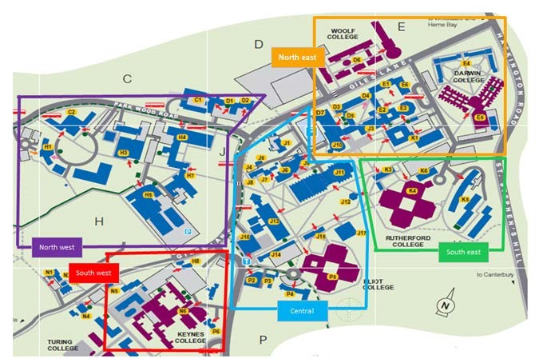

In Medway, the two principal zones are the Pembroke campus and the Dockyard. Every effort is made to avoid schools having to move from their home zone.

Requests for specialist equipment and timetable changes after the initial room allocations in May/June may affect the ability to apply zoning principles.

## A close-up of a grid Description automatically generated3.3 Timeline and summary of responsibilities

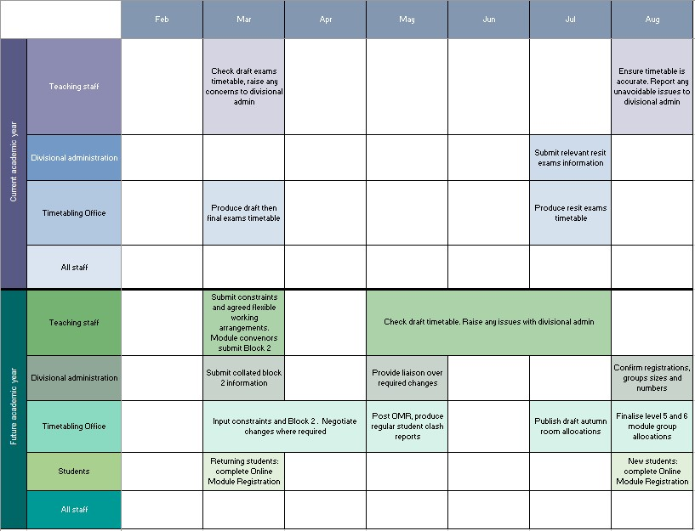

## 3.4 Useful links

[Online Timetable Information System (OTIS)](https://www.kent.ac.uk/timetabling/otis/otis.html)

This is accessible for all staff who have a staff login and either a network or VPN connection.

[The timetable process and guidance](https://livekentac.sharepoint.com/sites/Timetabling/SitePages/timetable.aspx)

[Teaching constraints policy](https://livekentac.sharepoint.com/sites/HR/SiteAssets/Forms/AllItems.aspx?id=%2Fsites%2FHR%2FSiteAssets%2FSitePages%2FTeaching%2DConstraints%2FTeaching%2DConstraints%2DPolicy%2D%2D%2DV3%2E0%2Epdf&parent=%2Fsites%2FHR%2FSiteAssets%2FSitePages%2FTeaching%2DConstraints)

[Flexible working policy](https://livekentac.sharepoint.com/sites/HR/SitePages/Flexible-Working.aspx)

[Guidelines for teaching room use](https://www.kent.ac.uk/timetabling/student-room-booking#process)

[Room type and capacity](https://livekentac.sharepoint.com/sites/Timetabling/SitePages/rooms.aspx#teaching-rooms)

# Document control & approval

**Author**

|  |  |  |
| --- | --- | --- |
| Name | Position | Contact details |
| Kimberly Hill | Acting Timetabling Manager | K.Hill@kent.ac.uk |

**Revision history**

|  |  |  |  |
| --- | --- | --- | --- |
| Version | Issue date | Author/editor | Description of changes |
| 0.1 | December 2021 | Gill Sinclair | Creation of document |
| 0.2 | 13.12.21 | Kyra Harwood-Lucas, Louise Naylor, Education and Student Experience Managers | Reviewer |
| 0.3 | 29.03.22 | Kyra Harwood-Lucas | Reviewer |
| 0.4 | 26.04.22 | Louise Naylor | Reviewer |
| 0.5 | 10.05.22 | Education and Student Experience Board | Reviewer |
| 1.0 | June 2022 |  | Final version |
| 1.1 | June 2024 | Kimberly Hill | Document update |
| 1.2 | June 2024 | William Collier | Reviewer |
| 1.3 | August 2024 | Richard Reece | Reviewer |
| 2 | August 2024 |  | Final version |

1. See section 3.3.5 for zone information.
2. See also summary of timeline section 3.5.5
3. See section 3.3 for the timeline of timetable production.