**SDG Trail**

Take a walk around the Canterbury Campus and see if you can find all 17 of the Sustainable Development Goals dotted around. You can find SDG 1: Zero Poverty on central campus in between the Senate Building and Rutherford Extension. Follow the trail to find the wonderful Kent Community Oasis Garden at the end.

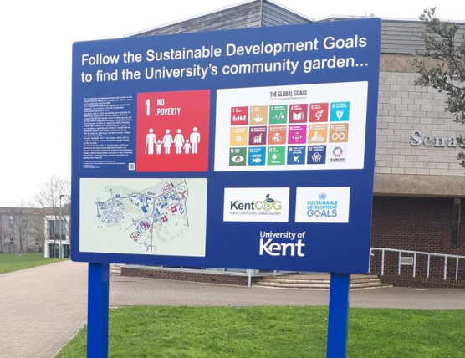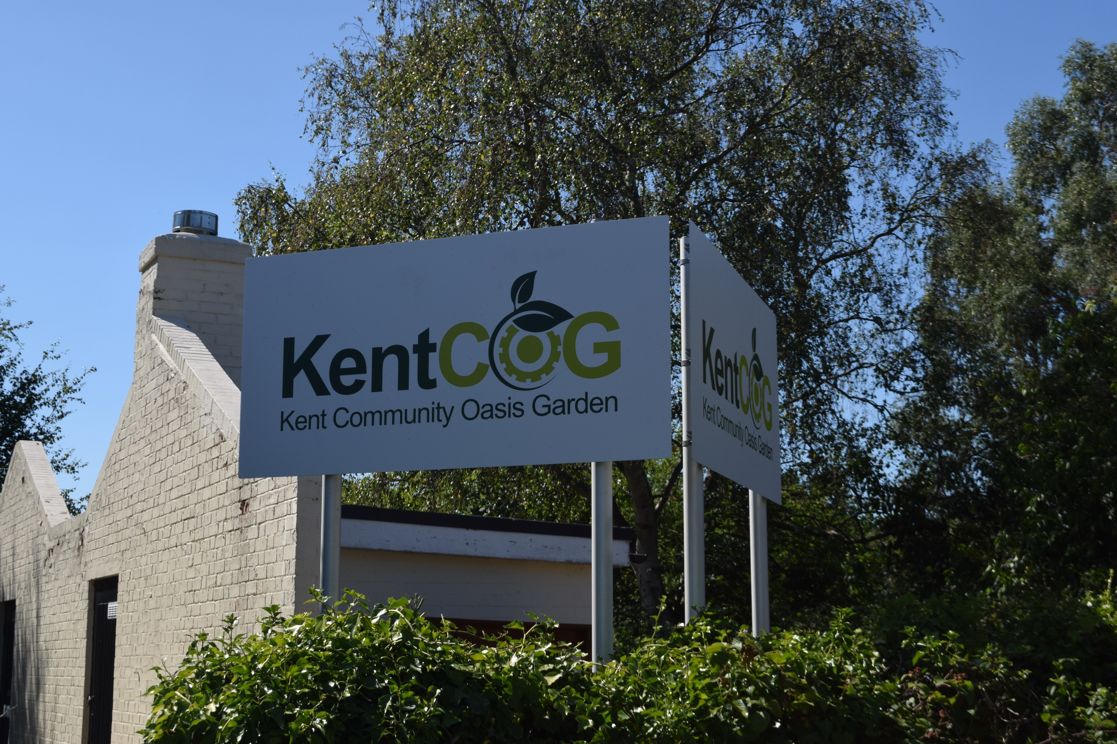

The Sustainable Development Goals (also known as the [Global Goals](https://www.globalgoals.org/) or SDGs) are 17 goals that outline a vision for a sustainable world by 2030. The 17 goals and underlying targets were created and signed by 193 countries at the UN Sustainable Development Summit in 2015.

The goals seek to finish the job that was started by the Millennium Goals which ran from 2000 to 2015 and brought 850,000,000 people out of extreme poverty and yet saw carbon emissions increase by 9,850,000 kilotons.

The University of Kent has signed the SDG Education Accord that commits us to embedding all 17 goals into our operations, teaching and research. As part this we would like all staff and students to become familiar with the goals by getting out and about across campus and discovering all 17.

The trail starts with SDG 1: No Poverty, which aims to eradicate extreme poverty and reduce overall poverty by 50% by 2030. You will find the starting board on central campus between the Senate building and Rutherford Extension.

The trail ends with SDG 17: Partnerships, which you will find at the Kent Community Oasis Garden, our flagship community partnership project at the Canterbury campus where food growing is used as a way of meeting new people, reducing stress, learning new skills and getting some fresh air.

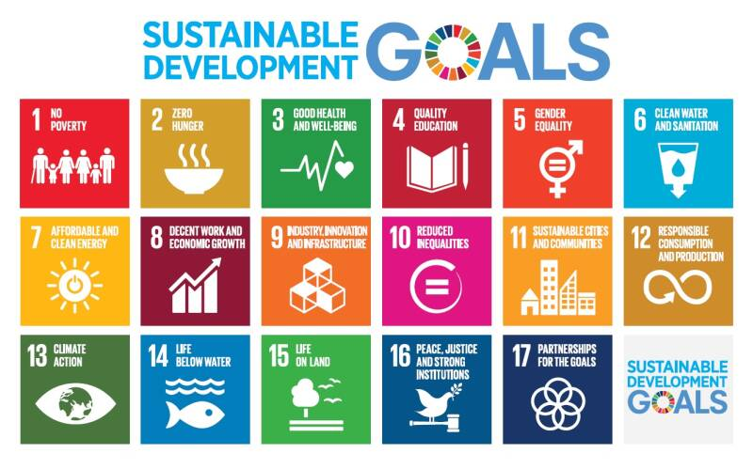

The Sustainable Development Goals are:

1: No Poverty

2: Zero Hunger

3: Good Health and Wellbeing

4: Quality Education

5: Gender Equality

6: Clean Water and Sanitation

7: Affordable and Clean Energy

8: Decent Work and Economic Growth

9: Industry, Innovation and Infrastructure

10: Reduced Inequalities

11: Sustainable Cities and Communities

12: Responsible Consumption and Production

13: Climate Action

14: Life Below Water

15: Life on Land

16: Peace, Justice and Strong Institutions

17: Partnerships for the Goals