# Note-making or Note-taking…Is there a difference?

## The short answer is, yes!

Note-taking is literally taking notes directly from a source, usually in abbreviated form, while we are reading or listening. While abbreviated, note-taking does not involve altering the original words.

On the other hand, note-making is about writing content from a source abbreviated in your own words. Consequently, we usually ‘take’ notes when we listen (for example in a lecture, or when receiving feedback from a tutor). However, ‘making’ notes is a better approach when reading.

Both approaches require you to think critically so you only focus on key information but note-taking is naturally a faster method of recording content, while note-making requires you to assimilate the information, ensuring you understand it fully. Either way, there is evidence to suggest that both approaches enhance learning and understanding of a subject.

This study guide will focus on note-making.

## Why make notes?

* Notes are a permanent record of information that will help you prepare for seminars, presentations, assignments and examinations.
* Note-making helps you concentrate on what you are reading, watching or hearing; it helps you to understand new information and new ideas, and how they relate to each other.
* Effective note-making is invaluable in helping you avoid plagiarism and study more efficiently (see our separate study guide on ‘Plagiarism and how to avoid it’).

**Do**

* Note relevant information that will aid your understanding and knowledge development e.g. key terms, concepts, definitions, names formulas etc.
* Always record your sources – date, subject, lecturer, title, author, page number etc.
* Use “speech marks” or a different coloured pen to identify direct quotations.
* Allow space to fill in gaps in knowledge or information.
* Update your notes where necessary with additional material and further research.
* Use colour, shape, dotted lines, to highlight, link, group ideas.
* Keep separate notebooks/binders/folders for each course – don’t muddle them.

**Don’t**

* Copy word for word unless explicitly told to do so.
* Rely on PowerPoint handouts, make your own notes in addition. You are expected to undertake independent research for assignments, that does not mean quoting from lectures.
* Worry if you miss something, aim to get the big picture rather than all the details, you can add details where relevant after.
* Write down more than you would want to read again.

## What to note

Think about what information you need to be able to understand the topic and be able to research the topic further. Generally, the kinds of information you are looking or listening out for are:

* Core discussions & debates.
* Terminology & definitions.
* Facts such as dates, events, people, data.
* Concepts/themes.
* Theories.
* Legislation.
* Equations/formulae/rules.
* Processes/sequence of events.
* Case studies/ examples/passages.

## Methods of note-making

There are several different ways in which you can make notes: linear, keywords, timeline, flowchart, matrix/grid, mindmaps/spidergrams, herringbone. Each method has its advantages and disadvantages. Please see below for a variety of ways to make notes along with examples:

## Linear notes

**Advantages**

* Simple and familiar approach.
* Good for listing information.

**Limitations**

* Order tends to follow the source.
* Difficult to go back and insert additional information.
* Repetitive format.
* Poor at getting bigger picture and not always possible to link ideas.
* Can reduce complex issues to lists.

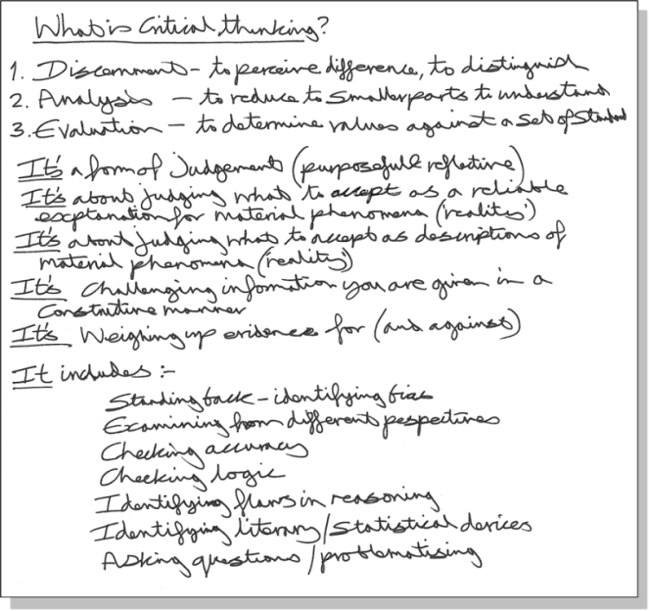

## Keyword notes

**Advantages**

* Presents information in a clear and simple manner.
* Good for organising information into categories and hierarchies.
* Good for structuring information into a memorisable format.

**Limitations**

* Can segregate information in an artificial manner.
* Can reduce complex issues to lists.

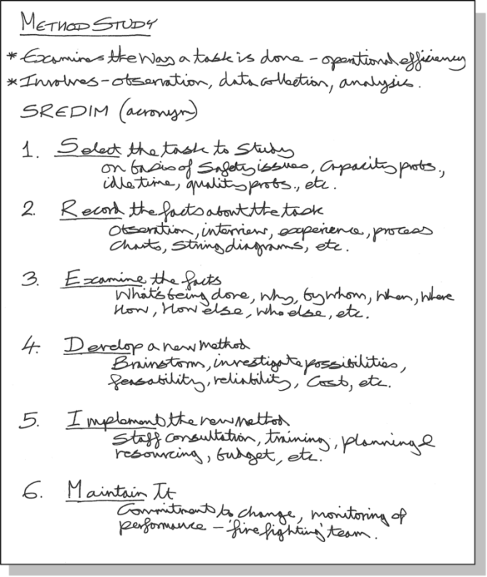

## Timelines

**Advantages**

* Good for clarifying the sequence of complex events/ideas/etc.
* Clear, simple and logical.
* Good for structuring information into a memorable format.

**Limitations**

* Can over-simplify a more complex picture.
* Tends to be very descriptive.

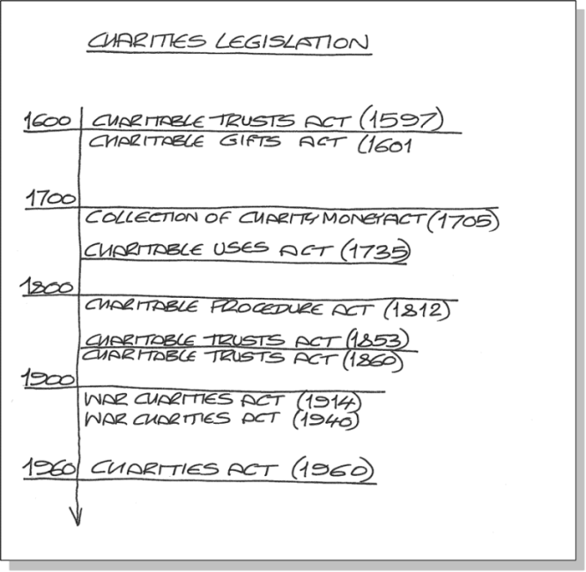

## Flow-chart notes

**Advantages**

* Presents complex processes/ideas in a simple, easy to understand manner.
* Can help to reduce volumes of text.
* Links ideas offering a bigger picture, thus encouraging critique.

**Limitations**

* May require practice.

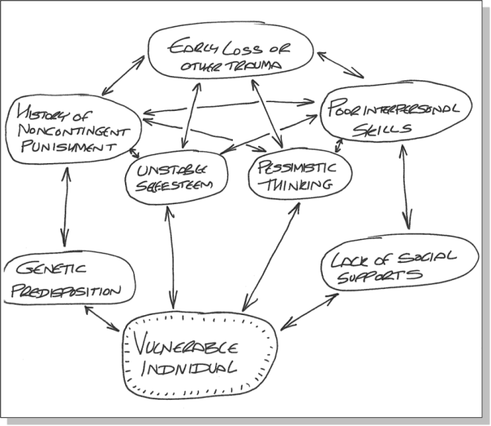

## Matrix/grid notes

**Advantages**

* Good for understanding a topic thematically.
* Good for deconstructing complex information.

**Limitations**

* Danger of categorising complex information in overly simple positive/negative terms.

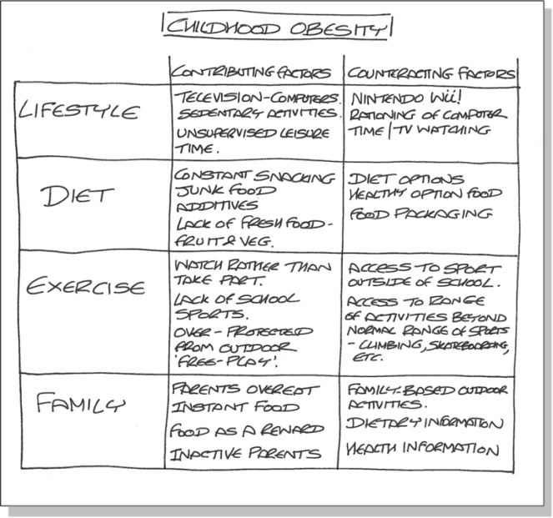

## Mind maps/spidergrams

**Advantages**

* Generates processed information.
* Highly personalised.
* ‘Whole brain’ activity.
* Can reduce large volume of text to simple graphics.
* Easy to arrange and link information.
* Good for showing connections/ big picture.
* More engaging than copying.

**Limitations**

* Can become confused.
* Requires practice.

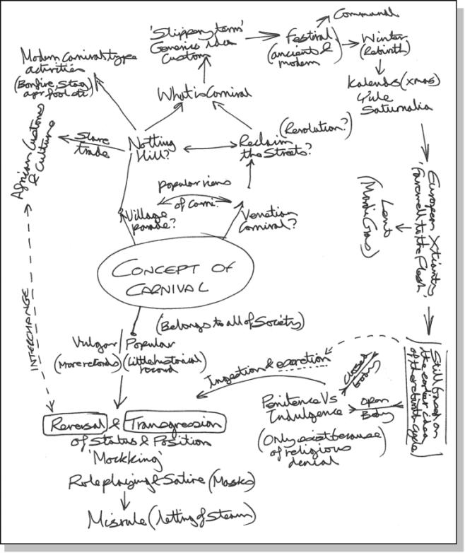

## Herringbone notes

**Advantages**

* Clarity.
* Good for compare/contrast type approaches to a topic.
* Good for setting out arguments/ opposing viewpoints.

**Limitations**

* Danger of categorising complex information in overly simple positive/negative terms.

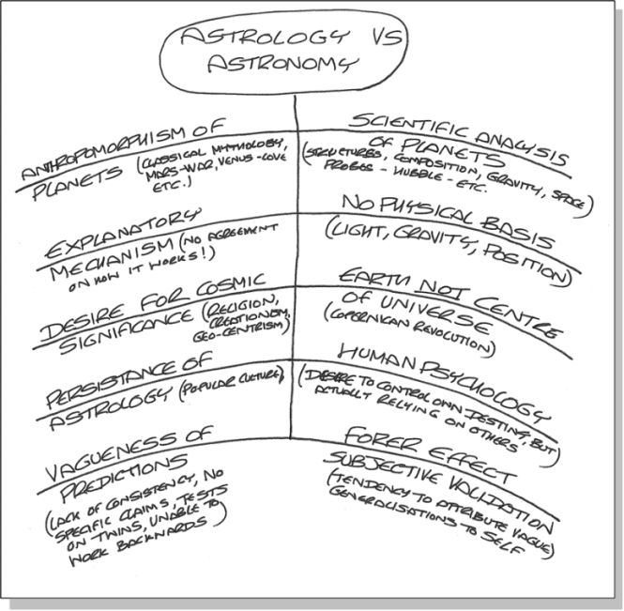

## Making the most of your notes

If you just ‘file and forget’ your notes, they’ll be of little value to you in the future. To make your notes an effective resource, spend time processing the information you have collected while it’s still fresh in your mind. This may involve:

* Undertaking research and filling in gaps in knowledge (annotating or summarising).
* Highlighting keywords, themes and topics
* Recording questions that the notes address or raise.

The **Cornell** method encourages you to make the most of your notes as it promotes reflection, consistency and accurate record keeping, any style of note-making can be used with **Cornell**:

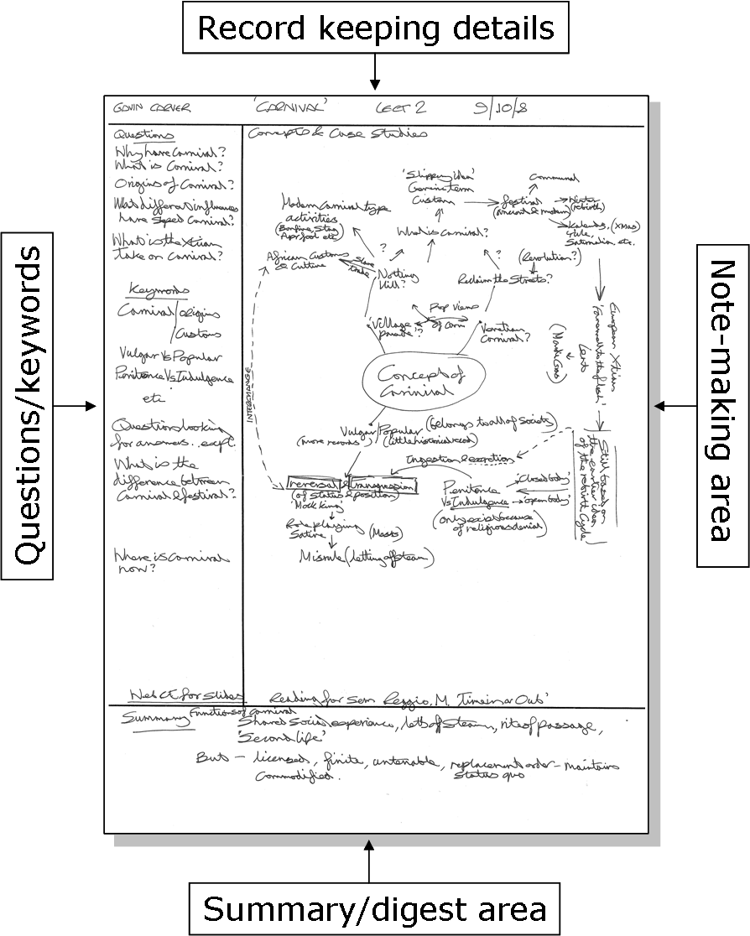

The note-making and record keeping areas are filled in while note-making, the summary/digest and questions/keywords areas completed later during reflection.

**Using your notes**

Notes are only useful if you use them appropriately:

* Use your lecture, seminar and/or research notes as a reminder of module content; to use key words for undertaking research for assignments; to help you revise for exams.
* Make notes from sources as you conduct research for writing assignments. Ensure you include source details including page numbers. Highlight points of similarity/difference (in different colours) to help you synthesise evidence.
* Use notes taken from feedback given to you by tutors/markers as a checklist for improving your performance.

If you need help or advice with any issue raised in this study guide, please book an appointment with the Skills for Academic Success team (S.A.S.).

Scan the QR code to book appointments, view our events calendar, watch skills videos and more…

