Table of Contents
Related links 1
1. Overview and scope of this procedure 1
2. Attendance and Engagement Definitions 2
3. Attendance Escalation procedure 2
4. Attendance and Engagement Escalation Steps 4
6. Students Notifying Absences 7
7. Flowchart to show escalation procedure: 8
8. Appendix 1: Exclusions to the procedure 9
9. Appendix 2: Requests for review of withdrawal decision 10

Related links
- Contact the Student Engagement team: https://student.kent.ac.uk/support/engagement
- Procedure Guidance: https://student.kent.ac.uk/studies/engagement-with-study
- Attendance and Engagement Policy: Attendance and Engagement Policy
- Presto: https://student.kent.ac.uk/studies/presto-student
- Extenuating Circumstances: https://student.kent.ac.uk/studies/extenuating-circumstances
- Support to Study procedure: https://www.kent.ac.uk/student-services/student-services-policies

Overview and scope of this procedure
  - The University has a Student Attendance and Engagement Policy that applies to all students enrolled on an undergraduate or taught postgraduate course. This document outlines the procedure for the implementation of this policy. Exceptions to this procedure are detailed in Section 3.2 of the Attendance and Engagement Policy and Appendix 1 of this procedure document.
  - The University of Kent commits to supporting all students to succeed. The Attendance and Engagement Procedure is designed to ensure that students have the support that they need to engage fully and succeed in their studies, while also ensuring that the University meets all statutory and regulatory requirements as outlined in the Attendance and Engagement policy.

Attendance and Engagement Definitions
The following definitions clarify the terminology used in this document:
  - Timetabled teaching activities: Timetabled, live events related to academic study including (but not limited to) lectures, seminars, workshops, labs and practical activities, examinations, and in-course assessments (when timetabled and requiring that students attend all together.)
  - Attendance: Attendance is one form of engagement, defined as participation in timetabled teaching activities (as defined above).
  - Engagement: Participation in activities that are related to academic study. While not an exhaustive list, engagement includes:
    - Attending live, timetabled teaching activities (e.g. lectures).
    - Completing and submitting in-course assessments (e.g. coursework).
    - Completing examinations.
    - Regularly engaging with module content on Moodle (e.g. watching module recordings, and reviewing module slides).
    - Attending scheduled meetings with Academic Advisers and/or Supervisors.
  - Low attendance: For the purpose of the Attendance and Engagement escalation procedure, the low attendance threshold is defined as 10% or less attendance at in-person timetabled teaching activities. While any level of non-attendance is a concern, a pattern of low in-person attendance below the minimum threshold will trigger intervention and lead to escalation under the Attendance and Engagement Policy, with withdrawal from study as a possible consequence.
  - Note on Attendance vs Engagement: The Attendance escalation procedure is based on in-person attendance at timetabled teaching activities. However, as outlined in the Attendance and Engagement Policy, students are expected to fully engage with their studies.
  - While escalation in this procedure is based only on in-person attendance, all engagement will be included as part of discussions with students at each step of the escalation process.

Attendance Escalation procedure
  - As per the Student Charter and the University Attendance and Engagement Policy, students are expected to fully engage with their studies and to attend all timetabled teaching activities. For postgraduate students, this includes completing the project/dissertation element of their course where regular supervision must take place.
  - Students with low attendance are at a higher risk of non-continuation, non-completion of studies, and/or compromised outcomes, and for this reason the University has put in place supportive measures for students with low attendance as described in the escalation procedure outlined below.
The University reviews in-person attendance at regular checkpoints in each teaching term, and students will be escalated if they have 10% or less in-person attendance between consecutive escalation checkpoints (across terms). Checkpoints run across terms, and so students identified through the Attendance and Engagement procedure may be escalated at any point in the academic year. For clarity, please see an example below:
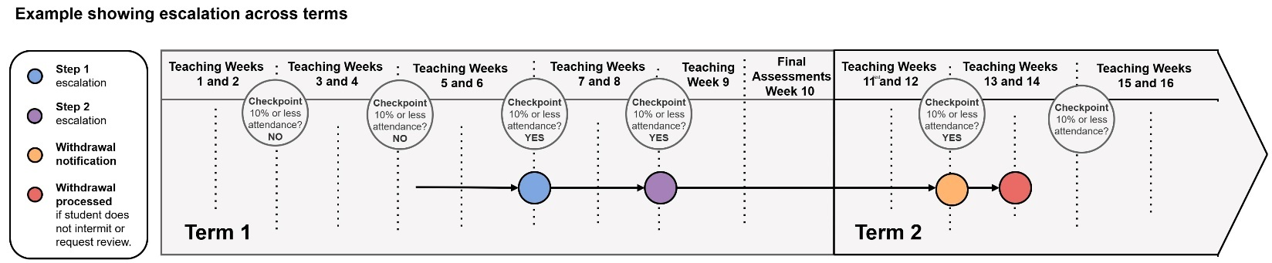
  - For students who are not attending teaching for an extended period of time, statutory and regulatory requirements mean that the University cannot allow students to continue on their course of study. Students with a pattern of ongoing in-person attendance below the minimum threshold will be escalated, and the University will normally withdraw students from their course of study if they remain below the minimum threshold for attendance across three checkpoints (as explained below).
  - In addition to the escalations checkpoints during teaching for students with in-person attendance below the minimum threshold, the University also checks overall average attendance for all undergraduate and postgraduate taught students in each month of teaching.
  - Students with above 10% average attendance will not be escalated as outlined in the procedure, but may be contacted in each term to check-in. For students with lower overall attendance or intermittent low attendance, the University will contact to offer support, and for students with consistently higher levels of attendance the University will contact to offer congratulations.
  - Student visa holders sponsored by the University will be included in these check-ins, and any such student with two (2) months of low overall attendance or intermittent low attendance (overall attendance between 10 – 50%) will be flagged to the Student Immigration Compliance team for review and possible withdrawal of visa sponsorship where they are not meeting UKVI requirements. Students who have visa sponsorship withdrawn will also be withdrawn from their course of study.

Attendance and Engagement Escalation Steps
The following escalation steps will apply when students have in-person attendance below the minimum threshold as outlined below:
  - Step 1 Escalation: Engagement support staff will contact students who have 10% or less in-person attendance at one checkpoint, and will invite students to drop-in and visit the team to discuss their attendance and options for support. In addition, students will be encouraged to submit an Attendance & Engagement Support Form. This form will help Academic Advisers and engagement support staff to understand students’ circumstances and plans, so that staff can provide appropriate support.
  - Step 2 Escalation: Engagement support staff will contact students who have 10% or less in-person attendance across two checkpoints.
At this point, students will be responsible to meet with their Academic Adviser (or other appropriate staff) within seven (7) calendar days of being contacted to discuss their attendance. These meetings are intended to be supportive, and the purpose of the meetings will be to:
    - Discuss any personal circumstances stopping students from engaging with their studies.
    - Discuss the support options available to help students mitigate any circumstances that are stopping them from engaging.
    - Discuss other options (e.g. change of course, or intermission) if appropriate.
    - Agree on an action plan to help students get back on track and engage fully with their studies moving forward.
  - Notification of pending withdrawal: For students who have 10% or less in-person attendance across three checkpoints:
    - Engagement Support staff will consult with specialist University support teams to consider if a move to Support to Study is needed. Support to Study is a separate procedure designed to provide personalised support for students when there are concerns that a student’s mental or physical health is significantly affecting their ability to participate fully and effectively in their academic studies. Any Support to Study referral will begin at the “continuing” or “significant” concerns stage, as the Attendance and Engagement procedure will already cover the “emerging” concerns stage.
    - If a move onto the Support to Study procedure is not advised, then Engagement Support staff will notify students of pending withdrawal from their course of study by email sent to their Kent student email address.
    - From the date that a student receives a notification of pending withdrawal (sent to the student’s University of Kent email address), they will have seven (7) calendar days to either:
- Request intermission by completing the Request to Intermit form.
- Submit a Request to Review Decision to Withdraw for Non-Attendance
- Withdraw from their course of study.
  - Requesting a review of a withdrawal decision:
    - A student may request a review of a withdrawal decision within seven (7) calendar days of receiving a pending withdrawal notification email.
    - To submit a review of withdrawal request a student must submit the request within seven (7) calendar days of pending withdrawal notification using the Request to Review Decision to Withdraw for Non-Attendance form.
    - Any request must meet the criteria set out in Appendix 2 and include any relevant supporting evidence or documentation.
    - Requests to review the withdrawal decision will be considered by the Director of Student Life (or nominee) in consultation with relevant departments, including the Student Immigration Compliance team where appropriate.
    - The decision of the Director of Student Life (or nominee) is final and there is no further right of review.
    - The Director of Student Life (or nominee) can determine one of three possible outcomes:
- The student is permitted to continue to be a registered student with appropriate conditions to improve attendance. If these conditions are not met, the student will be withdrawn from study without further right of review.
- The decision to withdraw the student remains and the student will be withdrawn from the University. In such cases a Completion of Procedures letter will be issued within twenty-eight (28) calendar days of the decision being provided to the student (please see OIA section 9.9).
- The student is permitted an additional seven (7) calendar days to request to intermit. If intermission is not requested within the timeframe stated, the student will be withdrawn from study without further right of review.
4.4.7 If a student does not submit an intermission request or request for review of withdrawal decision, then the student will be withdrawn from the University.
Student visa holders who are withdrawn from study or intermit will have Student visa sponsorship withdrawn.
4.4.8 Students are advised to contact the Kent Union Advice Service (Canterbury) or The Hub Advice Centre (Medway) for any questions regarding finance or visa implications of intermission or withdrawal.
5. Students Registering Attendance
  - The Attendance escalation procedure is based on recorded attendance at in-person teaching activities, and for this reason it is essential that students register their attendance at each teaching activity as outlined in Section 7.1 of the Attendance and Engagement Policy.
  - Students need to register their attendance at the start of each teaching activity. Registration after the first 20 minutes of teaching will be recorded as late attendance.
  - If students are unable to register attendance at a teaching activity, they must speak to a staff member during the session to ask that the staff member update the attendance record on their behalf. It will be difficult for staff to confirm whether students did attend the session if students speak to a staff member after a teaching activity has ended, and so it is important for students to speak to staff right away when the issue arises.
  - Students that may struggle with the registration of attendance due to a disability should speak to a Student Support and Wellbeing Adviser to see if any reasonable adjustments may apply via their Inclusive Learning Plan.
  - For online teaching sessions, students need to join/access the session via their University account in order to ensure that their attendance is correctly registered.
  - Students are expected to behave honestly and in a professional manner and only register their own attendance. Attempting to register attendance for another student and/or sharing attendance registration codes with students not otherwise in attendance is considered a breach of Student Code of Conduct and thereby any such student may be subject to disciplinary action in line with the Student Discipline Procedure.
  - In the case of professionally regulated courses, such behaviour could also lead to a Suitability to Practice (or similar) investigation.

Students Notifying Absences
6.1 The University recognises that students may occasionally have to miss some teaching activities due to unavoidable and unforeseen circumstances. If this happens, students should notify the University of the absence, in advance where possible, or on the first day they are unable to attend.
6.2 To notify the University of necessary absence, students should submit a Self-Reported Absence form, and indicate the dates of absence. This needs to be completed for each period of absence. Students should see the Presto webpage for guidance and contact their Engagement Support team if they need help to report an absence.
6.3 Notification of absence does not replace the need to submit an Extenuating Circumstances request via Kent Vision if a student’s circumstances will impact submission of work. For details, please see the webpage https://student.kent.ac.uk/studies/extenuating-circumstances.
6.4 Please note that even when students self-report absence, the Attendance escalation procedure will still apply, and students that self-report absence will still be escalated in line with the Attendance and Engagement policy and escalation procedure. However, students are encouraged to self-report absence because notifying the University of necessary absence will help the Engagement Support team to provide appropriate support.
6.5 The University recognises that some students may need to miss some scheduled attendance due to ongoing or new/emerging conditions as indicated by their Inclusive Learning Plan. Students with this as a reasonable adjustment should still complete the self-reported absence form for each period of absence. Students that fail to meet the attendance policy requirements will not be exempt from escalation regardless of any reasonable adjustment around attendance. Students with ILPs who are struggling with attendance should speak to a Student Support and Wellbeing adviser.

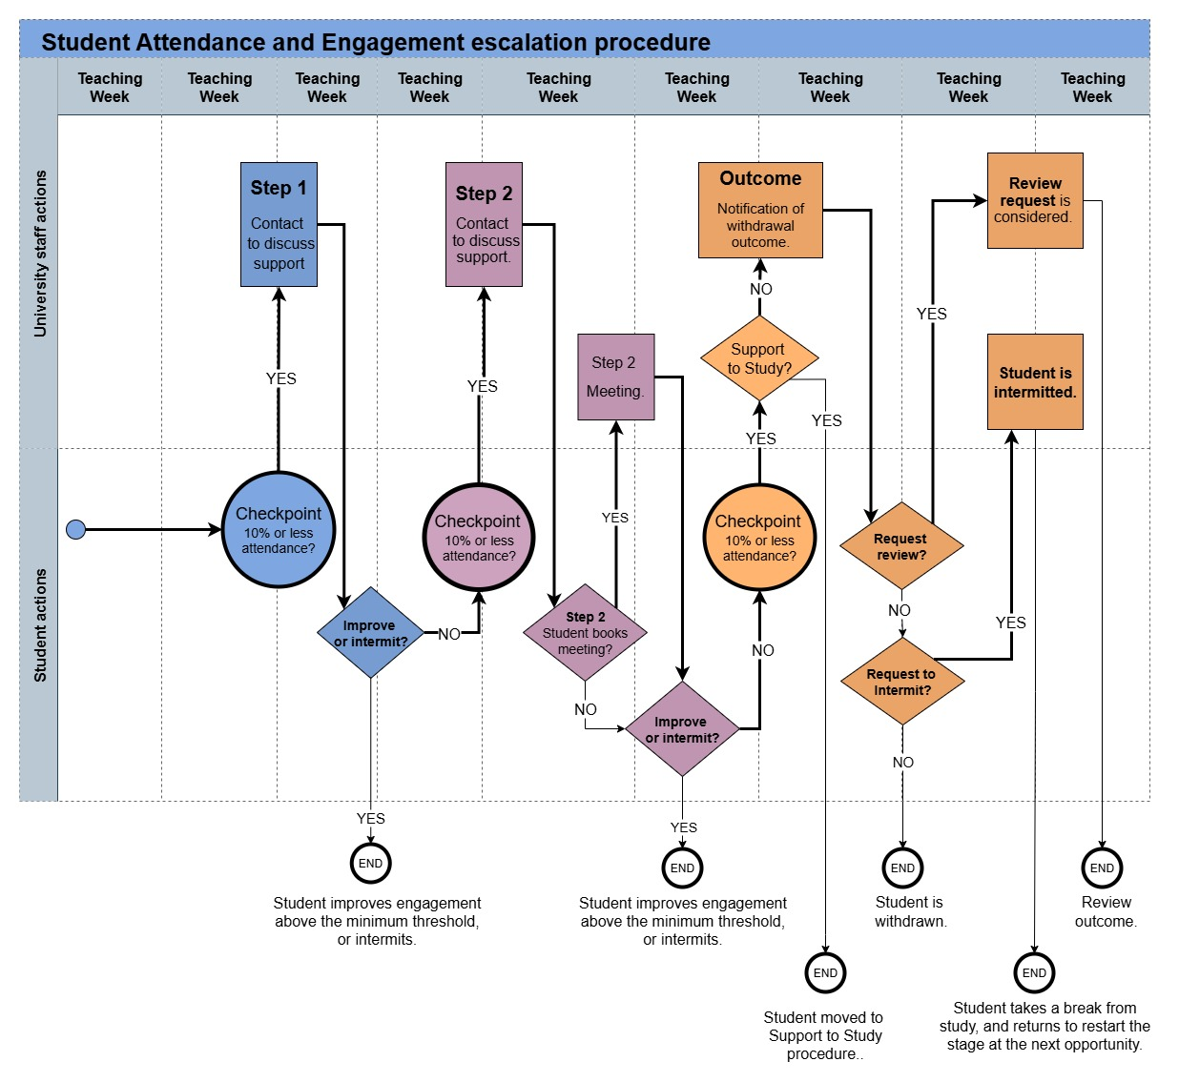
Flowchart to show escalation procedure:

Appendix 1: Exclusions to the procedure
  - The procedure outlined above applies to all undergraduate and postgraduate taught students with the following exclusions. Students not included in the Attendance and Engagement escalation procedure will be monitored and supported following different procedures as indicated below:
    - Postgraduate Research students are monitored separately as per Annex H and J of the Codes of Practice for Research courses
    - Students on placement are monitored separately by the Placements team (placements@kent.ac.uk). For any specific attendance and engagement requirements, such as whom to notify in the case of absence and attendance reporting requirements for students on a Student Route visa, students should refer to their School, and the contract that is in place for their particular placement.
    - Apprenticeship students and Distance Learners are monitored separately as per Annex T of the Quality Assurance Policy for Higher and Degree Apprenticeships (see Codes of Practice for Taught Courses of Study - Regulatory Framework - University of Kent).
    - Students placed on Support to Study (see Student Services Policies - Student Services - University of Kent.
    - Students placed on Fitness to Practice or Professional Suitability procedures (see Procedures and Guidance in relation to Quality Assurance - Regulatory Framework - University of Kent)
    - Students who have reasonable adjustments in place for hybrid study because of exceptional circumstances, agreed and monitored by Student Support and Wellbeing (kentssw@kent.ac.uk)
    - Students with course-specific attendance requirements as indicated in course and module specifications (in which case the escalation steps will apply, but the course-specific attendance requirement will be applied).
    - Students for whom sponsorship agreements supersede the University Attendance and Engagement policy.
    - Students in KMMS are monitored separately as per the KMMS Attendance and Engagement Policy: https://kmms.ac.uk/about/policies/
    - Students on year abroad are monitored separately by International Partnerships (studyabroad@kent.ac.uk).
    - Students studying at the International College are monitored separately by the International College through a process which follows the same principles while complying with UKVI requirements for below-degree level contact hours. The process is owned by the Student Immigration Compliance team (visacompliance@kent.ac.uk).

9. Appendix 2: Requests for review of withdrawal decision
9.1 Students may submit a Request to Review Decision to Withdraw for Non-Attendance if one or more of the following criteria apply:
- If there has been a procedural error or other irregularity in applying the Attendance and Engagement procedure.
and/or
- If there is new evidence that the student could not provide before the Withdrawal outcome agreed, which could have affected the outcome of the decision.
9.2 Students must submit a request using the Request to Review Decision to Withdraw for Non-Attendance Form and should include any supporting evidence as part of their submission, within seven (7) calendar days of receiving the notification of Withdrawal decision.
9.3 If the student does not complete the form within seven (7) calendar days to request a review, they will be withdrawn from study, with no further right to review.
9.4 If a student submits a request within seven (7) calendar days of receiving the Withdrawal notification, the Director of Student Life (or nominee) will consider the review request.
9.6 The following outcomes are available to the Director of Student Life (or nominee):
- Uphold the review request and recommend what option other than withdrawal can be agreed.
- Dismiss the case, which will mean that the withdrawal decision remains and the student will be withdrawn.
  - The Decision of the Director of Student Life (or nominee) is final and there is no further right of review. The student will receive decision in writing within seven (7) calendar days of the request submission deadline.
9.8 Where a student review is unsuccessful, the student will be issued with a Completion of Procedures letter within 28 Calendar days of the outcome being issued.
  - Office of the Independent Adjudicator for Higher Education: Once all stages of this procedure have been exhausted, the student has the right to refer the case to the Office of the Independent Adjudicator for Higher Education for further review. An application to the OIA must be submitted within 12 months of the issue of a Completion of Procedures Letter. Full details regarding the OIA’s rules and guidelines are available at their website.

