Study Advanced Child Protection online while continuing your professional career
Thinking about studying an advanced online course in child protection?
We’re hosting an Online Virtual Open Event for UK and international students. Join us to learn about our online, distance-learning PG Advanced Child Protection courses starting in January 2027. Applications close in November 2026. Joining details are provided below.
🗓 Date: Friday, 23 October 2026
🕒 Time: 13:00 – 14:00 (UK time / BST)
💻 Where: Online (via Microsoft Teams)
Joining Link: PG ACP Virtual Open Day | Meeting-Join | Microsoft Teams
Meeting ID: 312 782 983 341 088
Passcode: cd6UA2rY
🌐 Please note the event time is listed in UK time. Check your local time zone before joining!
Click here for course details and how to apply: https://www.kent.ac.uk/courses/postgraduate/326/advanced-child-protection
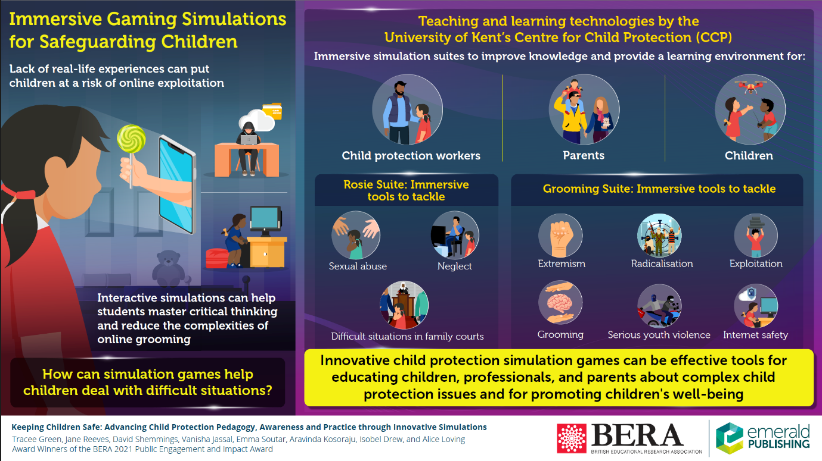
For over 10 years we have specialised in teaching child safeguarding and protection professionals from agencies across the UK, including education, health, social care, police, charities and voluntary organisations. In addition, professionals from outside the UK, often working with NGOs in humanitarian contexts, have found considerable value in accessing our courses. Our PG courses strengthen the skills, knowledge, and confidence of all those supporting vulnerable children, young people, and their families.
The Virtual Open Event will introduce the course structure, explain how the programme is taught remotely, and demonstrate our engaging and interactive approach to online learning. We hope you can join the session!

