Student Voice for Taught Study Procedures

Contents
Related links 1
1 Overview and scope of this procedure 1
2. Channels for ad-hoc student feedback 2
3. Annual University-wide surveys 3
4. Pulse Surveys 3
5. Mid-Module Evaluation 4
6. School-wide Student Voice channels 4
7. School Student Voice Forum (SVF) 5
8. Complaints 8
Appendix 1: Student Voice Forums workflow 9
Appendix 2: University-Level Student Voice 10
Appendix 3: School-Level Student Voice 10

Related links
- Policy: Once published
- University Student Voice webpage: https://student.kent.ac.uk/life/your-uni-your-say
- KSU Student Rep webpage: https://ksu.co.uk/student-voice/student-reps
- Student Voice in Postgraduate Research study (once available)
- Student Voice in HDA study (once available).

1 Overview and scope of this procedure
  - The University has a Student Voice for Taught Study policy to ensure that:
    - All taught students have opportunities to feed back regarding their experiences of study in each academic year,
    - All taught students are kept informed regarding how student feedback has been considered and actioned.
    - All taught students have opportunities to contribute to planning and decision-making processes and are empowered to actively engage in analysis of student feedback, discussion of actions, and design and delivery of enhancements to academic study.
    - Student Voice at Kent is inclusive, accessible, and representative of the full range of student experiences, perspectives, and priorities.
    - Student Voice at Kent is consistently delivered, compliant with OfS B2 conditions, and aligned with sector best practice.
1.2 The procedures outlined below apply to Student Voice as related to modules, courses and resources, facilities and support for academic study. This policy does not cover Student Voice outside of these academic themes.
1.3 These procedures apply to all taught students (undergraduate and postgraduate) while registered and studying at University of Kent, but will need to refer to separate procedures and guidance still under development for specific cohorts:
1.3.1 Apprenticeship students have specific Student Voice requirements as stipulated by employers, and Student Voice for HDA programmes.
1.3.2 Postgraduate Research students have a different cycle of activity across the year, and are not involved in academic study in the same way as taught students.

2. Channels for ad-hoc student feedback
2.1 To ensure that all taught students have opportunities to feedback regarding their experiences of study, the University and Kent Students’ Union (KSU) support multiple channels in different formats (both online and in-person) to allow for ad-hoc feedback across the year, in addition to informal peer-to-peer conversations.
2.2 Course Mate is an online platform monitored by the KSU Student Voice team, with volunteer Course Reps and part-time paid School Reps helping to escalate and respond to student feedback submitted via the platform. This platform allows students to individually submit ideas, comments and issues at any point across the year for their Course and School Reps to review. Student Course and School Reps review the submissions that fall within their schools / courses and a) escalate and/or action the feedback; b) provide an update or response back to the student who has submitted the feedback.
2.3 School-wide drop-in sessions are coordinated by the University Student Voice and Experience team, and led by Course / School Reps and academic Student Experience Leads (SELs). The locations and formats for drop-ins are flexible and will be agreed at the start of each academic year by SELs and Reps as appropriate for each school. Drop-in sessions allow students to discuss individual feedback with their Reps and academic leads.

3. Annual University-wide surveys
3.1 University of Kent runs annual surveys for all taught students to individually feedback in each academic year, to better understand students’ overall experience of academic study. These surveys include:
3.1.1 The Kent Undergraduate Experience Survey, an internal survey administered by the University professional services teams and run for non-finalist undergraduates in Foundation, Stage 1 and Stage 2. All responses are used for internal consideration only, and are anonymised before comments and reports are shared with academic staff.
3.1.2 The National Student Survey (NSS), an external survey administered by Ipsos for finalist undergraduate students. All responses are anonymised by Ipsos before comments and reports are shared with the University. Responses are used internally for University enhancements, and also for benchmarking against other institutions in the sector.
3.1.3. The Postgraduate Taught Experience Survey (PTES), an external survey hosted on JISC but administered by the University Student Voice and Experience team. All responses are anonymised before comments and reports are shared with academic staff within the University. Responses are used internally for University enhancements, and are also shared with AdvanceHE for benchmarking against other institutions in the sector.

4. Pulse Surveys
4.1 Pulse Surveys are a channel to engage with the wider study body, to better understand student experience in targeted topics related to academic study.
Pulse Surveys typically run for 1-week at a time and will include 2 – 4 multiple-choice or scaled/rating-style questions on a specific topic (for example, Academic Advising). Pulse Surveys are administered by the University Student Voice and Experience team, with the team visiting student study spaces and other communal spaces to get a sample of students who might not normally engage with surveys or Student Voice activity.

5. Mid-Module Evaluation
5.1 Mid-Module evaluations will:
- inform the continuous improvement of modules and courses.
- provide timely developmental feedback to help teaching staff improve course/module design and teaching.
- encourage students to reflect on their own teaching and learning needs.
5.2 These will take place mid-module through anonymous surveys, conducted online. Mid-module evaluations are generally light-touch, with students asked to reflect on what they have enjoyed/appreciated about the module so far and where they feel that changes could be made that would improve their experience of the module.
Each module convenor will manage data collection, analyse responses, and provide feedback to students in line with School policy.
5.3 Academic leads within the school (as appropriate) will summarise course feedback obtained via mid-module evaluations, Student Voice Forums, the PTES, NSS and Kent Student Experience surveys and share themes and insights with School Reps to feed into School Student Voice Forums.

6. School-wide Student Voice channels
6.1 While the channels outlined above provide students with opportunities to share individual feedback, School-wide activities provide space for students to feed back in a group setting and engage in dialogue.
6.2 School-wide activity is coordinated by the University Student Voice and Experience team with support from the KSU Student Voice team and is led by the Course / School Reps and academic Student Experience Leads for each school.
6.3 Activities are delivered flexibly across the academic cycle according to local requirements, to engage with all taught students within a school or subject. Activities are planned to follow different formats depending on what the Reps and academic leads agree at the start of the academic year. Activities may include larger (200+) Town Hall-style sessions to discuss ad-hoc feedback, medium-sized workshops (50 – 80 students) to collect ideas and on specific themes, and smaller focus groups (10 – 20 students) to discuss specific academic topics in more depth.
The number and timings of school-wide Student Voice activity will be agreed by Reps and academic leads for each school, but will also depend on what capacity and resource is available from the University Student Voice and Experience team to support activities.

7. School Student Voice Forum (SVF)
7.1 The Students’ Union runs a system of Student Representatives which includes two levels. For full role descriptions and expectations, please see the Students’ Union Student Rep Handbook.
- Course Reps: This is a voluntary role, with no limit on the number of students who can volunteer. Course Reps are expected to actively collect and respond to feedback from their peers, and to attend and contribute to:
  - School Student Voice Forums.
  - School-wide Student Voice events.
- School Reps: This is a part-time paid role, with one School Rep per study level per School. School Reps are expected to actively collect and respond to feedback from their peers, and are also expected to work closely with academic leads within their School to take on more of a leadership role within School Student Voice. At a minimum, School Reps are expected attend and contribute to:
  - Meetings to set agendas and plan proposals for School Student Voice Forums.
  - School Student Voice Forums (acting as Co-Chairs).
  - School Education and Student Experience Committee.
  - School-wide Student Voice events (acting as co-hosts / co-leads).
7.2 Purpose and overview: Student Voice Forums (SVF) provide a channel for taught students to contribute to planning and decision-making processes within their school in consultation with academic leads. At Student Voice Forums, Course and School Reps will work with the school Student Experience Lead and other academic staff (as appropriate) to actively engage in analysis of student feedback, discussion of proposals, agreement of actions, and design and delivery of enhancements to academic study. Student Voice Forums are for discussion of options and ideas, and for action planning, and not for general feedback or reporting of issues.
7.1.1 Ahead of each SVF, School Reps and staff Student Experience Leads will consider feedback from across all channels, identify themes and provide insight to shape the discussion and planning activity at the next SVF. The University Student Voice and Experience team will facilitate the collation of feedback across channels to support this work.
7.2.2 SVFs will consider student feedback related to academic study (modules / course / academic experience), and any feedback not directly related to academic study will be considered and actioned via the appropriate channel outside of Student Voice Forums.
7.2.3 SVFs will consider wider course and school themes and will not address specific module feedback or local issues (e.g. temperature in a specific lecture theatre).
7.2.4 SVFs will consider feedback already collected and are primarily a forum to agree on proposed plans/actions for enhancement (and not primarily a forum for new feedback items).
7.3 Frequency and schedule: Each School will plan two Student Voice Forums in each academic year. Student Voice Forums may be held in any teaching term, and the schedule and timings of forums will be agreed between the School Reps and academic Student Experience Lead (within the constraints of when the University Student Voice team is able to support), and may be scheduled in any of the teaching terms (Autumn, Spring, Summer).
SVF meetings will be arranged, as far as is possible, for times and dates when the majority of Course and School Reps and academic leads are able to attend.
SVF will be held in-person whenever possible for schools that do not have distance learning courses or courses based in Medway. SVF will be held as hybrid in-person / Teams meetings for schools that have distance learning courses and/or students who are based in both Canterbury and Medway campuses.
All SVFs follow a common preparation timetable as outlined below.
Deadlines (all within teaching term time) | Required activity | Responsible
15 working days before | Uni Student Voice team chases updates on outstanding actions / SEL prepares update regarding progress for any previously agreed plans/actions. | University Student Voice team.  Student Experience Lead.
10 working days before | Co-Chairs meet to review the feedback, agree topics and sequence for discussion, and set agenda. Co-Chairs prepare notes/proposals based on feedback to present and discuss at SVF. | School Reps and academic Student Experience Leads
5 working days before | Agenda and any notes/proposals are circulated to members. | University Student Voice team
Meeting | To consider ideas/proposals based on feedback already collected and then agree on actions to progress. | All members
Within 10 working days after | Record of plans/actions circulated to members and published on school webpage for all students and staff within the school to view. | University Student Voice team.
Before the next meeting | Progress is updated, and unresolved cross-University or professional service issues are routed to the appropriate owner and tracked. | University Student Voice team.

7.4 Membership and attendance requirements: Membership of SVFs is limited to Undergraduate and Postgraduate Taught School and Course Reps, the School Student Experience Lead, and the University Student Voice and Experience team, with professional services and other staff invited as Subject Matter Experts as appropriate.
Student representatives are recruited through Kent Student’s Union (KSU) and full training is provided to ensure that students have the skills required, and understand the responsibilities and expectations of the role.
School Reps are co-partners with the Chair, and should therefore lead the first part of the meeting involving student feedback with the academic, with the academic taking the lead of academic updates and specific specialist responses to raised issues.
The University Student Voice and Experience team will record the attendance of student representatives at Student Voice Forums and share this record with KSU.
7.5 Minimum requirements for each session: All SVFs need to include the following:
- An agenda set jointly between the staff Student Experience Lead (SEL) and School Reps, based on feedback falling into a specific NSS / PTES themes, and circulated in advance to all members.
- Co-Chairing of the session by the Student Experience Lead and School Reps.
- Discussion of reports / proposals prepared in advance by School Reps and SELs.
- A format that allows for consideration of each study level and subject (as appropriate).
- A record of the topics / themes discussed and any agreed plans, actions or next steps.

7.6 Agenda-setting and circulation: Ahead of each SVF, School Reps will meet with staff Student Experience Leads (and/or other academic leads as appropriate) set the agenda for the session. As part of this, the School Reps and academic leads will review the feedback available, identify specific topics/themes to prioritise, and prepare ideas or proposals to bring to the Student Voice Forum for discussion.
As part of their training, KSU and the Student Voice and Experience team will ensure that School Reps are aware of their responsibilities, role, and the format of SVFs prior to their first meeting. KSU and The Student Voice and Experience team will ensure that all representatives understand and are comfortable with the processes prior to their first meeting.
Agendas for meetings and associated notes/proposals will be sent to all members in advance of meetings (prepared by the School Reps and academic lead, and then circulated to SVF membership by the University Student Voice and Experience team).
7.7 Communicating updates, plans and outcomes to students: Following each SVF, the University Student Voice and Experience team collates the notes from the session and circulates updates to all members. Updates are focused on agreed actions / plans rather than full transcripts, and include:
• a summary of the topics / themes discussed;
• agreed actions, named owners and realistic timescales;
• items requiring referral beyond the school;
• progress against actions from the previous meeting; and
• a clear explanation where a proposed change cannot be made.

Course and School Reps are asked to help to update peers following each SVF, and the University Student Voice and Experience team will also add a summary of SVF plans, progress and outcomes on the School webpages for all students within the school.

8. Complaints
8.1 Early Resolution: For concerns regarding the delivery of University Student Voice activity, or for complaints regarding the services and support provided by the University Student Voice and Experience team, please contact the manager of the team in the first instance via StudentExperience@kent.ac.uk to consider what Early Resolution may be possible to resolve the issue.
8.2 Formal Complaint: If you are not satisfied with the outcome of the Early Resolution as advised by the manager (or designee) of the University Student Voice and Experience team, then you have the option to consider a formal complaint. Please see the University Student Complaints webpage for details regarding the complaints process (https://student.kent.ac.uk/support/student-complaints) and please contact the Kent Students’ Union Advice Service for independent advice if you need help with the complaints process (https://ksu.co.uk/advice).
8.3 Students’ Union complaints: Please note that the Students’ Union is separate from the University, and any concerns or complaints related to KSU Student Voice activities, services or support will need to be handled via the KSU complaints process. Please contact the KSU Advice Service for guidance.

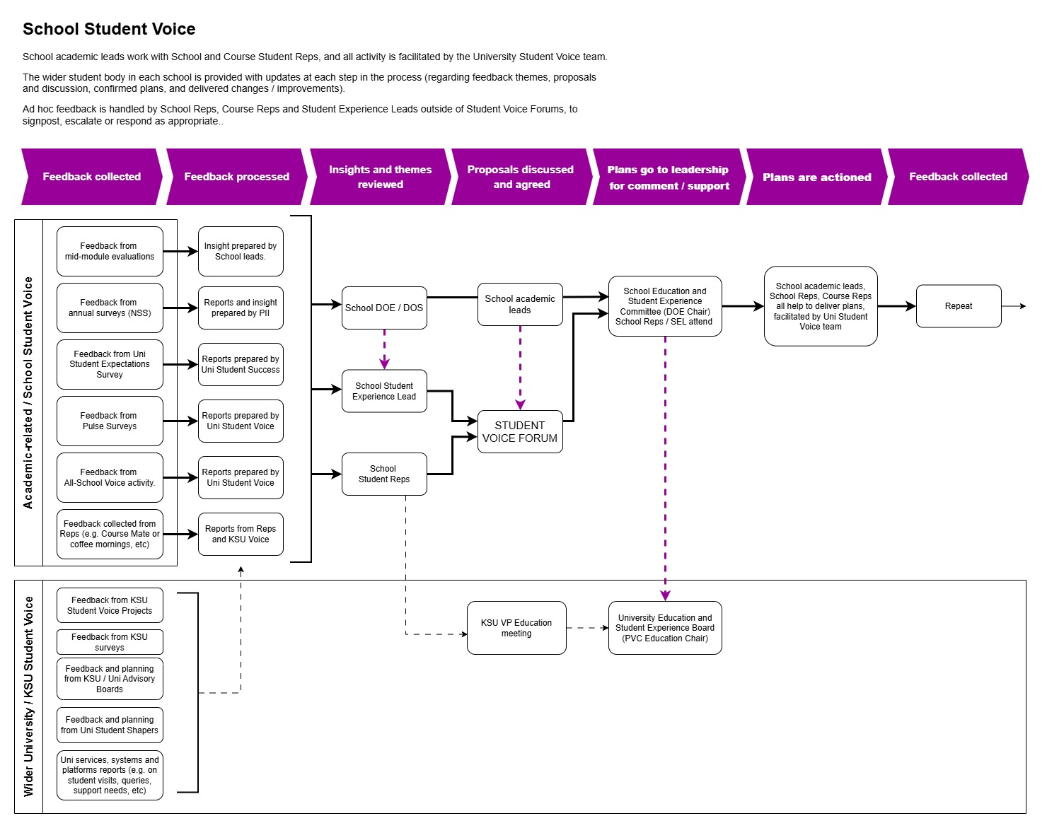
Appendix 1: School Student Voice feedback cycle

